**Addition challenge**

Use the number line, or concrete resources such as counters, Lego bricks, or buttons to help you find the answer to these addition sentence.

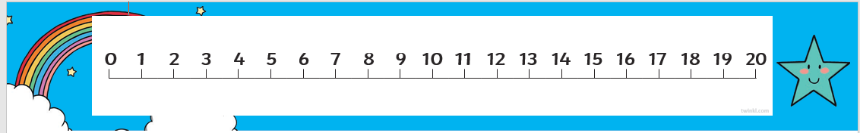

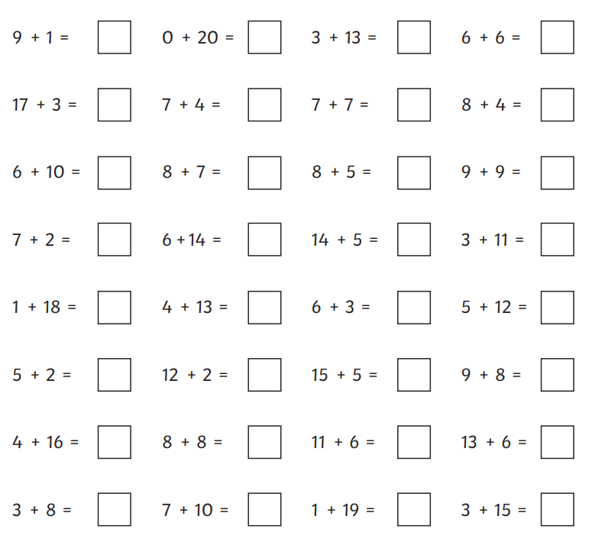

+ 4

Challenge – use your number skills to find the missing number in these addition sentences. Use the number line to help you.



