Reception class homework 6th February 2025

Addition challenge – use your fabulous number skills to find the answer to these addition sentences. Remember, when you **add** numbers, your answer will get **bigger**.

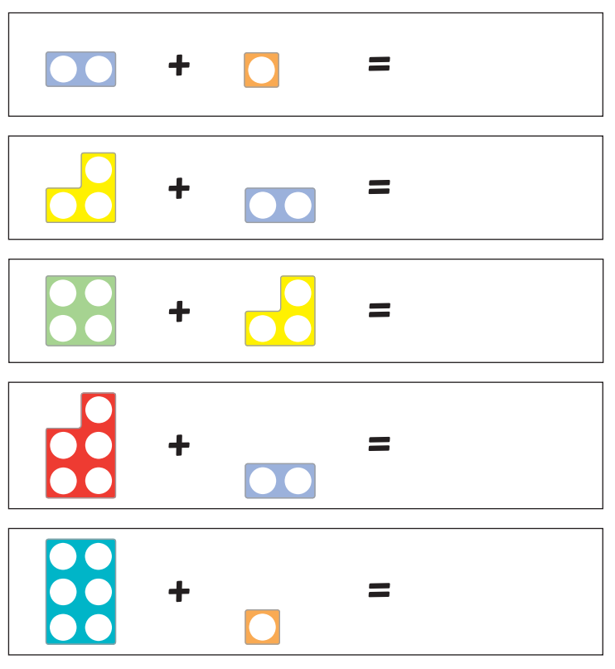

Challenge – have a go at recording some of these pictorial sums using numerals. For example Q1 would be: 2+1=3

