Double it!

Complete the ten frames and double facts number sentences. Remember doubling is when **two equal** numbers are added together.

The first one has been done for you.

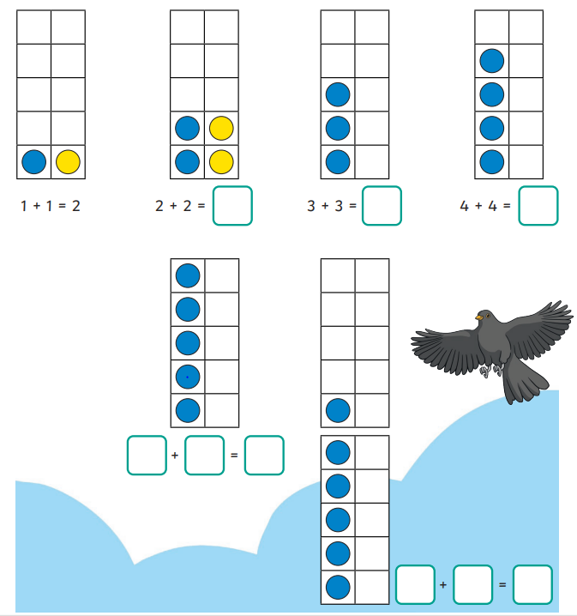

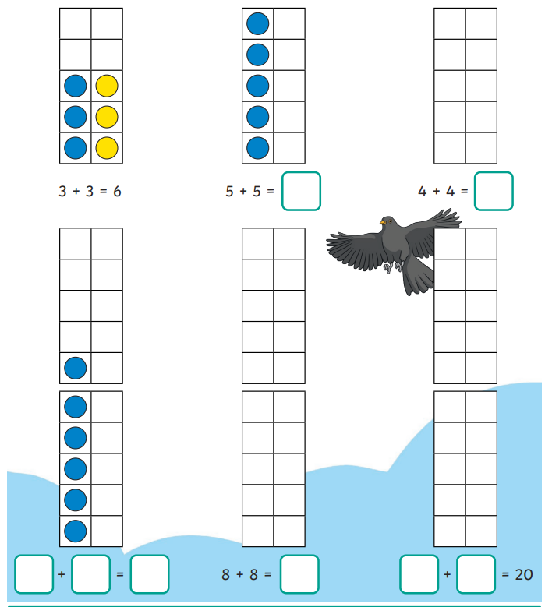

Challenge – have a go at completing these questions

Double 4 is Two lots of five is

2 x 6 = 7 doubled is

Double 10 is 2 lots of 8 is