**Amber Class Homework Spring term 2 week 4**

Homework due: Tuesday 25th March 2025

|  |
| --- |
| **Reading: Daily for 30 minutes, write up in your Reading Record with a comment about what was read/discussed.**  **Spelling: see below**  Maths Games:  <https://www.topmarks.co.uk/maths-games/hit-the-button>    [**https://ictgames.com/mobilePage/mostlyPostie/index.html**](https://ictgames.com/mobilePage/mostlyPostie/index.html) |

**Spellings:**

|  |  |  |
| --- | --- | --- |
| Group 1 | Group 2 | Group 3 |
| describe  calendar  disappear  opposite  purpose  occasionally  potatoes  various | Learn  believe  regular  caught  strange  though  separate  build | come  people  pull  wild  everybody |

Use this space to practice your spellings!

**Complete the math’s activities**

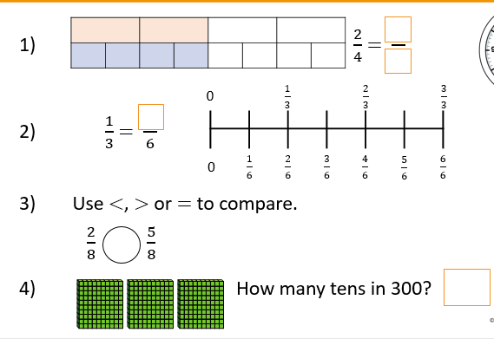

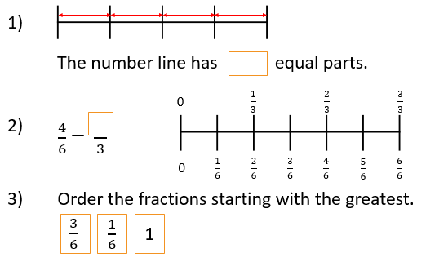

**Maths challenge:**

Remember 1kg is the same as 1000g

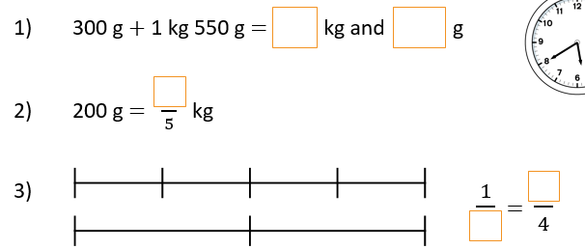

**English:** Write a poem on the Romans using ether alliteration, rhyming, similes or natural sounds.

**Alliteration example –** Ruthless ruined romans

**Rhyming example** – Their bold outfits were made of gold

**Similes example** – Their sword was as sharp as a knife

**Natural sounds example** – Their thundering boots clattered through the fields.