**Amber Class Homework Spring term 2 week 3**

Homework due: Tuesday 18th March 2025

|  |
| --- |
| **Reading: Daily for 30 minutes, write up in your Reading Record with a comment about what was read/discussed.**  **Spelling: see below**  **Fractions:**  Complete the fractions quiz on purple mash  <https://phet.colorado.edu/sims/html/build-a-fraction/latest/build-a-fraction_en.html> |

**Spellings:**

|  |  |  |
| --- | --- | --- |
| Group 1 | Group 2 | Group 3 |
| knowledge  learn  length  library  material  medicine  mention  minute | arrive  believe  bicycle  breath  breathe  build  busy  business | Water  People  Steak  Clothes  Beautiful |

Use this space to practice your spellings!

**Complete the math’s activities -**

Can I have the measurements of the lines in centimeters please.

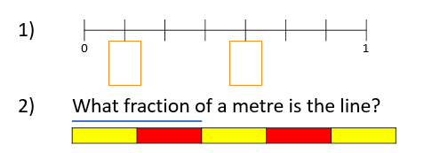

What is the equivalent fraction? (equivalent meaning the same)

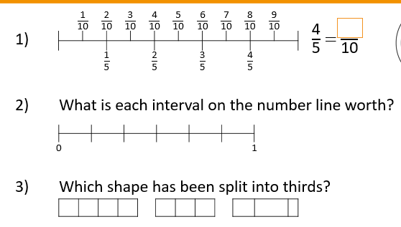

**Maths challenge:**

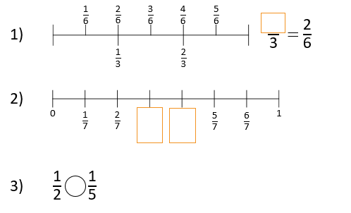

**English:** Research a famous scientist who made difference; finding out about adaptation in ether animals, plants or environment.