**Amber Class Homework Spring term 2 week 2**

Homework due: Tuesday 11th March 2025

|  |
| --- |
| **Reading: Daily for 30 minutes, write up in your Reading Record with a comment about what was read/discussed.**  **Spelling: see below**  **Fractions:**  Complete the fractions quiz on purple mash    <https://www.topmarks.co.uk/times-tables/coconut-multiples> |

**Spellings:**

|  |  |  |
| --- | --- | --- |
| Group 1 | Group 2 | Group 3 |
| ordinary  particular  peculiar  perhaps  popular  position  possess  possession | centre  century  certain  circle  complete  consider  continue  decide | improve  behind  even  hour  again |

Use this space to practice your spellings!

**Complete the math’s activities -**

Can I have the measurements of the lines in centimeters please.

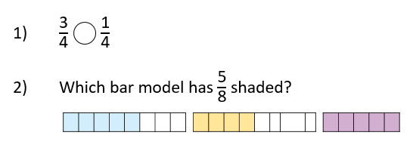

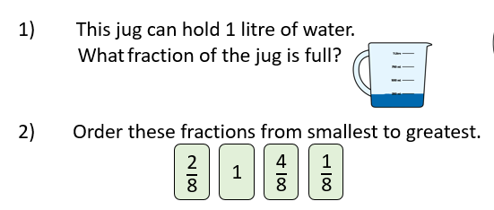

**Maths challenge:**

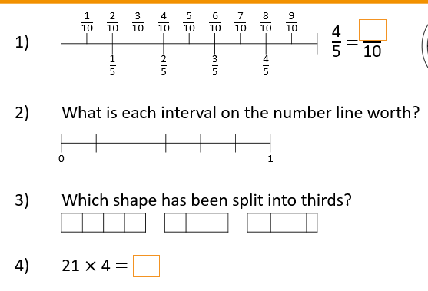

**English:** Write a paragraph about your favourite part of Colchester castle was.