**Emerald Class Homework Spring 2 week 3 – Y5**

Homework due: Tuesday 18th March 25

|  |  |  |  |
| --- | --- | --- | --- |
| **Next week we are learning:** | | | |
| Maths | Literacy | Science | RE |
| We will be continuing our unit on Fractions | We will be will be working on some elements of SPaG and writing some poems | We will be our unit on continuing our Living things and habitats | We will be continuing our unit on Salvation |

|  |
| --- |
| Some Useful Websites:  Nrich.maths.org - https://nrich.maths.org/  Coolmath-games.com - https://www.coolmathgames.com/  Woodlands Junior School - https://www.primaryhomeworkhelp.co.uk/  BBC Bitesize - https://www.bbc.co.uk/bitesize/primary  Counton.org - <https://count-on.co.uk/>  <https://www.topmarks.co.uk/>  <https://www.tomscott.com/usvsth3m/maths/>  Purple Mash also have some lovely Maths and spellings activities  Or use other websites/ways that you enjoy 😊.  ***Spellings:***  Practise spellings ready for weekly spelling test- see below for your child’s spelling group – These groups are subject to change as they are based on their current spelling ages.  ***Reading:***  Read every day for 30 minutes. Please log this in Reading Records.    ***Maths – Fractions - improper to mixed number fractions and adding and subtracting with the same denominator***  ***English – pronouns*** |

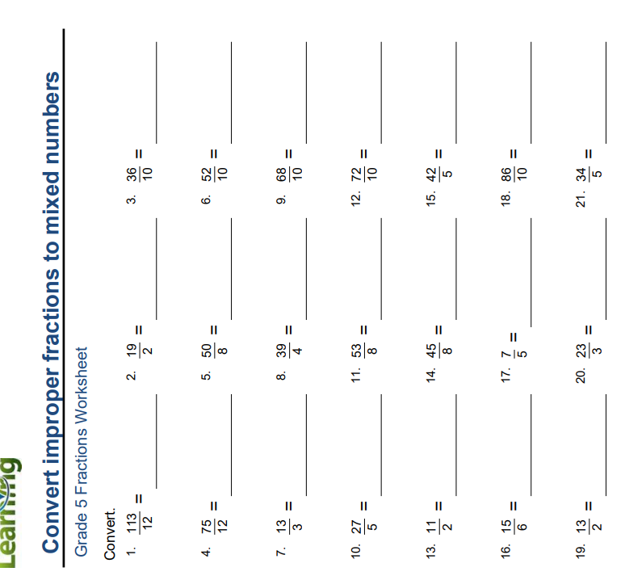Spellings:

|  |  |  |
| --- | --- | --- |
| **group 1 -**  homophones and near homophones | group 2- | group 3 – |
| grate  great  grown  groan  plain  plane  peace  piece  rain  reign  battle  survived | girls’  boys’  babies’  parents’  teachers’  women’s  men’s  children’s  people’s  mice’s    Reign  corset | forty  scorch  absorb  decorate  afford  enormous category  tornado according opportunity  protestant  execute |

Please write your spellings in sentences to show a correct understanding of the words

………………………………………………………………………………………………………………………………………………………………………………………………………………………………………………………………………………………………………………………………………………………………………………………………………………………………………………………………………………………………………………………………………………………………………………………………………………………………………………………………………………………………………………………………………………………………………………………………………………………………………………………………………………………………………………

Remember what stays the same

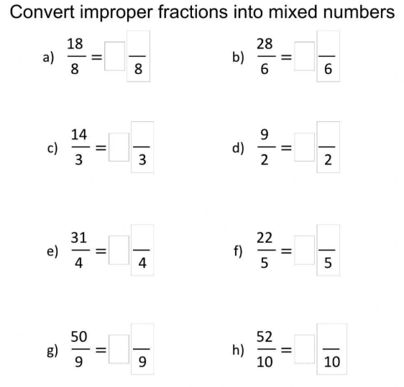

Remember in order to convert you need to use your knowledge of multiplication and division to help identify the whole numbers. For example a) there are 2 lots of 8 in 18 which 2 remaining, which then becomes

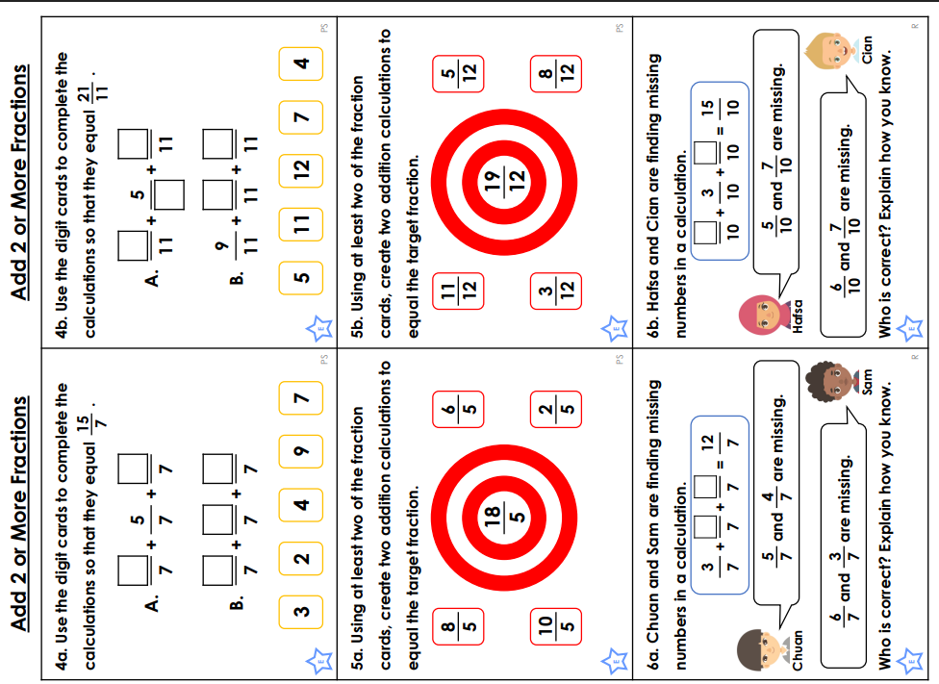

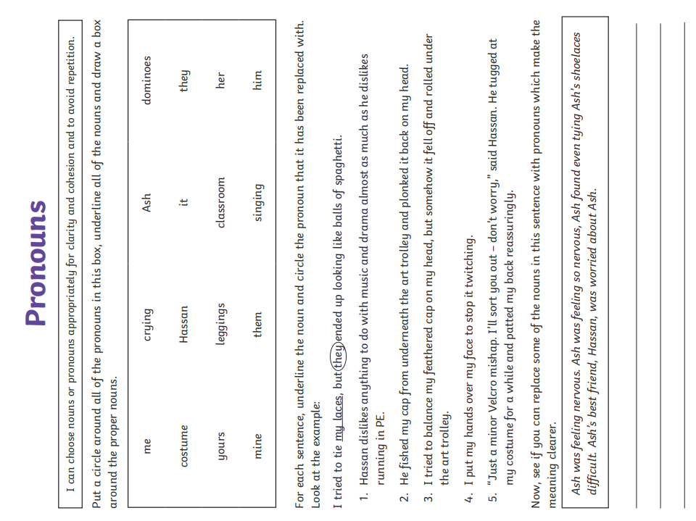

Challenge – optional