Ruby Class Homework Spring 2 week 3
A

Homework due: Tuesday 18th March 2025
Next week we are learning:

Maths | Literacy | Science | RE
We will be looking at division. We will be learning about two different methods: grouping and sharing. | We will be learning about poetry.  We will be looking at rhyming schemes and similes. | We will be celebrating science week with the theme adapt and change. | We will be looking at the theme of salvation in Christianity. This week we will be exploring the significance of the Easter story.

Spellings:
Practise spellings ready for weekly spelling test- see below for your child’s spelling group – These groups are subject to change as they are based on their current spelling ages.

Reading:
Read every day for 15 minutes.
Please log this in Reading Records.
Children must write a small comment in their journals everyday about their book.

Maths: grouping and sharing

SPaG: Correcting punctuation accurately.

Challenge (optional): Improve the sentence

Spellings:
Group 1 | Group 2
put  some  come  one  two | their  there  they’re  hopeful  hopeless  careful  careless  helpful  helpless

look | say | cover | write | check
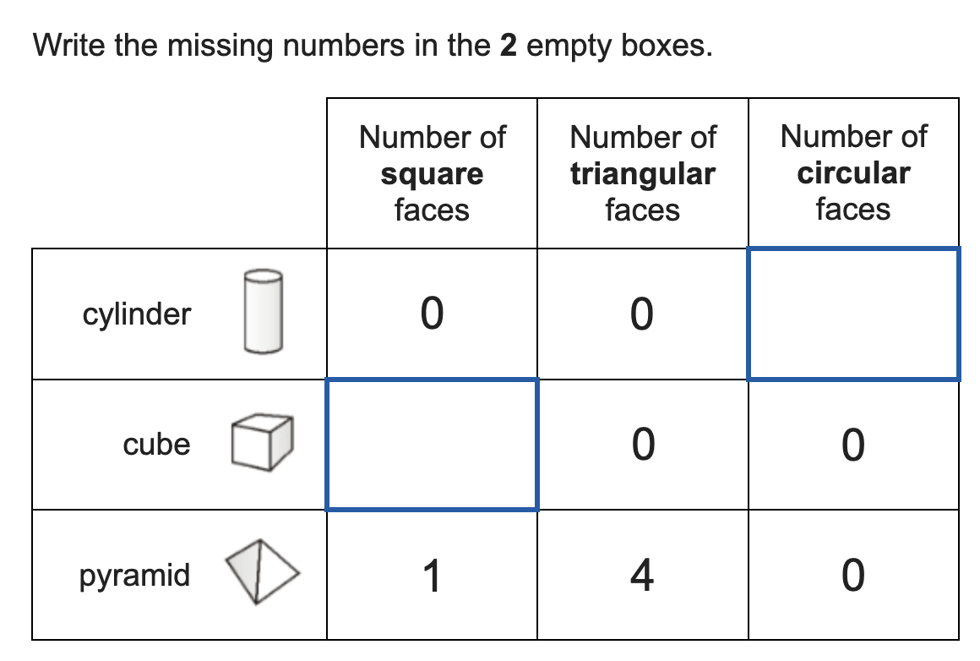
Maths:

1. ____ = 34 + 24  2. ____ = 47 + 25  3. 78 – 34 = ____  4. 64 – 23 = ____  5. 52 – 18 = ____ | 6. 9 x 2 = ____  7. 6 x 2 = ____  8. 10 x 2 = ____  9. 2 x 3 = ____  10. 8 x 1 = ____
Solve the equations:
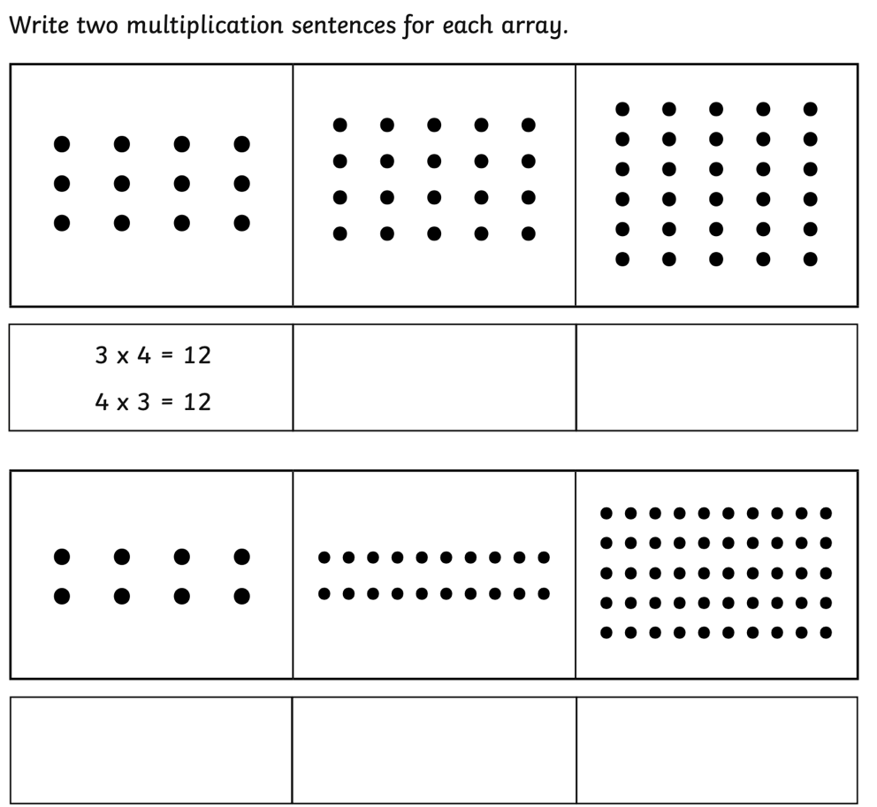
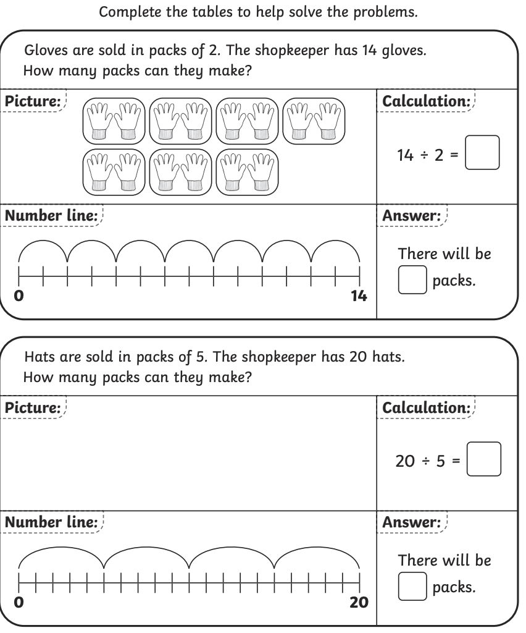

SPaG
Rewrite the sentences below with the correct punctuation.

1. The monsters roar could be heard for miles

2. Where did the horrifying beast come from

3. quickly the fluffy gigantic monster raced past

4. With glowing red eyes and a huge mouth the monsters face looked fierce

Challenges:
SPaG
Improve the sentence by adding an adverb and two adjectives.

The monster crept through the door.

Maths
