Ruby Class Homework Spring 2 week 2
A

Homework due: Tuesday 11th March 2025
Next week we are learning:

Maths | Literacy | Science | RE
We will be looking at division. We will be learning about two different methods: grouping and sharing. | We will be learning at writing instructional texts. First, we will be exploring the features of instruction texts. | We will be celebrating science week with the theme adapt and change. | We will be looking at the theme of salvation in Christianity. This week we will be exploring the significance of the Easter story.

Spellings:
Practise spellings ready for weekly spelling test- see below for your child’s spelling group – These groups are subject to change as they are based on their current spelling ages.

Reading:
Read every day for 15 minutes.
Please log this in Reading Records.
Children must write a small comment in their journals everyday about their book.

Maths: grouping and sharing

SPaG: Correcting punctuation accurately.

Challenge (optional): Improve the sentence
Multi-step problem

Spellings:
Group 1 | Group 2
are  where  were  push  pull | where  were  whole  hole  see  sea  here  hear

Maths:
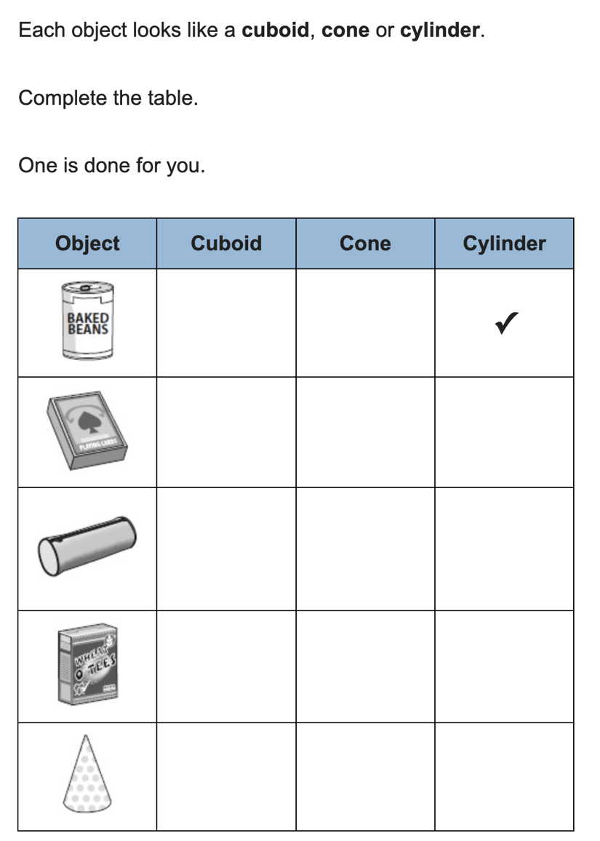
1. _____ = 2 + 28 + 2  2. ____ + 26 = 32  3. ____ = 32 – 5 – 5  4. 10 + 60 + 30 = _____ | 5. 2 x 4 = ____  6. 5 x 2 = ____  7. 0 x 2 = ____  8. 2 x 6 = ____
Solve the equations:
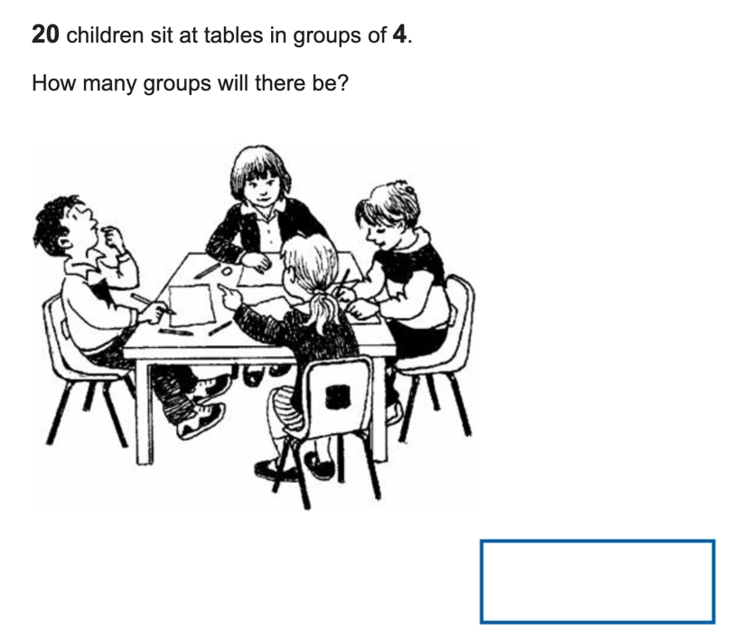

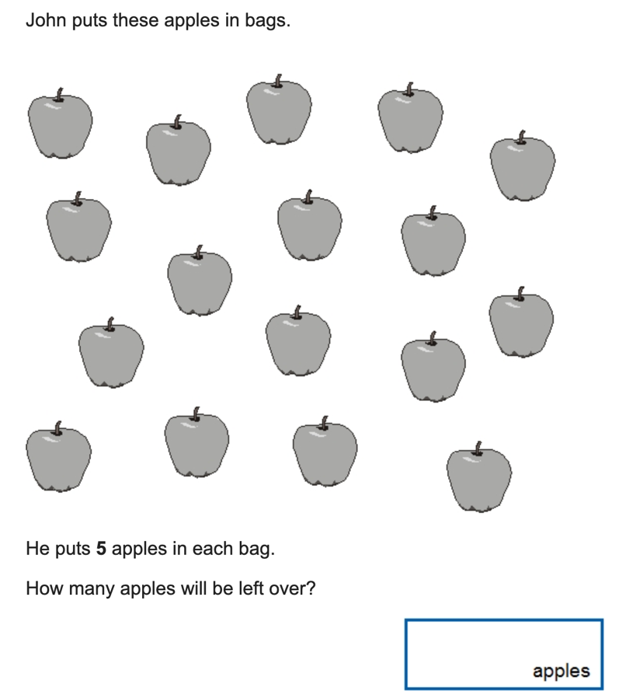

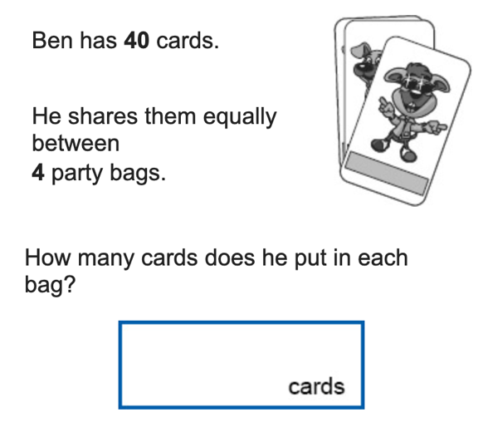

SPaG
Rewrite the sentences below with the correct punctuation.

1. australia is the smallest continent in the world

2. The great barrier reef is home to many colourful fish turtles and sharks

3. Did you know that kangaroos can jump really high

4. what a fantastic animal it is

5. you wont find any penguins in the desert

Challenges:
SPaG
Improve the sentence by adding an adverb and two adjectives.

The turtle swam in between the coral.

Maths