**Emerald Class Homework Spring 2 week 1 – Y4**

Homework due: Tuesday 4th March 25

|  |  |  |  |
| --- | --- | --- | --- |
| **Next week we are learning:** | | | |
| Maths | Literacy | Science | RE |
| We will be starting our unit on Fractions | We will be will be working on some elements of SPaG | We will be our unit on continuing our Living things and habitats | We will be continuing our unit on Gospel then into Salvation |

|  |
| --- |
| Some Useful Websites:  Nrich.maths.org - https://nrich.maths.org/  Coolmath-games.com - https://www.coolmathgames.com/  Woodlands Junior School - https://www.primaryhomeworkhelp.co.uk/  BBC Bitesize - https://www.bbc.co.uk/bitesize/primary  Counton.org - <https://count-on.co.uk/>  <https://www.topmarks.co.uk/>  <https://www.tomscott.com/usvsth3m/maths/>  Purple Mash also have some lovely Maths and spellings activities  Or use other websites/ways that you enjoy 😊.  ***Spellings:***  Practise spellings ready for weekly spelling test- see below for your child’s spelling group – These groups are subject to change as they are based on their current spelling ages.  ***Reading:***  Read every day for 30 minutes. Please log this in Reading Records.    ***Maths – Fractions***  ***English – suffixes*** |

Spellings:

|  |  |  |
| --- | --- | --- |
| **group 1 dis prefix** | group 2- tion suffix | group 3 – homophones and near homophones |
| dislike  disobey  discolour  discover  disappear  dishonest  disallow  disbelieve  disapprove  discontinue | information  adoration  sensation  preparation  education  location  exaggeration concentration imagination organisation | alter  altar  ascent  assent  bridal  bridle  cereal  serial  compliment complement |

Please write your spellings in sentences to show a correct understanding of the words

……………………………………………………………………………………………………………………………………………………………………………………………………………………………………………………………………………………………………………………………………………………………………………………………………………………………………………………………………………………………………………………………………………………………………………………………………………………………………………………………………………………………………………………………………………………………………………………………………………………………………………………………………………………………………………..

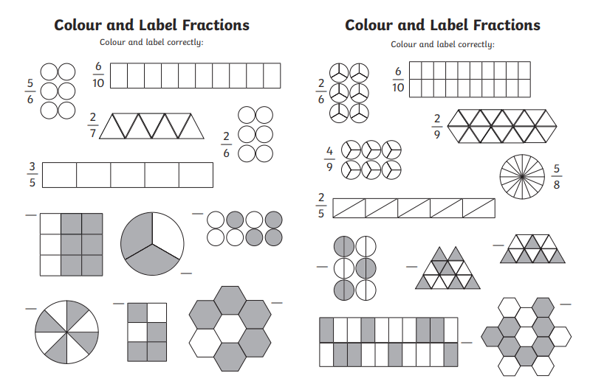

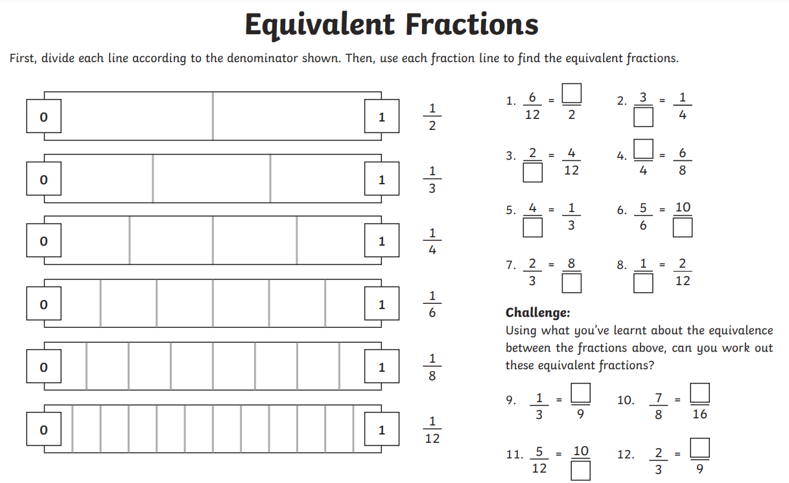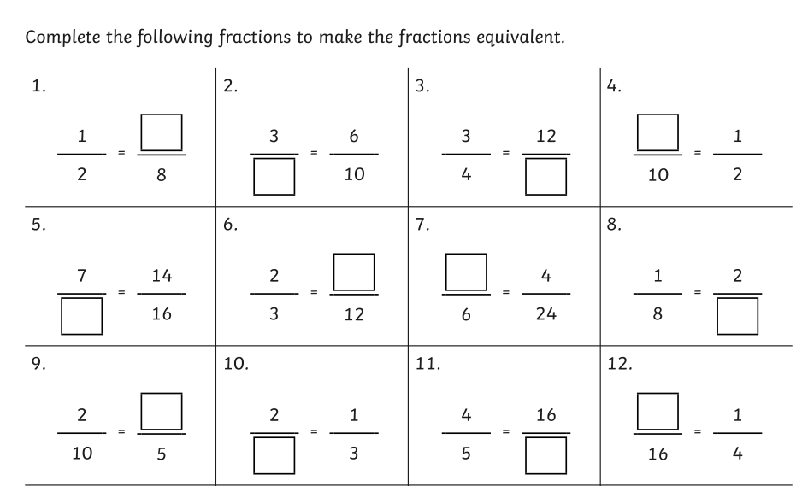

Challenge – optional

