## Ruby Class Homework Spring 2 week 1

B

Homework due: Tuesday 4th March 2025

|  |  |  |  |
| --- | --- | --- | --- |
| **Next week we are learning:** | | | |
| Maths | Literacy | Science | RE |
| We will be starting our new topic: multiplication and division. First, we will be looking the meaning of the word equal and using repeated addition to support our understanding of multiplication. | We are looking at non-chronological reports to create a fact file on an Australian animal. First, we will be preparing research questions to gather and record information on our chosen animal. | We will be looking at a range of particular habitats and their features. We will investigate why particular animals are suited for their habitats. | We will be looking at the theme of salvation in Christianity. This week we will be exploring the significance of Palm Sunday and Cleansing of the Temple. |

|  |
| --- |
| ***Spellings:***  Practise spellings ready for weekly spelling test- see below for your child’s spelling group – These groups are subject to change as they are based on their current spelling ages.  ***Reading:***  Read every day for 15 minutes.  Please log this in Reading Records.  Children must write a small comment in their journals everyday about their book.  ***Maths:*** Addition  **SPaG:** Correcting punctuation accurately.  Challenge (optional): Improve the sentence.  Problem Solving |

**Spellings:**

|  |  |
| --- | --- |
| **Group 1** | **Group 2** |
| of  his  has  they  here  there | sure  sugar  eye  half  here  hear  one  won |

**Maths:**

3D shapes have been identified as an area of challenge in Ruby class. To support this, homework will include a 3D shape question each week to provide extra practice.

Solve the equations:

1. 22 + 2 + 2 = ____

2. ____ + 13 = 19

3. 35 + 5 + 5 = ____

4. 40 + 20 + 10 = _____

Complete the sentences for each set of ten frames.

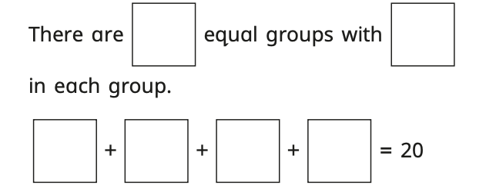

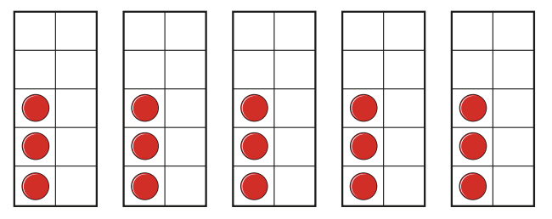

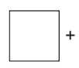

SPaG

Rewrite the sentences with the correct capital letters and full stops.

1. the sun is shining today

2. we went to the beach and built a sandcastle

3. my best friend is called ben

4. On sunday we had a picnic in the park

5. australia is a big country with lots of animals

**Challenges:**

SPaG

Improve the sentence by adding an adverb and two adjectives.

**The kangaroo hopped across the desert.**

Maths