## Ruby Class Homework Spring 2 week 1

A

Homework due: Tuesday 4th March 2025

|  |  |  |  |
| --- | --- | --- | --- |
| **Next week we are learning:** | | | |
| Maths | Literacy | Science | RE |
| We will be starting our new topic: multiplication and division. First, we will be looking the meaning of the word equal and using repeated addition to support our understanding of multiplication. | We are looking at non-chronological reports to create a fact file on an Australian animal. First, we will be preparing research questions to gather and record information on our chosen animal. | We will be looking at a range of particular habitats and their features. We will investigate why particular animals are suited for their habitats. | We will be looking at the theme of salvation in Christianity. This week we will be exploring the significance of Palm Sunday and Cleansing of the Temple. |

|  |
| --- |
| ***Spellings:***  Practise spellings ready for weekly spelling test- see below for your child’s spelling group – These groups are subject to change as they are based on their current spelling ages.  ***Reading:***  Read every day for 15 minutes.  Please log this in Reading Records.  Children must write a small comment in their journals everyday about their book.  ***Maths:*** Addition  **SPaG:** Correcting punctuation accurately.  Challenge (optional): Improve the sentence.  Problem Solving |

**Spellings:**

|  |  |
| --- | --- |
| **Group 1** | **Group 2** |
| of  his  has  they  here  there | sure  sugar  eye  half  here  hear  one  won |

**Maths:**

3D shapes have been identified as an area of challenge in Ruby class. To support this, homework will include a 3D shape question each week to provide extra practice.

Solve the equations:

1. 22 + 2 + 2 = ____

2. ____ + 13 = 19

3. 35 + 5 + 5 = ____

4. 40 + 20 + 10 = _____

Complete the sentences for each set of ten frames.

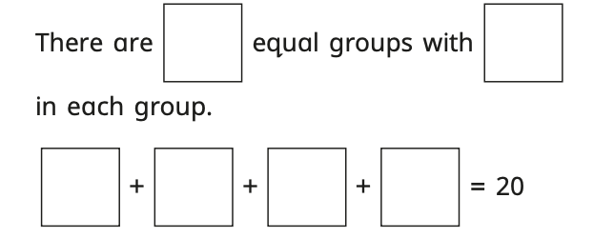

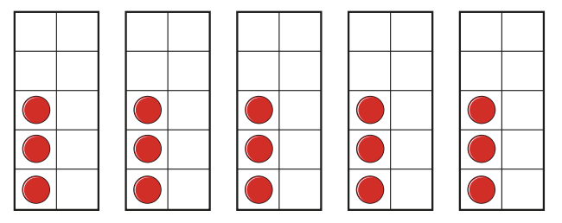

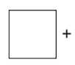

SPaG

Rewrite the sentences below with the correct punctuation.

1. i went to the zoo and saw a kangaroo koala and a snake

2. toms bike is red and blue

3. where is sarahs dog

4. What a beautiful day

5. I cant find my spotty socks.

**Challenges:**

SPaG

Improve the sentence by adding an adverb and two adjectives.

**The kangaroo hopped across the desert.**

Maths