**Emerald Class Homework Spring 1 week 4 – Y5**

Homework due: Tuesday 21th January 25

|  |  |  |  |
| --- | --- | --- | --- |
| **Next week we are learning:** | | | |
| Maths | Literacy | Science | RE |
| We will be continuing unit on Multiplication and division | We will be will be continuing our unit on Everest | We will be starting our unit on Living things and habitats | We will be beginning our unit on Incarnation and Gospel |

|  |
| --- |
| Some Useful Websites: Nrich.maths.org - https://nrich.maths.org/  Coolmath-games.com - https://www.coolmathgames.com/  Woodlands Junior School - https://www.primaryhomeworkhelp.co.uk/  BBC Bitesize - https://www.bbc.co.uk/bitesize/primary  Counton.org - <https://count-on.co.uk/>  <https://www.topmarks.co.uk/>  Purple Mash also have some lovely Maths and spellings activities  Or use other websites/ways that you enjoy 😊.  ***Spellings:***  Practise spellings ready for weekly spelling test- see below for your child’s spelling group – These groups are subject to change as they are based on their current spelling ages.  ***Reading:***  Read every day for 30 minutes. Please log this in Reading Records.    ***Dividing by 10, 100***  ***Optional challenge – multiplying by 10, 100 and 1000***  ***Into the next column (TH) for multiplying by 100 = 3700 (37 x 1000 = 37,000) it goes the opposite direction for dividing the number decreases for example 37 divide by 10 3.7 then 0.37***    ***English – Homophones and near homophones*** |

Spellings:

|  |  |  |
| --- | --- | --- |
| **group 1** | group 2 | group 3 – |
| |  | | --- | | myth  gym  Egypt  pyramid  mystery  hymn  system  symbol  lyric  typical  Challenge words  inaccurate  incorrect  inability | | |  | | --- | | though  although  dough  through  breakthrough  thought  bought  brought  fought  ought |   Challenge words  Challenge words  notorious  obsession  avalanches | |  | | --- | | community  curiosity  ability  visibility  captivity  activity  eternity  flexibility  possibility  sensitivity |   Challenge words  mountaineering conquered eccentric |

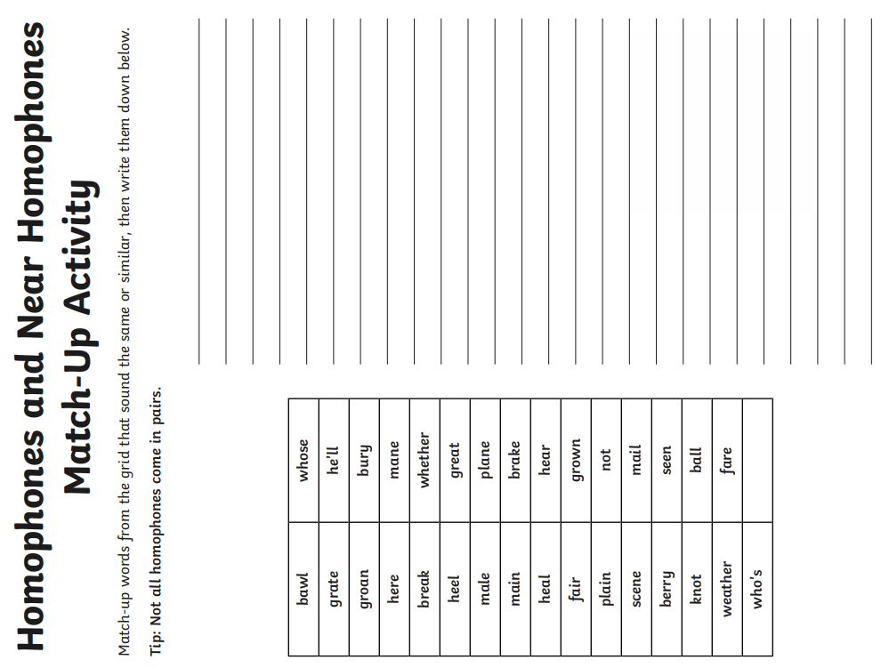

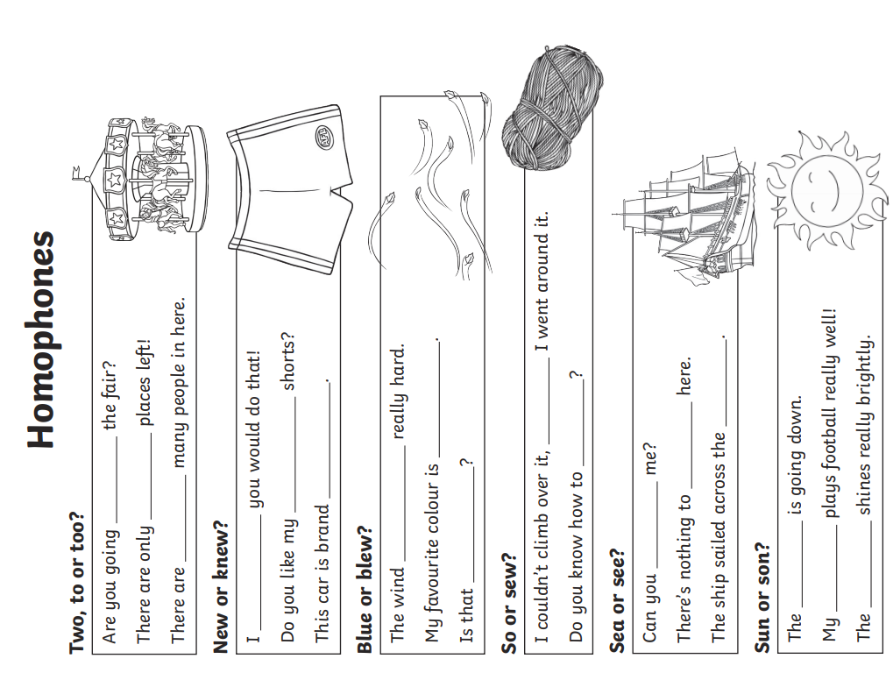

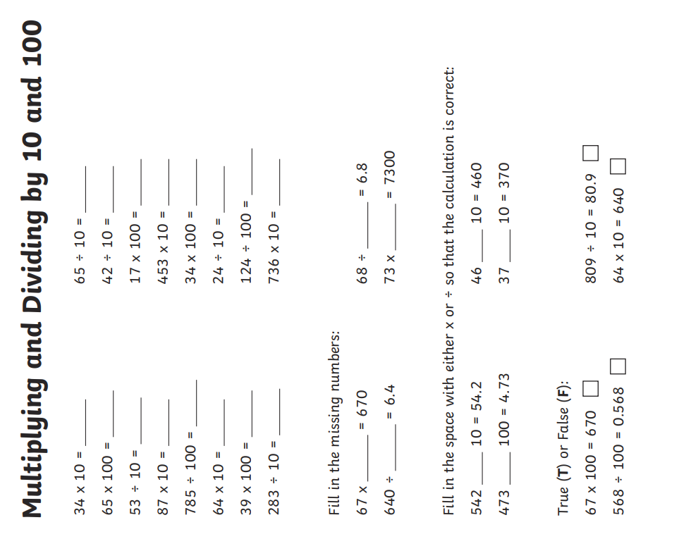

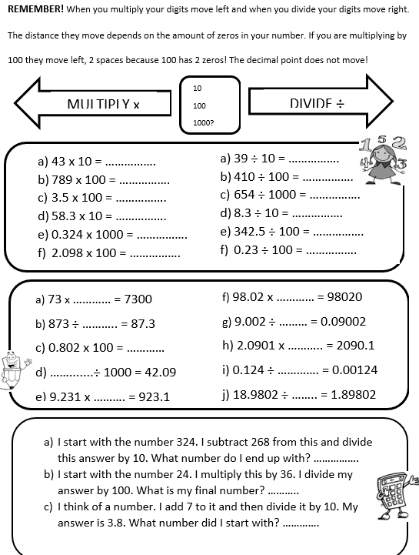 Challenge