Ruby Class Homework Spring 1 week 5
A

Homework due: Tuesday 11th February 2025
Next week we are learning:

Maths | Literacy | Science | RE
We will be continuing our topic on mass, capacity, and temperature. Next, we will explore volume and capacity. | We are looking at the book ‘Vlad and the Great Fire of London’ and exploring diary entries. | We will be looking at the properties of different materials. | We will be looking at Islam and the how Muslims belong to their faith family. We will be exploring Ramadan and Eid.

Spellings:
Practise spellings ready for weekly spelling test- see below for your child’s spelling group – These groups are subject to change as they are based on their current spelling ages.

Reading:
Read every day for 15 minutes.
Please log this in Reading Records.
Children must write a small comment in their journals everyday about their book.

Maths: Measure mass and capacity.

SPaG: Correcting punctuation accurately.

Spellings:
Group 1 | Group 2
today  said  says  are  were  your | mind  behind  only  both  even  great  break  steak

Maths:
As we move into multiplication and division after half term, we are continuing to strengthen counting in 2s, 5s, and 10s to build confidence and fluency in applying these skills.
- 5, ___, ___, 20, ___, 30, ___, ___
2. ___, 55, ___, ___, 40, 35, ____
2. 4, ___, 8, ____, ____, 14, 16, ____
3. 24, ___, ____, 18, 16, ____, ____
4. ___, 90, 80, ____, 60, ____, ____
Solve the equations:
1. 100 = 40 + ____

2. ___ + 70 = 100

3. 40 + ___ = 51

4. 46 + 34 = ____

5. 56 + 37 = ____
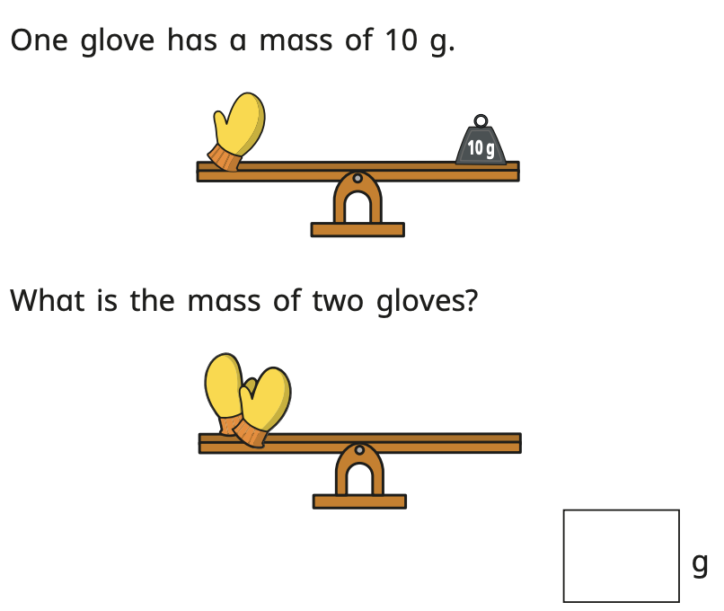

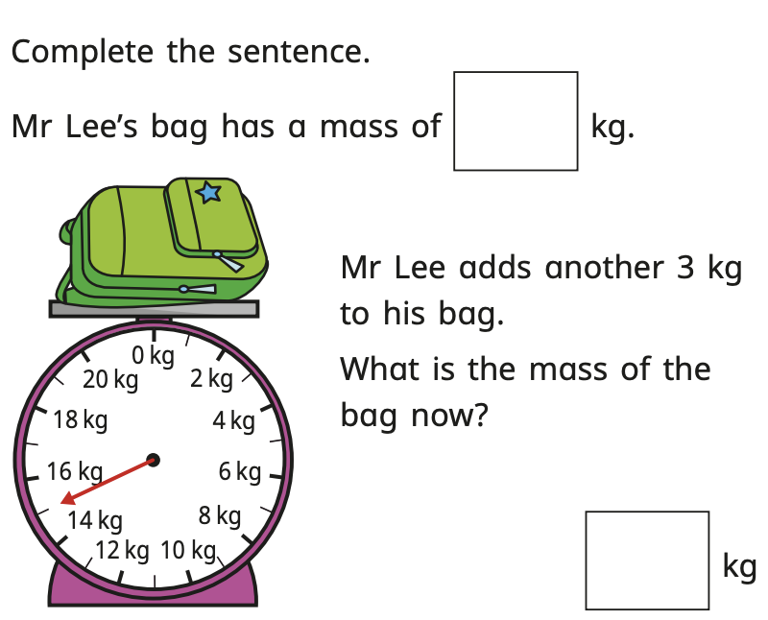

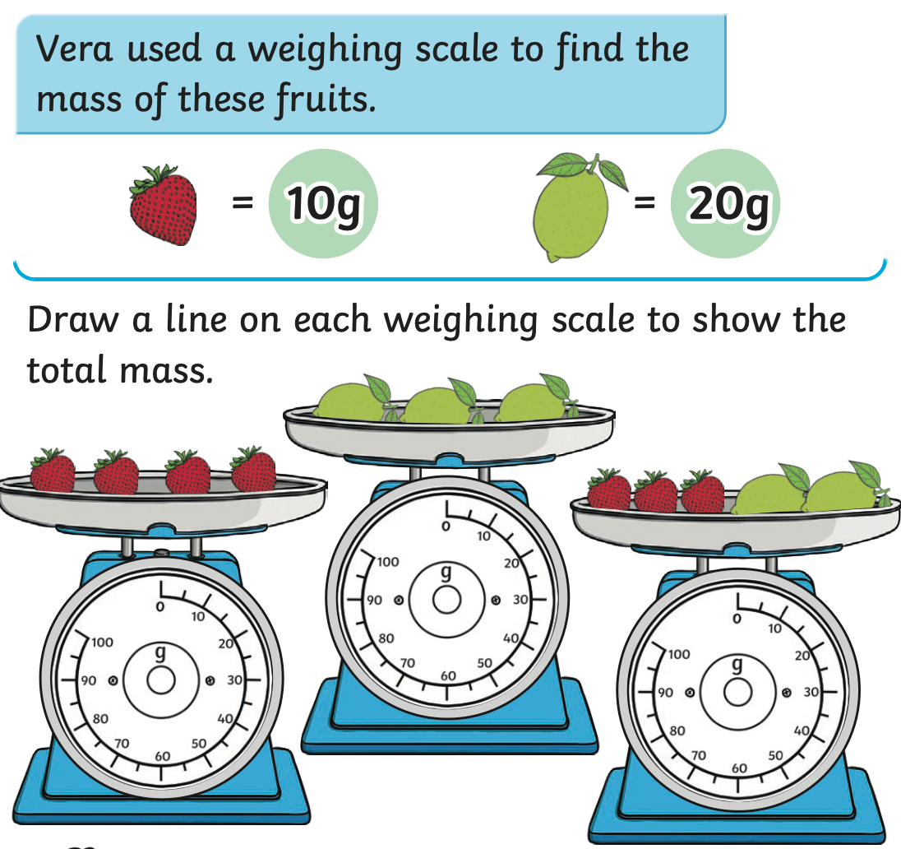

SPaG
Many children have been forgetting to use correct punctuation in their writing, and this has become a focused area of improvement. This week we have been focusing on improving our use of capital letters, full stops, commas for lists, apostrophes, exclamation marks, and question marks.

Rewrite the sentences below with the correct punctuation.

1. my favourite fruits are apples bananas grapes and oranges

2. toms hat was left on the table

3. where are we going for lunch

4. the sun was shining brightly in the sky

5. the big fluffy playful dog ran around the garden

