**Emerald Class Homework Spring 1 week 5 – Y5**

Homework due: Tuesday 4th February 25

|  |  |  |  |
| --- | --- | --- | --- |
| **Next week we are learning:** | | | |
| Maths | Literacy | Science | RE |
| We will be continuing unit on Multiplication and division | We will be will be continuing our unit on Everest | We will be our unit on continuing our Living things and habitats | We will be continuing our unit on Gospel |

|  |
| --- |
| Some Useful Websites:  Nrich.maths.org - https://nrich.maths.org/  Coolmath-games.com - https://www.coolmathgames.com/  Woodlands Junior School - https://www.primaryhomeworkhelp.co.uk/  BBC Bitesize - https://www.bbc.co.uk/bitesize/primary  Counton.org - <https://count-on.co.uk/>  <https://www.topmarks.co.uk/>  Purple Mash also have some lovely Maths and spellings activities  Or use other websites/ways that you enjoy 😊.  ***Spellings:***  Practise spellings ready for weekly spelling test- see below for your child’s spelling group – These groups are subject to change as they are based on their current spelling ages.  ***Reading:***  Read every day for 30 minutes. Please log this in Reading Records.    ***Maths – multiplies of 10, 100 and 1000***  ***Multiplying by 10, 100 and 1000***  ***English – commonly confused words*** |

Spellings:

|  |  |  |
| --- | --- | --- |
| **group 1** | group 2- homophones and near homophones | group 3 – ship suffix |
| forgetting  forgotten  beginning  beginner  preferred  preferring  occurred  occurring  forbidden  committed | accept  except  affect  effect  aloud  allowed  weather  whether  whose  who’s | membership ownership partnership dictatorship championship craftsmanship fellowship apprenticeship citizenship sponsorship |

Please write your spellings in sentences to show a correct understanding of the words

………………………………………………………………………………………………………………………………………………………………………………………………………………………………………………………………………………………………………………………………………………………………………………………………………………………………………………………………………………………………………………………………………………………………………………………………………………………………………………………………………………………………………………………………………………………………………………………………………………………………………………………………………………………………………………

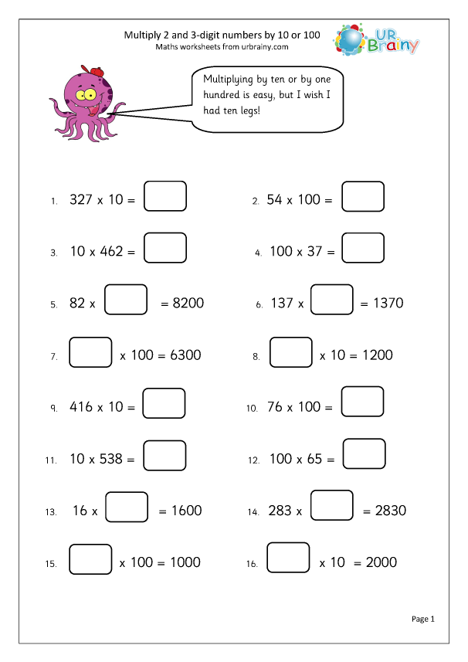

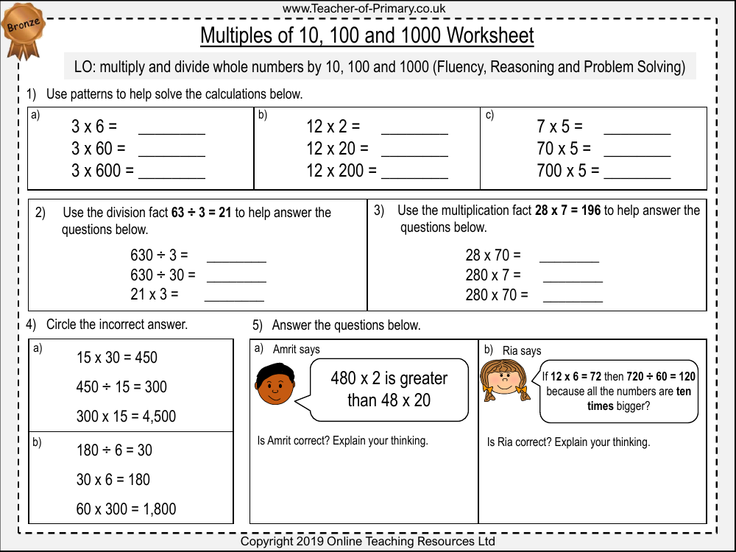

#

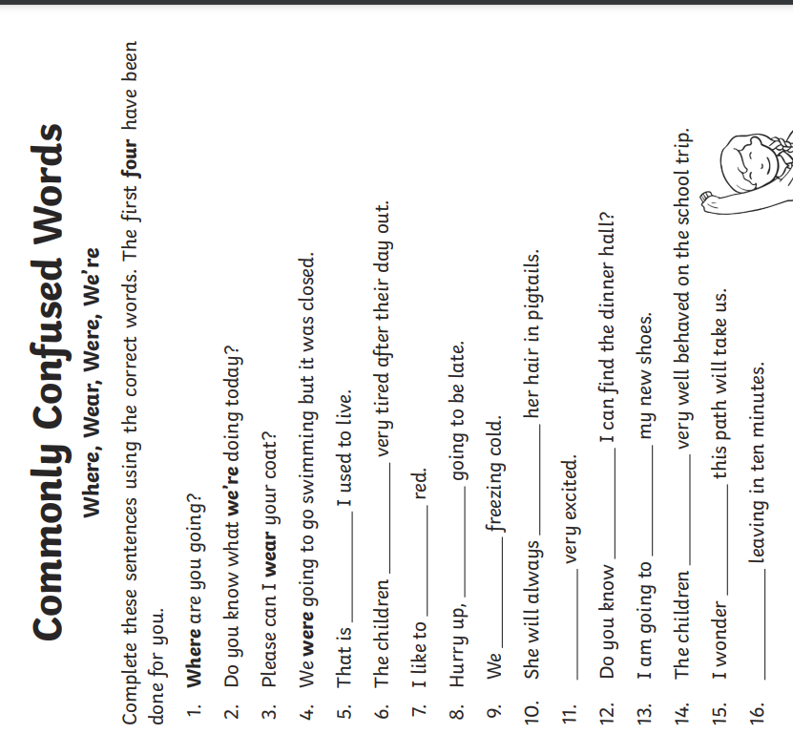

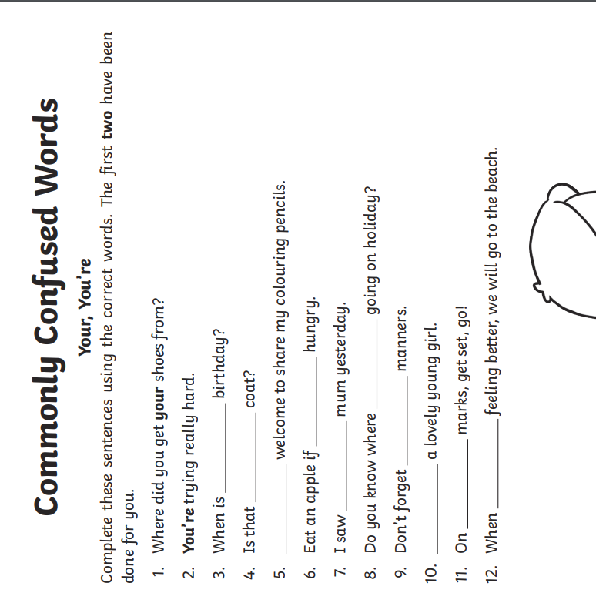

Challenge - optional

