Ruby Class Homework Spring 1 week 4
A

Homework due: Tuesday 4th February 2025
Next week we are learning:

Maths | Literacy | Science | RE
We are starting our new topic on mass, capacity, and temperature. First, we will begin by looking at grams and kilograms. | We are looking at the book ‘Vlad and the Great Fire of London’ and exploring diary entries. | We will be looking at the properties of different materials. | We will be looking at Islam and the how Muslims belong to their faith family. We will be learning about the Qur’an.

Spellings:
Practise spellings ready for weekly spelling test- see below for your child’s spelling group – These groups are subject to change as they are based on their current spelling ages.

Reading:
Read every day for 15 minutes.
Please log this in Reading Records.
Children must write a small comment in their journals everyday about their book.

Maths: Measure in grams

SPaG: Contractions

Challenges: Reasoning question
Improve the sentence

Spellings:
Group 1 | Group 2
once  one  ask  school  push  full | door  floor  poor  class  grass  pass  plant  path  bath  hour

Maths:
Complete the number tracks.
- 70, 65, ___, ___, 50, 45, ___
2. 80, ___, 60, ____, 40, 30, ____
3. ____, 15, ____, 21, 24, ____, _____
4. 7, 9, _____, 13, 15, ____

Solve the equations:
64 + 7 = ___

90 = 60 + ___

40 + ___ = 67

36 + 28 = ___

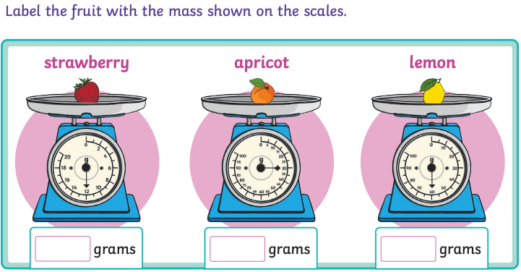
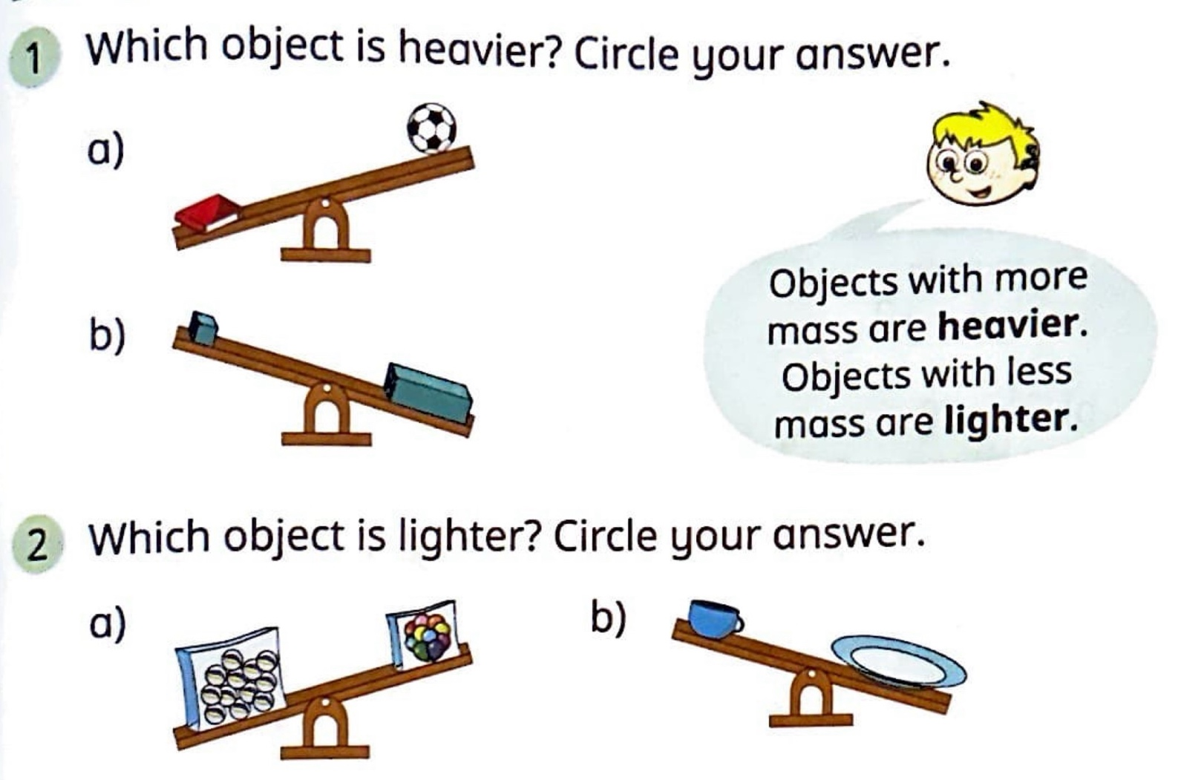

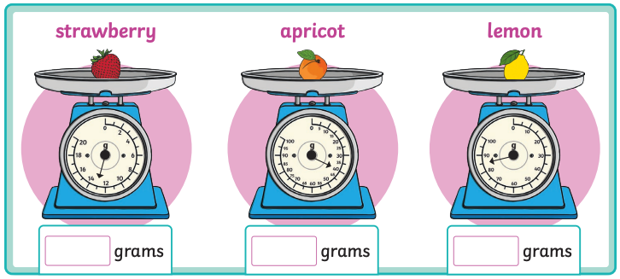
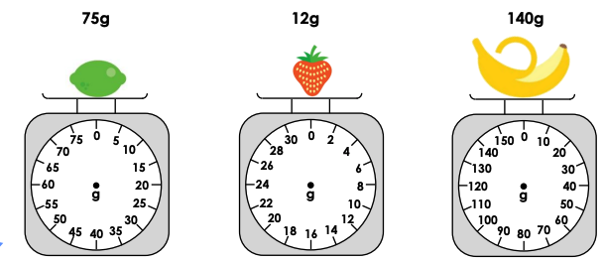
Draw the arrow to show the mass of the fruit.

SPaG

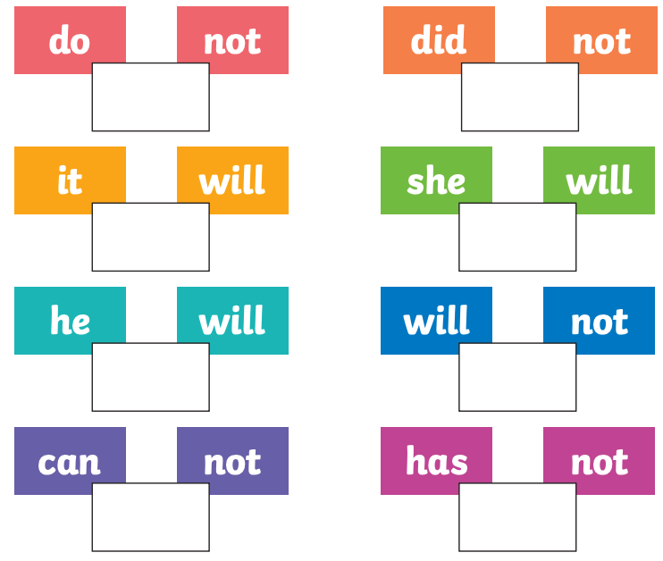
Write the contraction that matches with each pair of words.

Challenges
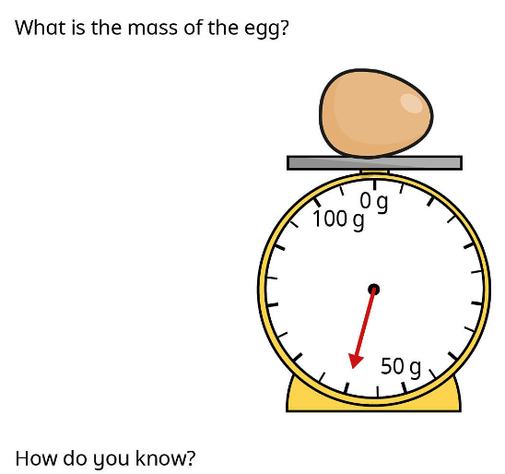

Can you carefully add interesting adjectives and adverbs to this sentence to make it more exciting?

The rat ran through the houses.

