Ruby Class Homework Spring 1 week 3
A

Homework due: Tuesday 28th January 2025
Next week we are learning:
Maths | Literacy | Science | RE
We are looking at length and height. We are exploring new units of measurement, centimetres (cm) and metres (m). | We are looking at explanation texts, using the Great Fire of London for inspiration. | We will be looking at the properties of different materials. | We will be looking at Islam and the how Muslims belong to their faith family. We will be learning about the Qur’an.

Spellings:
Practise spellings ready for weekly spelling test- see below for your child’s spelling group – These groups are subject to change as they are based on their current spelling ages.

Reading:
Read every day for 15 minutes.
Please log this in Reading Records.
Children must write a small comment in their journals everyday about their book.

Maths: Length and measure

SPaG: Identifying past and present tense.

Challenges: Reasoning question
Improve the sentence

Spellings:
Group 1 | Group 2
your  they  fire  wood  burn  house | metre  measure  because  flies  tries  copies  babies  carries

Maths:
Complete the number tracks.
- 30, 35, ___, ___, 50, 55, ___
2. 40, ___, 60, ____, 80, 90, ____
3. ____, 6, ____, 12, 15, ____, _____
4. 27, _____, _____, 18, 15, 12

Solve the equation:
47 + 5 = ___

80 = 30 + ___

20 + ___ = 56

65 + 23 = ___

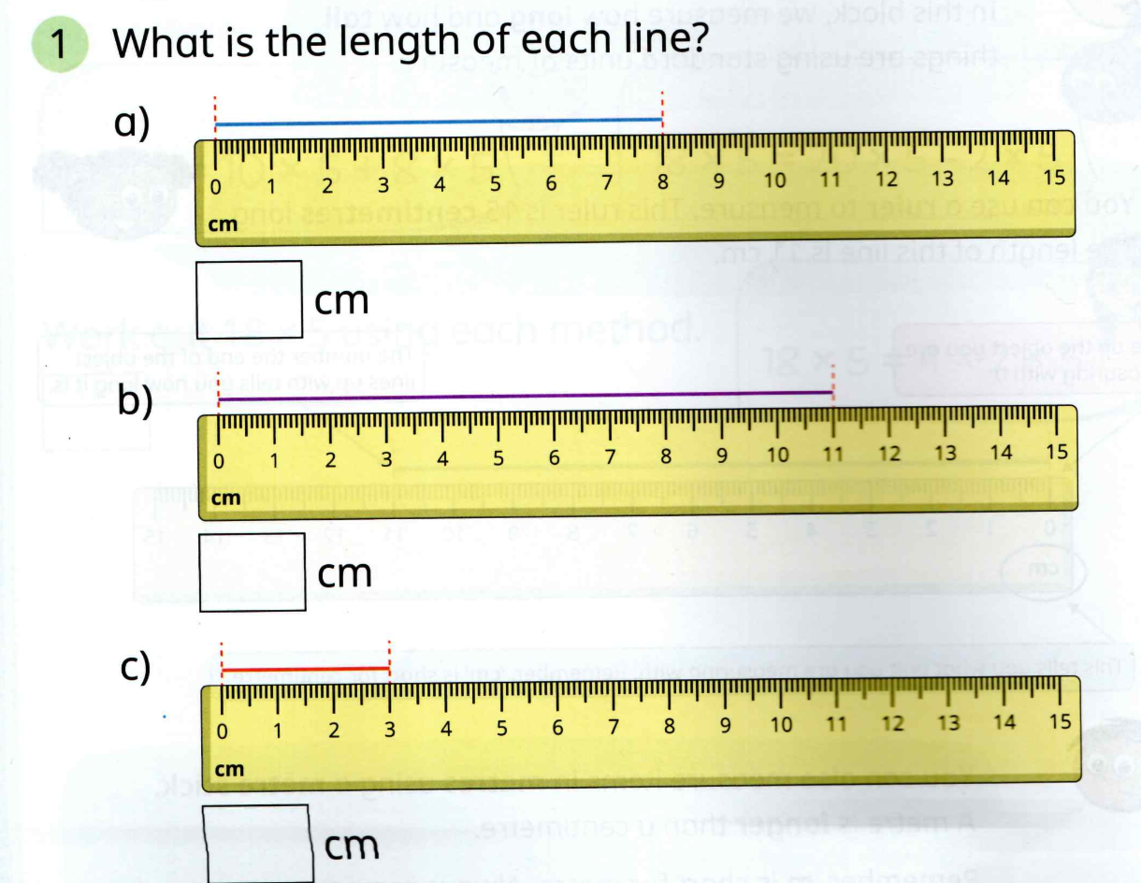

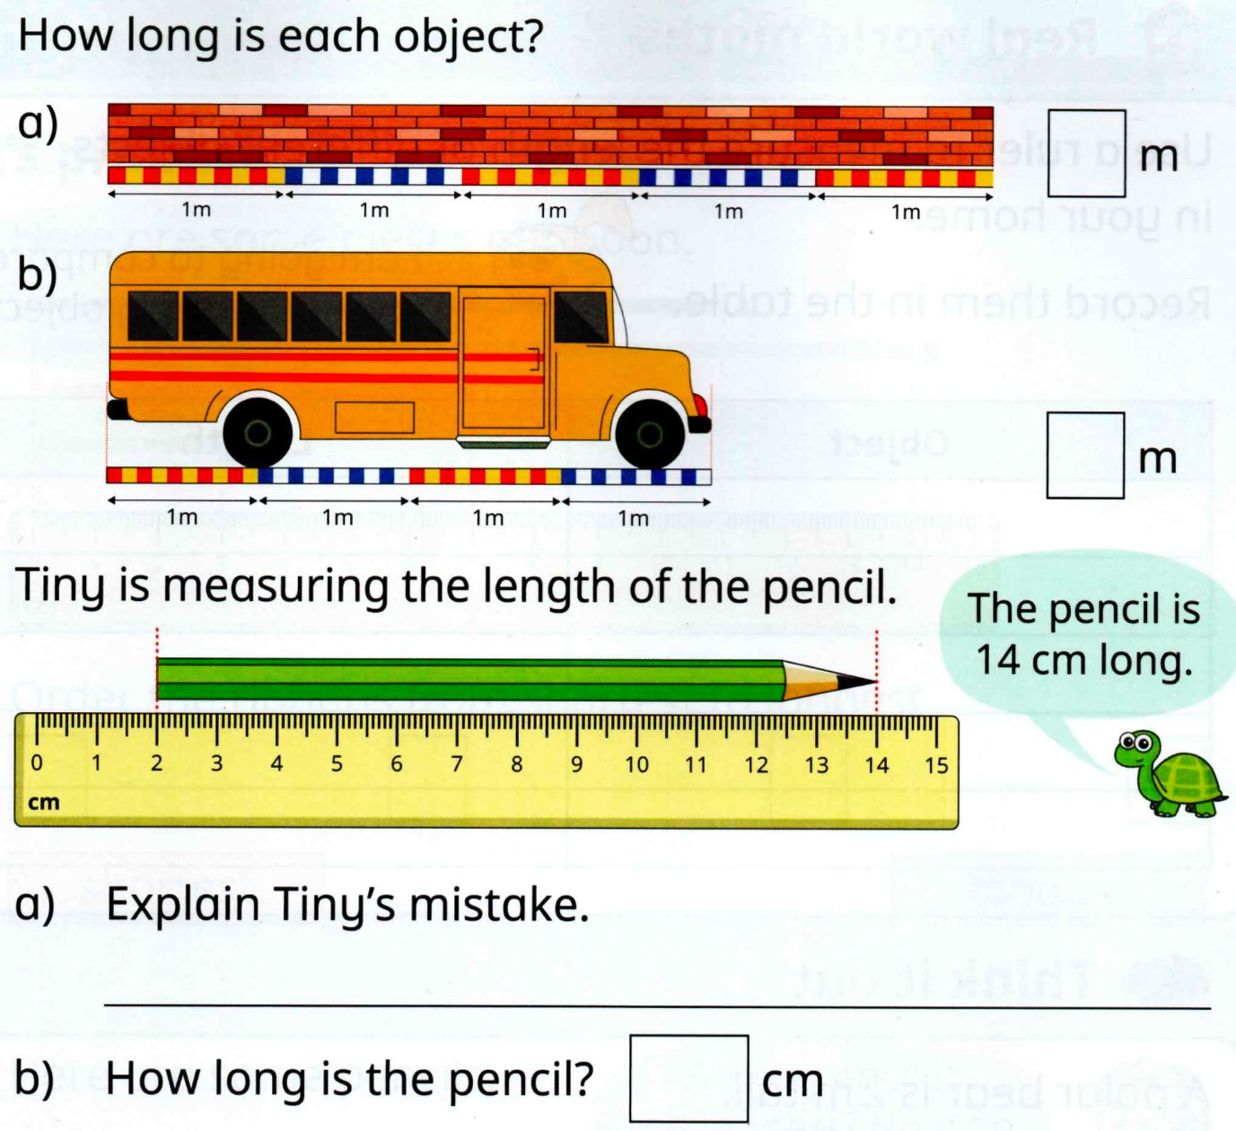

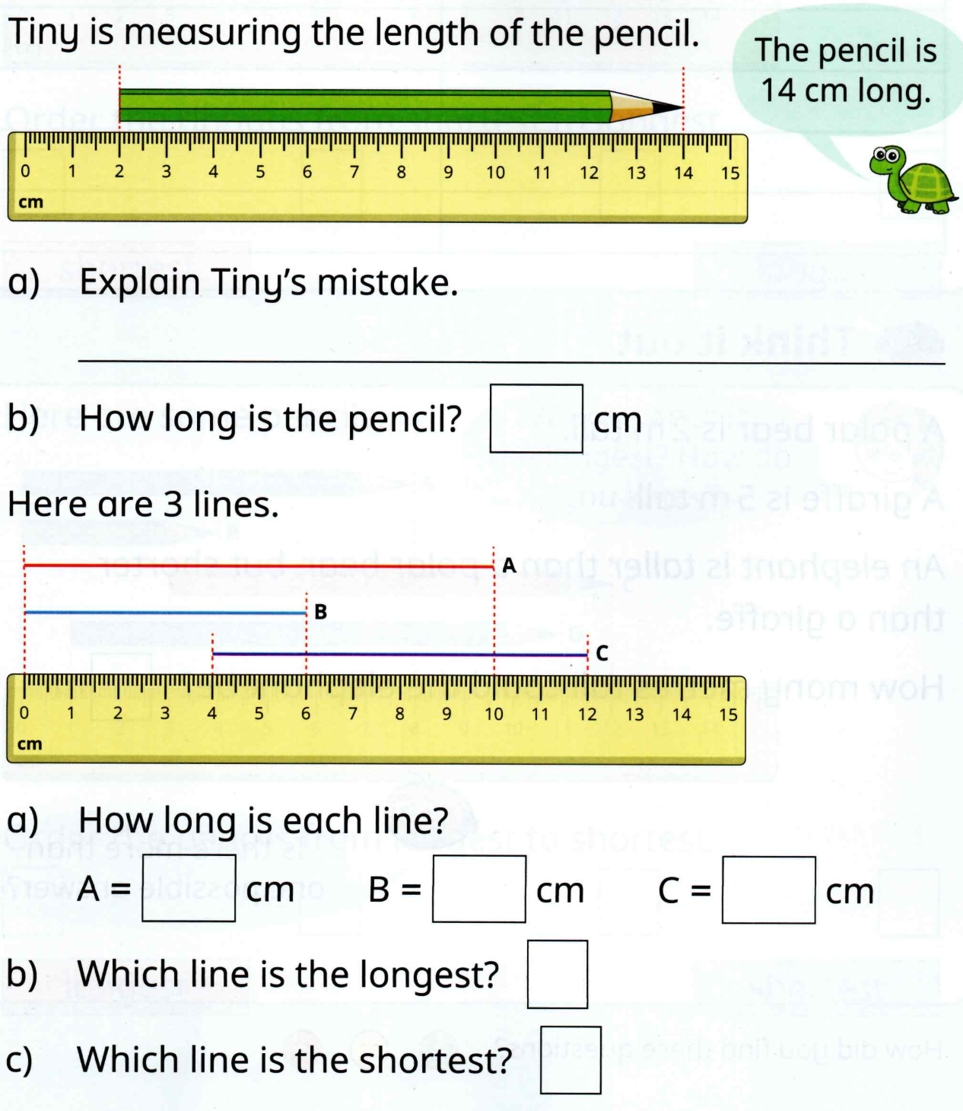

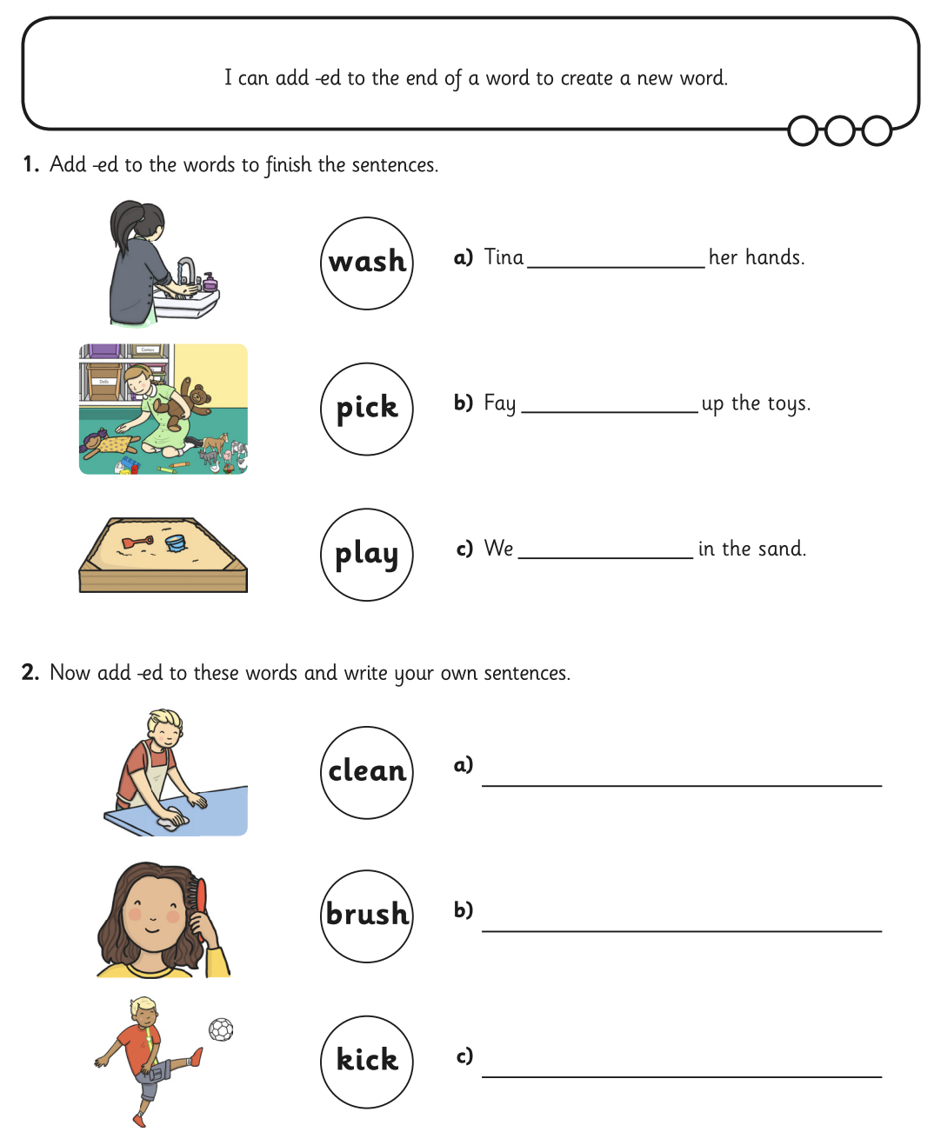
SPaG

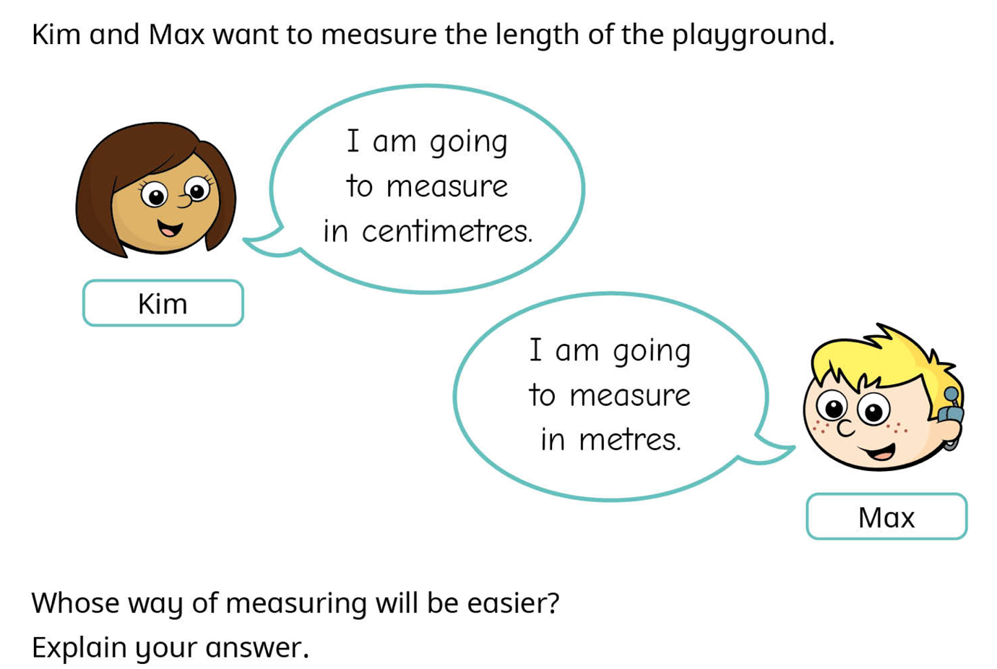
Challenges

Can you carefully add interesting adjectives and adverbs to this sentence to make it more exciting?

The fire started in a bakery.

