## Ruby Class Homework Spring 1 week 2

A

Homework due: Tuesday 21st January 2025

|  |  |  |  |
| --- | --- | --- | --- |
| **Next week we are learning:** | | | |
| Maths | Literacy | Science | RE |
| We are looking at the properties of 2D and 3D shapes. | We are looking at explanation texts, using the Great Fire of London for inspiration. | We will be looking at the properties of different materials. | We will be looking at Islam and the how Muslims belong to their faith family. We will be learning about the Prophet Muhammad (pbuh). |

|  |
| --- |
| ***Spellings:***  Practise spellings ready for weekly spelling test- see below for your child’s spelling group – These groups are subject to change as they are based on their current spelling ages.  ***Reading:***  Read every day for 15 minutes.  Please log this in Reading Records.  Children must write a small comment in their journals everyday about their book.  ***Maths:*** Properties of 3D shapes.  **SPaG:** Identifying past and present tense.  **Challenges:** Sorting 3D shapes.  Improve the sentence. |

**Spellings:**

|  |  |
| --- | --- |
| **Group 1** | **Group 2** |
| come  some  cry  dry  fly  try  sly | cube  sphere  cuboid  cylinder  pyramid  cry  reply  terrify  multiply  improve |

**Maths:**

Complete the number tracks.

1. 5, 10, ___, ___, 25, 30, ___

2. 30, ___, 50, ____, 70, 80, ____

3. ____, 9, ____, 15, 18, ____, _____

4. 30, _____, _____, 21, 18, 15

Solve the equation:

36 + 7 = ___

30 + ___ = 70

29 + ___ = 89

16 + 72 = ___

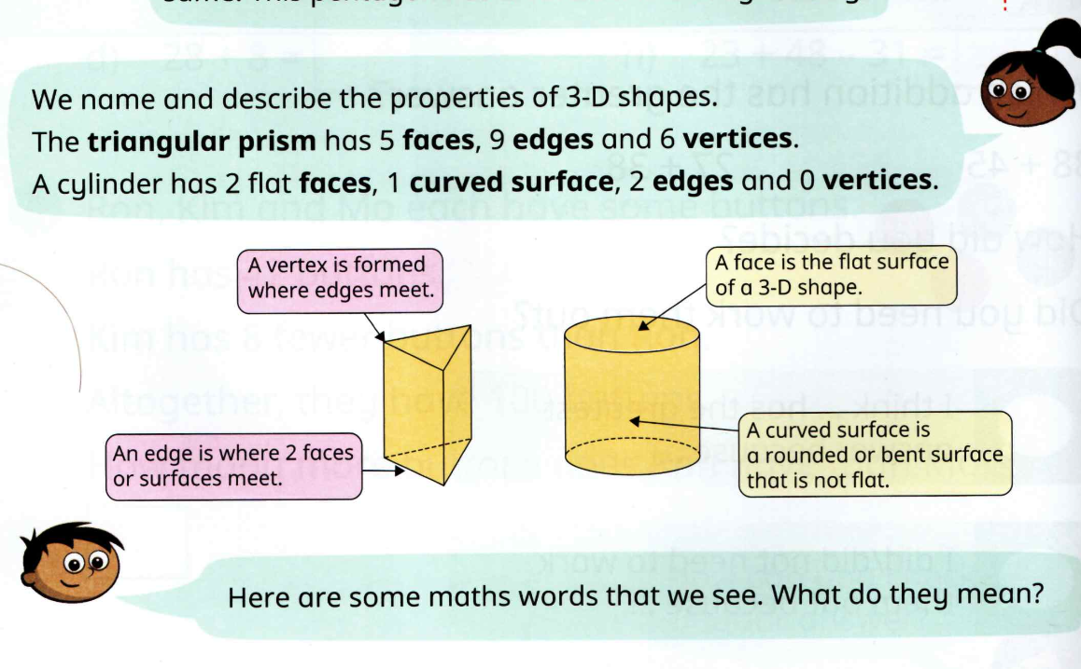

SPaG

Challenges

**Can you carefully add interesting adjectives and adverbs to this sentence to make it more exciting?**

**The people ran away from the fire.**