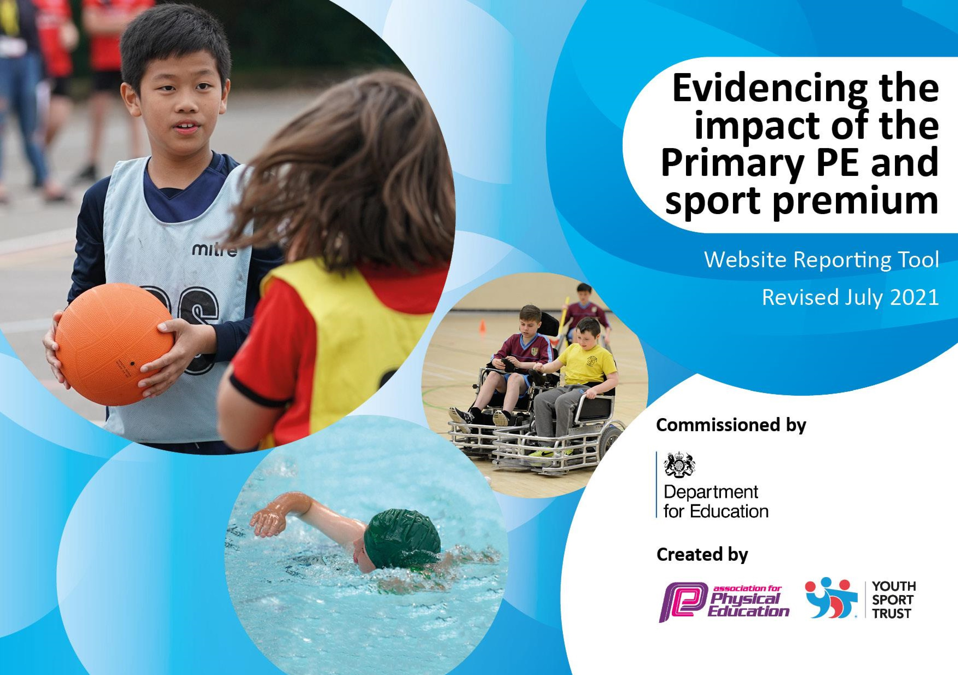

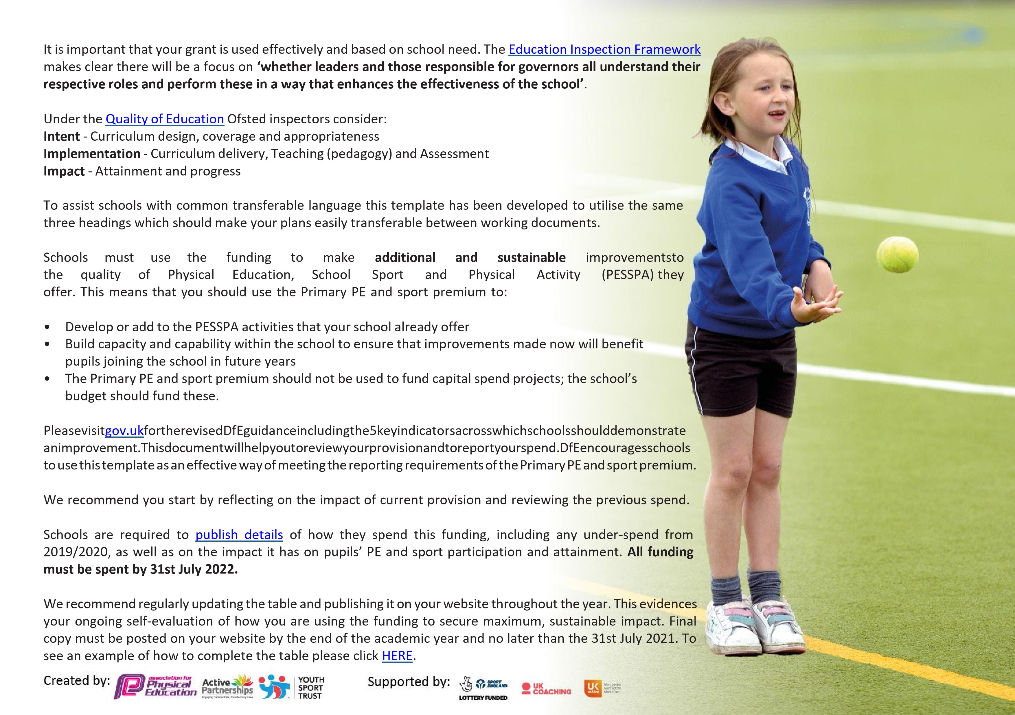



**Details**

**with**

**regard**

**to**

**funding**

Please

complete

the

table

below.

|  |  |
| --- | --- |
| Total amount carried over from 2020/2021 | £6,661 |
| Total amount allocated for 2021/2022 | £17,638 |
| How much (if any) do you intend to carry over from this total fund into 2022/23? | £0 |
| Total amount allocated for 2021/22 | £24,299 |
| Total amount of funding for 2021/22. To be spent and reported on by 31st July 2022. | £24,299 |



**Swimming**

**Data**

Please

report

on

your

Swimming

Data

below.

|  |  |
| --- | --- |
| Meeting national curriculum requirements for swimming and water safety.  N.B. Complete this section to your best ability. For example, you might have practised safe self-rescue techniques on dry land which you can then transfer to the pool when school swimming restarts.  **Due to exceptional circumstances priority should be given to ensuring that pupils can perform safe self-rescue even if they do not fully meet the first two requirements of the NC programme of study** | |
| What percentage of your current Year 6 cohort swim competently, confidently and proficiently over a distance of at least 25 metres?  **N.B.** Even though your pupils may swim in another year please report on their attainment on leaving primary school at the end of the summer term 2021. Please see note above | 100% |
| What percentage of your current Year 6 cohort use a range of strokes effectively [for example, front crawl, backstroke and breaststroke]? | 100% |
| **What percentage of your current Year 6 cohort perform safe self-rescue in different water-based situations?** | 100% |
| Schools can choose to use the Primary PE and sport premium to provide additional provision for swimming but this must be for activity **over and above** the national curriculum requirements. Have you used it in this way? | No |

**Action Plan and Budget Tracking**

Capture your intended annual spend against the 5 key indicators. Clarify the success criteria and evidence of impact that you intend to measure to evaluate for pupils today and for the future.



|  |  |  |  |  |
| --- | --- | --- | --- | --- |
| **Academic Year:** 2021/2022 | **Total fund allocated:** £24,299 | **Date Updated: November 2022** | |  |
| **Key indicator 1:** The engagement of all pupils in regular physical activity – Chief Medical Officers guidelines recommend that primary school pupils undertake at least 30 minutes of physical activity a day in school | | | | Percentage of total allocation: |
| %54 |
| **Intent** | **Implementation** | | **Impact** |  |
| Your school focus should be clear what you want the pupils to know and be able to do and about what they need to learn and to consolidate through practice: | Make sure your actions to achieve are linked to your intentions: | Funding allocated: | Evidence of impact: what do pupils now know and what can they now do? What has changed? | Sustainability and suggested next steps: |
| To ensure that teaching of PE is of a high quality across the school.    Lunchtime to be used for play leading to support children in games playing. Heartstart and play leader MDA to support with this.  Resources to be provided for classes for structured play at break and lunch. Daily Mile to be used by classes. | Subscription to Get Set 4 PE to support staff with planning and delivery of PE.    PE timetabled and SLT and PE leader monitor that children are engaging in PE and physical activity.    All classes receive a budget for purchasing equipment for play time and lunchtime. | £13,011 | High quality lessons because of staff being aware of what PE they need to teach throughout the year, and how to access the Get Set 4 PE lessons, assessment and key skills and vocabulary to teach the children.  Year 5 children have participated in some Play Leader training- the rest to be continued over to Autumn 2022.  Children planned, budgeted for and requested equipment for their class- this allowed for a range of games for all children, and use of quality equipment to improve their fitness during breaktimes and lunchtimes.  Children participated in daily mile- good feedback from the children and understanding of why it is important to keep moving. | PE lead to do drop in PE observations to ensure the correct PE is being taught. PE lead to carry out pupil conferencing to check key skills and vocabulary are being taught and explained to the children.  Get Set 4 PE to be carried on being used but the school overview to be looked at and re planned to ensure progression across the school.  Focus on vocabulary and skills progression as well.  Play leader training to be completed by Autumn 2022. |

|  |  |  |  |  |
| --- | --- | --- | --- | --- |
| **Key indicator 2:** The profile of PESSPA being raised across the school as a tool for whole school improvement | | | | Percentage of total allocation: |
| %5 |
| **Intent** | **Implementation** | | **Impact** |  |
| Your school focus should be clear what you want the pupils to know and be able to do and about what they need to learn and to consolidate through practice: | Make sure your actions to achieve are linked to your intentions: | Funding allocated: | Evidence of impact: what do pupils now know and what can they now do? What has changed? | Sustainability and suggested next steps: |
| To ensure that successes in sport are celebrated within and outside school. | Use of sports ambassadors to raise profile of school sport.    Central display to celebrate achievements in sport and PE.    School to take part in virtual and in person events this year and celebrate with school and parental community.    PE leader to work with sports leaders to support on whole school events.  Sporting achievements to be celebrated in the newsletter and celebration assembly. | £1,214 | Sports ambassadors successfully planned and helped run Sports day in June 2022. They designed the obstacle course, ensured children knew where they had to start for their races, and put equipment on and off the track. Children were extremely successful and Sports Day ran smoothly. Good feedback from parents.  Display celebrates sporting achievements- celebration assembly added in the Summer term to celebrate those sporting events. Children have a sense of pride in their achievements.  Children also nominated for Rising Stars events over the school holidays for being gifted and talented in certain areas of sports, giving them the chance to partake in quality sporting events and accelerate their abilities. | Continue to elect a group of sports ambassadors to run competitions, plan events/ part of events and represent the school at wider community events i.e. at WdF partnership. |

|  |  |  |  |  |
| --- | --- | --- | --- | --- |
| **Key indicator 3:** Increased confidence, knowledge and skills of all staff in teaching PE and sport | | |  | Percentage of total allocation: |
| %10 |
| **Intent** | **Implementation** | | **Impact** |  |
| Your school focus should be clear | Make sure your actions to | Funding | Evidence of impact: what do | Sustainability and suggested |
| what you want the pupils to know | achieve are linked to your | allocated: | pupils now know and what | next steps: |
| and be able to do and about | intentions: |  | can they now do? What has |  |
| what they need to learn and to consolidate through practice: |  |  | changed? |  |
| To release PE leader to attend updates at William De Ferrers so that they can support staff with high quality CPD.    To release PE leader to monitor the quality of education in PE across the school. | Calendar organised and leader released. Staff meeting cycle to include PE focussed staff meetings to support all staff.    Use of Jack of All Sports to support with modelling of high-quality PE teaching. | £2,429 | Updates from WDF school communicated with PE leader to ensure that children were given the opportunity to take part in extra events- e.g. Santa Dash, Rising Stars sporting events, mini games. Both KS1 and KS2 given opportunities to attend and take part in a range of events. | Continue with sporting events and ensuring that it covers both KS1 and KS2. |

|  |  |  |  |  |
| --- | --- | --- | --- | --- |
| **Key indicator 4:** Broader experience of a range of sports and activities offered to all pupils | | |  | Percentage of total allocation: |
| %15 |
| **Intent** | **Implementation** | | **Impact** |  |
| Your school focus should be clear | Make sure your actions to | Funding | Evidence of impact: what do | Sustainability and suggested |
| what you want the pupils to know | achieve are linked to your | allocated: | pupils now know and what | next steps: |
| and be able to do and about | intentions: |  | can they now do? What has |  |
| what they need to learn and to consolidate through practice: |  |  | changed? |  |
| Clubs to be run in range of sports by staff and outside providers where possible so that children have opportunities they would not otherwise have access to.  Children to develop resilience through activities such as boot camp. | Clubs to be started in autumn term and to be reviewed at end of term with new offer for spring term.    Liaise with EBC Inspire and Jack of All Sports regarding outside clubs for children. Also work with them for enrichment opportunities within the curriculum such as Reception Class “Bootcamp Buddies”. | £3,645 | Clubs offered included:  Tennis, football, yoga and mindfulness, netball, basketball and multisport.  This ensured that there was a variety of sporting clubs available across a range of sports. To include yoga and mindfulness so that children who are not as keen on sports to get the opportunity to try something different.  Whole school well-being week included yoga and mindfulness sessions across the school. Child and parent feedback was extremely positive around this. | Buddy Bootcamp to be looked into and attended next academic year, working with other schools in SWF. |
| **Key indicator 5:** Increased participation in competitive sport | | |  | Percentage of total allocation: |
| %16 |
| **Intent** | **Implementation** | | **Impact** |  |
| Your school focus should be clear | Make sure your actions to | Funding | Evidence of impact: what do | Sustainability and suggested |
| what you want the pupils to know | achieve are linked to your | allocated: | pupils now know and what | next steps: |
| and be able to do and about | intentions: |  | can they now do? What has |  |
| what they need to learn and to consolidate through practice: |  |  | changed? |  |
| For pupils to have access to a range of sporting events through festivals and competitions through William De Ferrers  School Sports Partnership | Subject Leader to attend all meetings and ensure calendar is shared with SLT and office.    Children organised to attend events and staff to attend on rota basis.    Funding used for transport as necessary.    In school events to be run by PE leader using SSP and SSCO to support. | £4,000 | Competitions and festivals attended included:  Football, Year 2 mini games, tennis, Swimming gala, netball, basketball.  Children across both key stages given the opportunity to participate in out of school events, which impacted positively on sportsmanship.  Some children also took part in the Swimarathon- a charity event. Giving them the knowledge and understanding of raising money whilst competing in a sport. | Continue this for next academic year. |

|  |  |
| --- | --- |
| Signed off by | |
| Head Teacher: | Janet Hoy |
| Date: | November 2022 |
| Subject Leader: | Alice Kavanagh |
| Date: | November 2022 |
| Governor: | Karen Munro |
| Date: | November 2022 |