Ruby Class Homework Autumn 2 week 6
B

Homework due: Tuesday 17th December 2024

Next week we are learning:
Maths | Literacy | Science | RE
We are at solving missing gap questions and bar models. | We will be looking elements of grammar. | We will be looking at what different animals eat to survive. | We will be looking at the meaning of Christmas symbols.

Spellings:
Practise spellings ready for weekly spelling test- see below for your child’s spelling group – These groups are subject to change as they are based on their current spelling ages.

Reading:
Read every day for 15 minutes.
Please log this in Reading Records.
Children must write a small comment in their journals everyday about their book.

Maths: Adding and subtracting two-digit numbers crossing 10 and worded problems.

SPaG: Identifying word classes.

Challenges; These questions are optional.

Spellings:
Group 1 | Group 2
me  she  we  be  he  see  tree  green  meet  week | camel  tunnel  squirrel  travel  towel  tinsel  bagel  jewel  saw  with

Maths:

Write these numerals in words:
1 _________
2 _________
3 _________
4 _________
5 _________

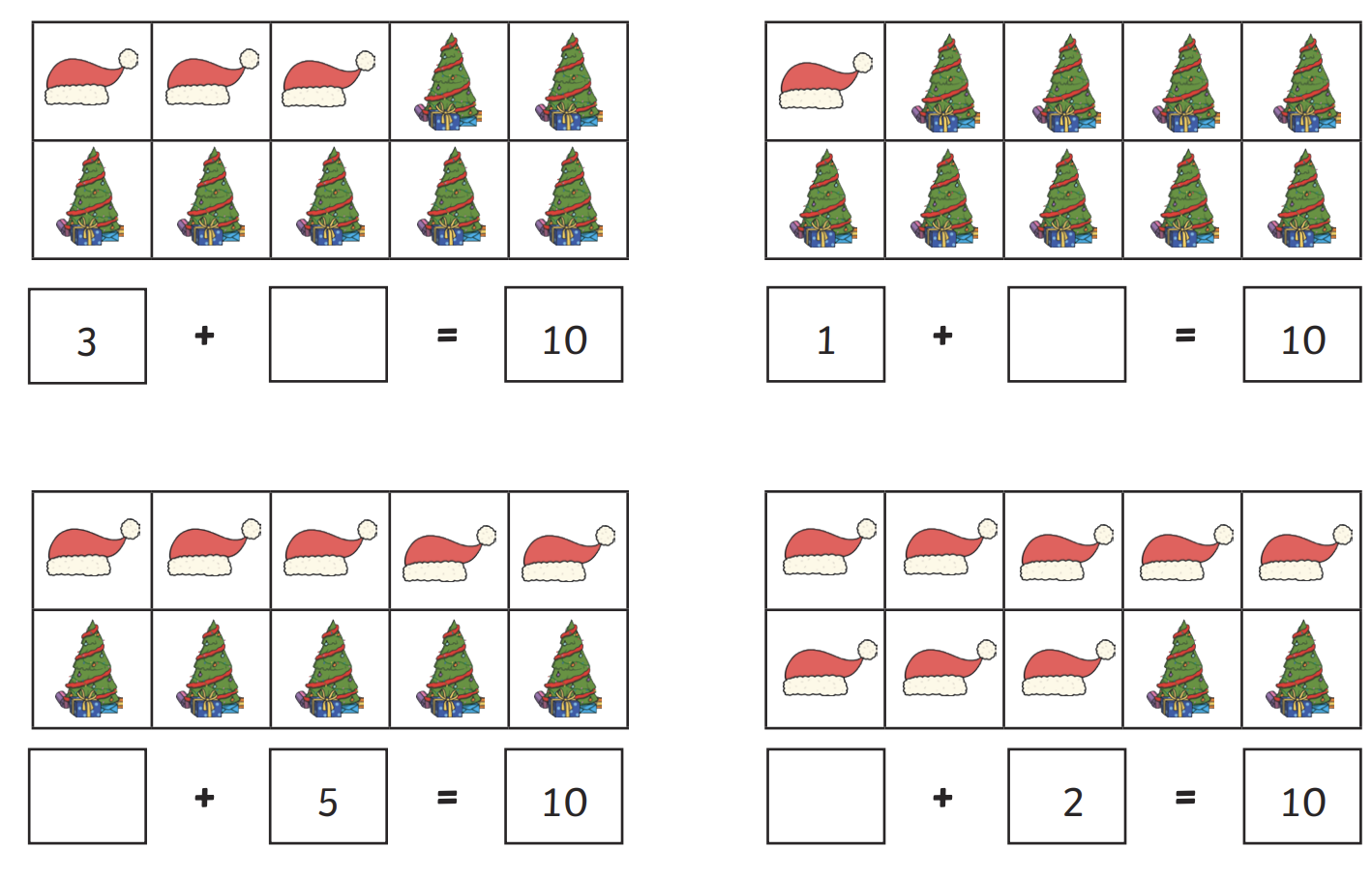
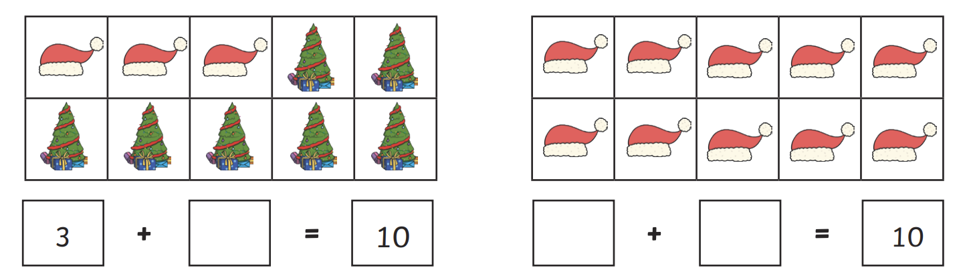

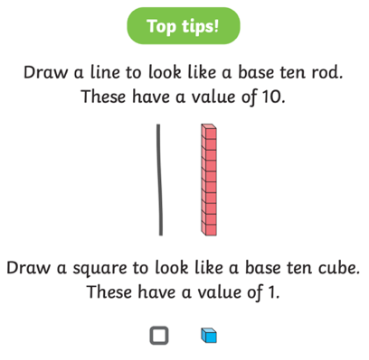

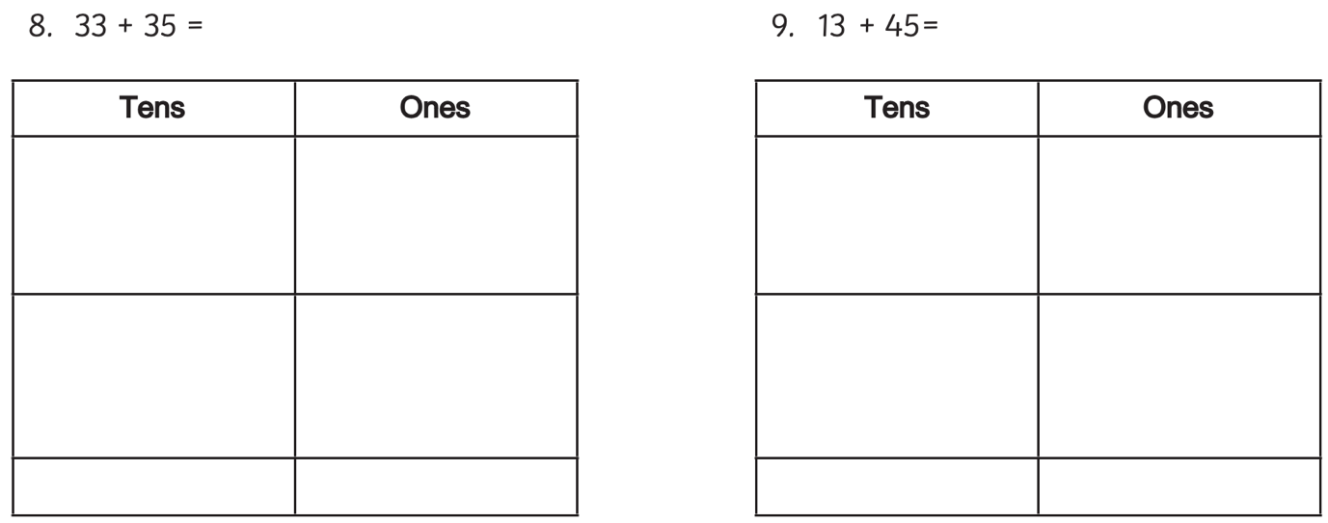
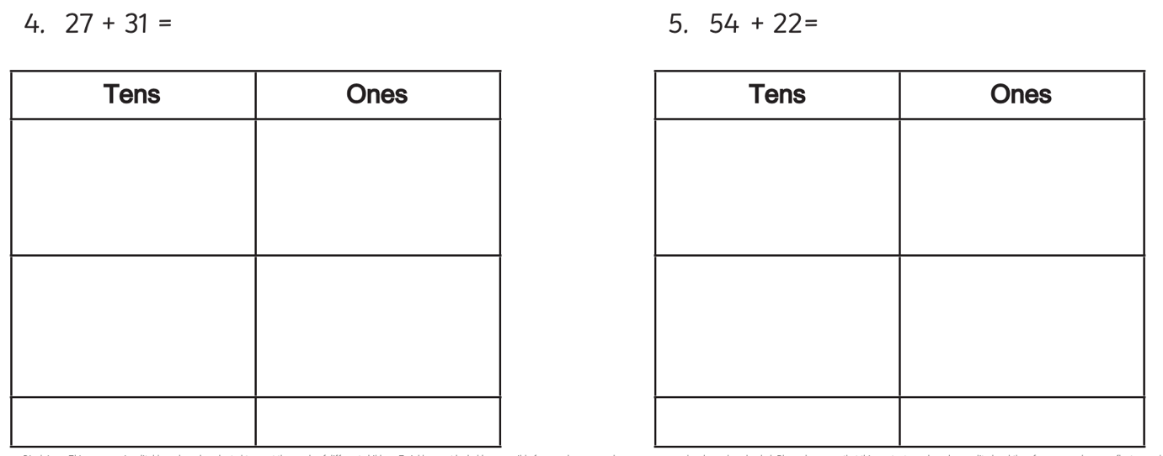
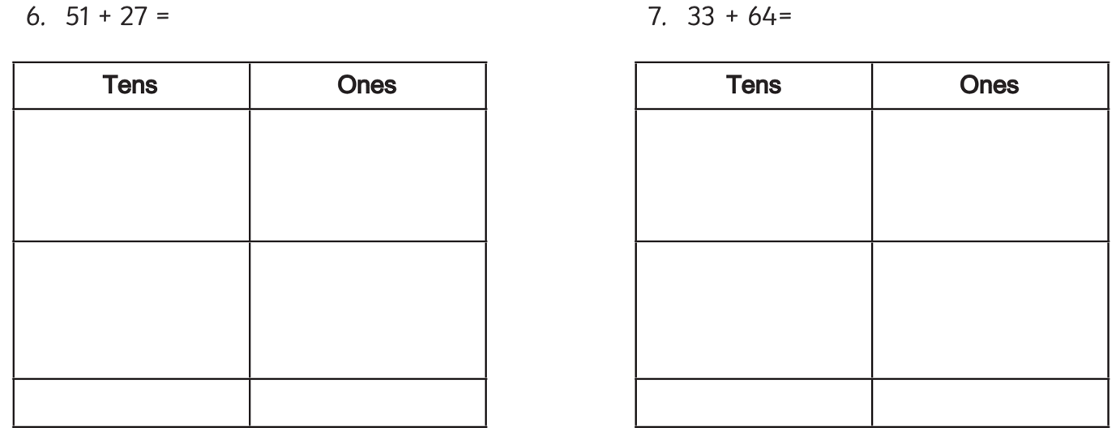
1. 34 + 25 = 2. 42 + 31 =
3. 61 + 23 = 3. 25 + 52 =
