Ruby Class Homework Autumn 2 week 4
B
Homework due: Tuesday 3rd December 2024

Next week we are learning:
Maths | Literacy | Science | RE
We are looking at how we can add two-digit numbers together without crossing 10. | We will be looking elements of grammar. | We will be looking at microhabitats. | We will be looking at the meaning of Christmas symbols.

Spellings:
Practise spellings ready for weekly spelling test- see below for your child’s spelling group – These groups are subject to change as they are based on their current spelling ages.

Reading:
Read every day for 15 minutes.
Please log this in Reading Records.
Children must write a small comment in their journals everyday about their book.

Maths: Adding two-digit numbers without crossing 10.

SPaG: Identifying word classes.

Spellings:
Group 1 | Group 2
rain  train  book  look  car  star  soil  she  you  was | gem  giant  magic  giraffe  energy  jacket  charge  hedge  there  some

Maths:

Write these numerals in words:
1 _________
2 _________
3 _________
4 _________
5 _________
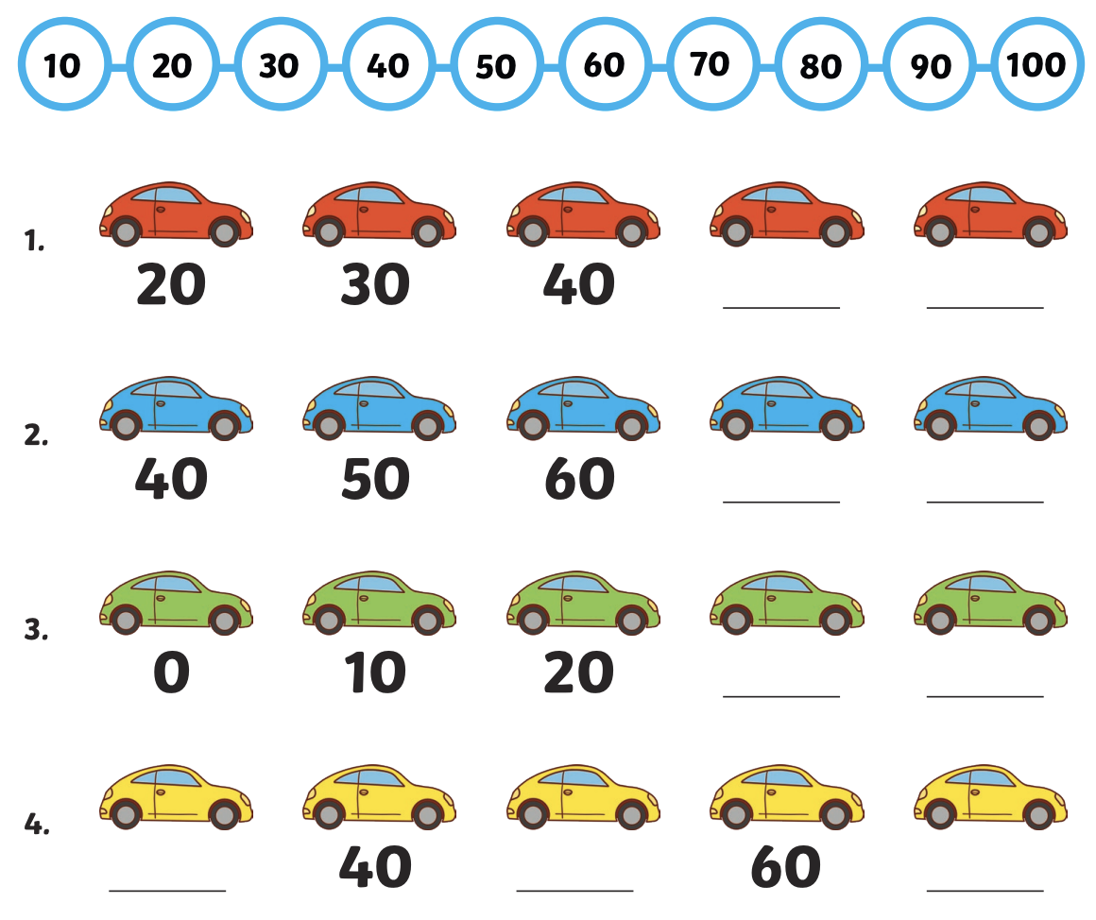

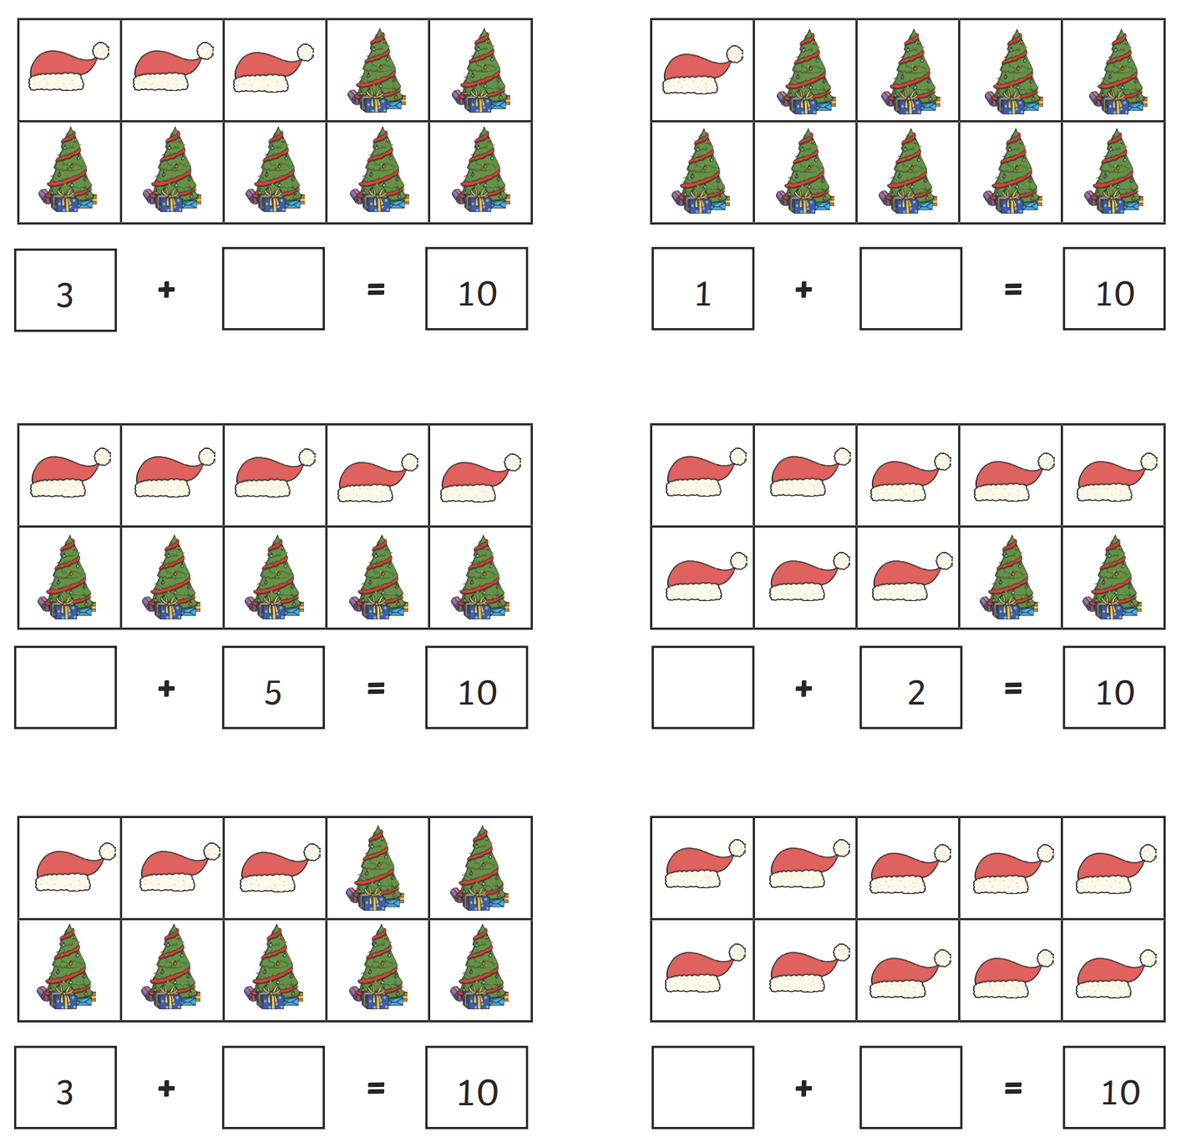

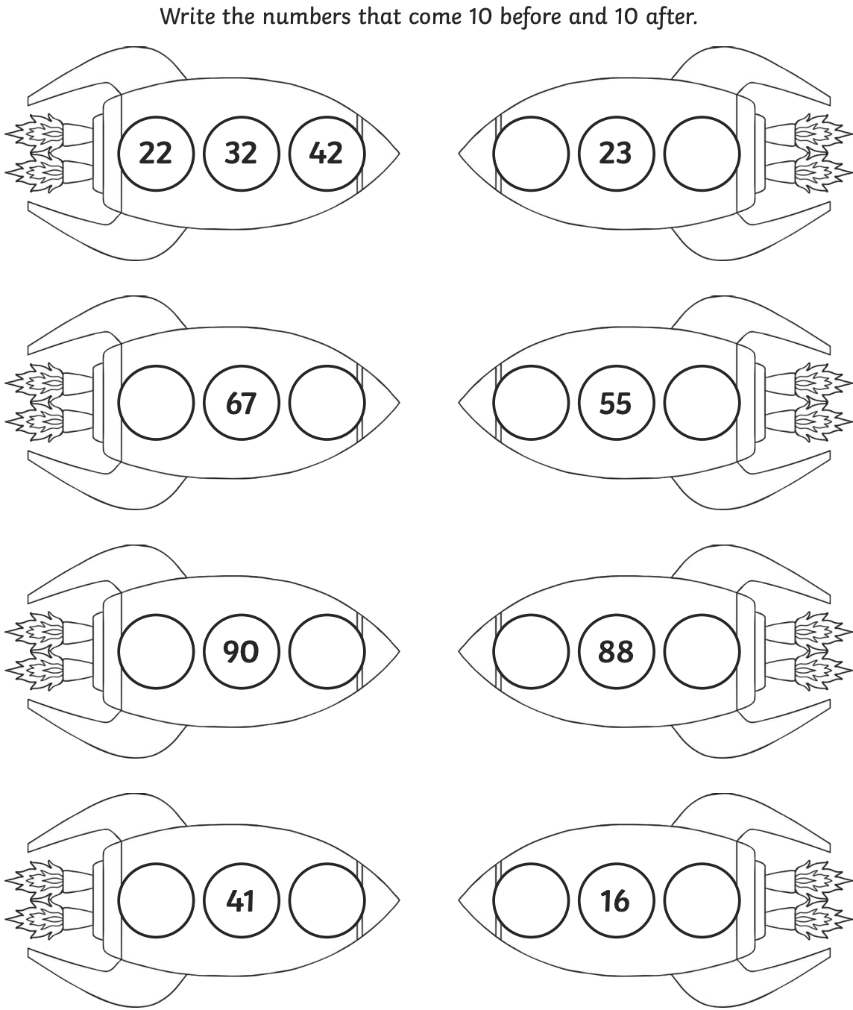

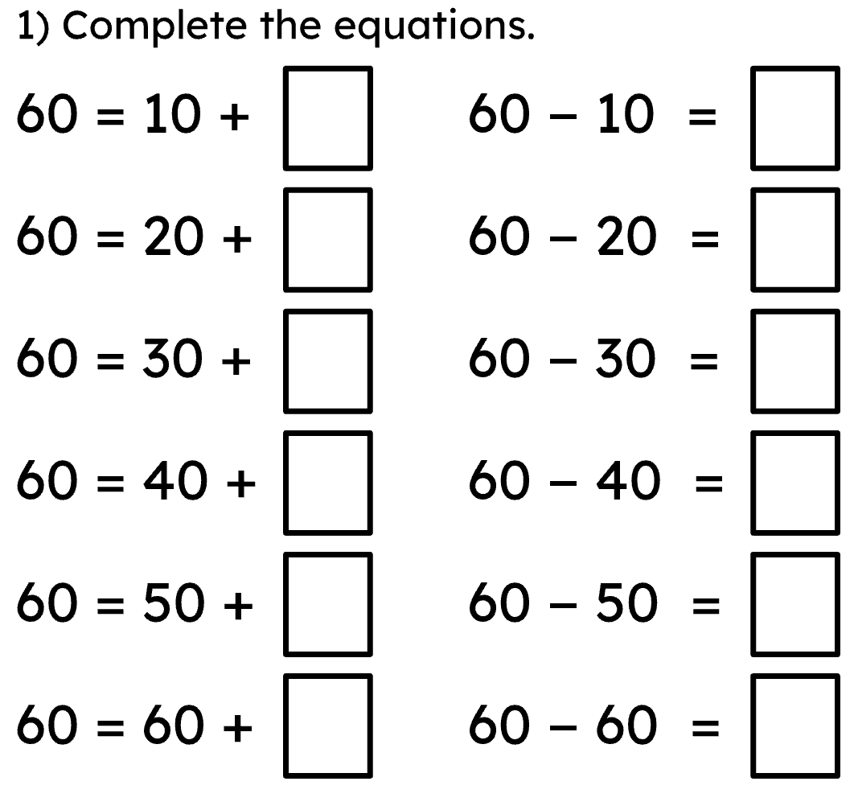
Complete the place value chart.
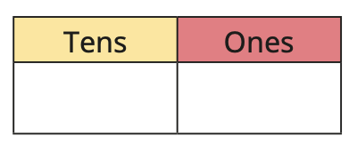
43
65
