## Ruby Class Homework Autumn 2 week 1

B

Homework due: Tuesday 12th November 2024

|  |  |  |  |
| --- | --- | --- | --- |
| **Next week we are learning:** | | | |
| Maths | Literacy | Science | RE |
| We will be starting our new unit ‘addition and subtraction’.  We will be looking at related facts, focusing on number bonds to 10, 20 and 100. | We will be looking at features of a recount. | We will be looking at identifying objects as living, dead and never alive. | We will be looking at the creation story in more depth and looking at what the story tells Christians about God. |

|  |
| --- |
| ***Spellings:***  Practise spellings ready for weekly spelling test- see below for your child’s spelling group – These groups are subject to change as they are based on their current spelling ages.  ***Reading:***  Read every day for 15 minutes.  Please log this in Reading Records.  Children must write a small comment in their journals everyday about their book.  ***Maths:*** counting in 2s and number bonds to 10  ***Challenges are optional –*** although please have a go if you can. |

**Spellings:**

|  |  |  |
| --- | --- | --- |
| **Group 1** | **Group 2** | **Group 3** |
| rain  wait  train  paid  afraid  oil  join  coin  soil  she | hunting  hunted  hunter  buzzing  buzzed  buzzer  jumping  jumped  jumper  cracker | wristband  wrinkle  wriggle  correct  terrible  current  landscape  compose  any  who |

**Maths:**

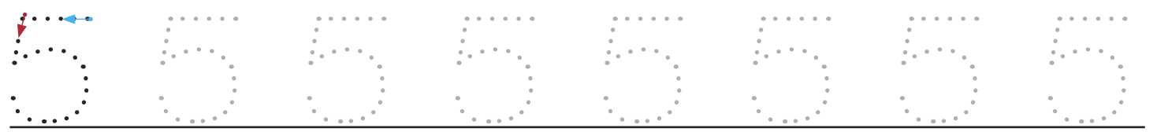



Write these numerals in words:

8 _____

2 _____

4 _____

1 _____

Colour the rekenrek to help you find the answer.



4 + ___ = 10



10 = ___ + 9



10 = 6 + ___



10 + ___ = 10



7 + ___ = 10

___ + 5 = 10





10 = 3 + ___

___ + 1 = 10

Challenges:

