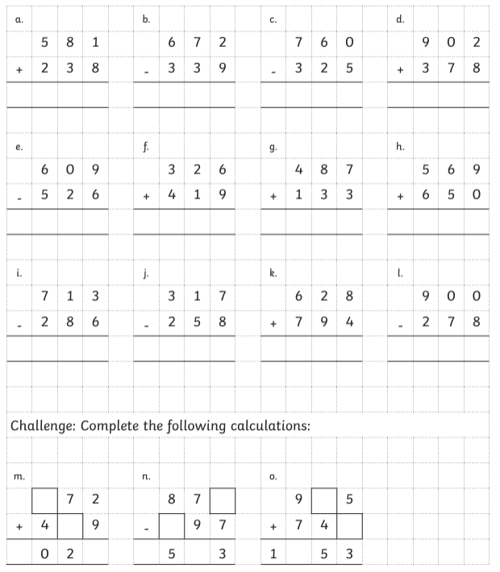**Humite Class Homework autumn 2 week 1**

Homework due: Wednesday 13th November 2024

|  |  |  |  |
| --- | --- | --- | --- |
| **Next week we are learning:** | | | |
| Maths | Literacy | Science | RE |
| We will move onto our multiplication and division topic. | We will be exploring Charlie and the Chocolate Factory, writing persuasively and getting evidence from the text. | We will start our topic on rocks. | Diving deeper into the story of Abraham and Isaac. |

|  |
| --- |
| **Reading: Daily for 30 minutes.**  **Spelling: see below**  **Times tables:** Log onto TTRockstars and play for 15 – 30 minutes. |

**Spellings:**

|  |  |  |
| --- | --- | --- |
| Group 1 | Group 2 | Group 3 |
| suppose  surprise  therefore  though  although  thought  through  various  weight | beautiful  after  everybody  eight  caught  centre  century  heart  breath  busy | improve  sure  sugar  eye  could  should  would |

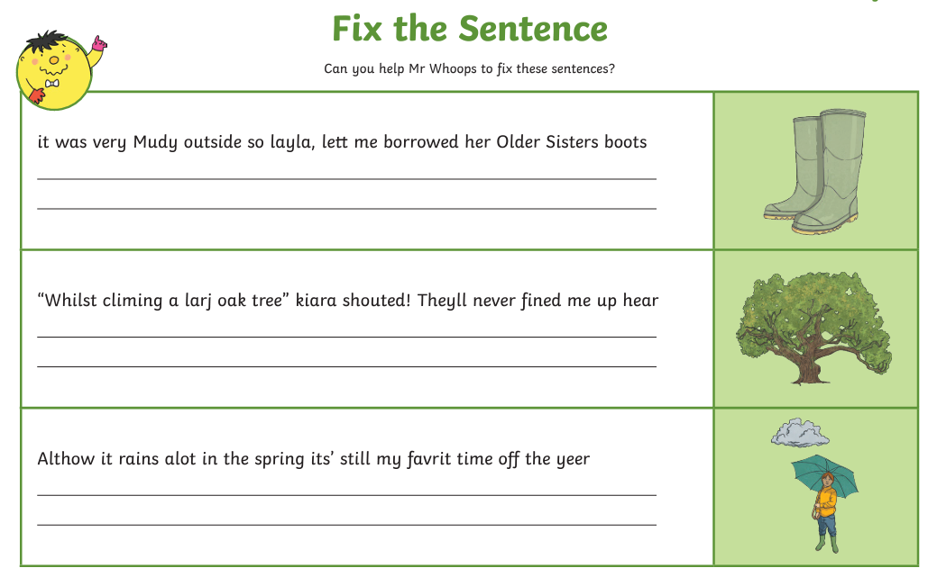

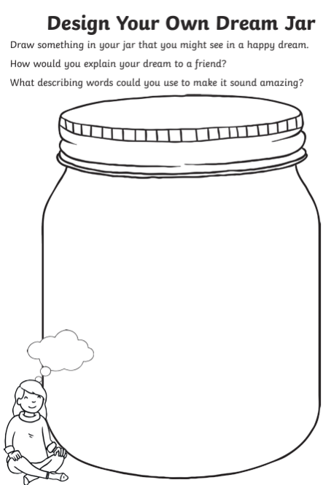

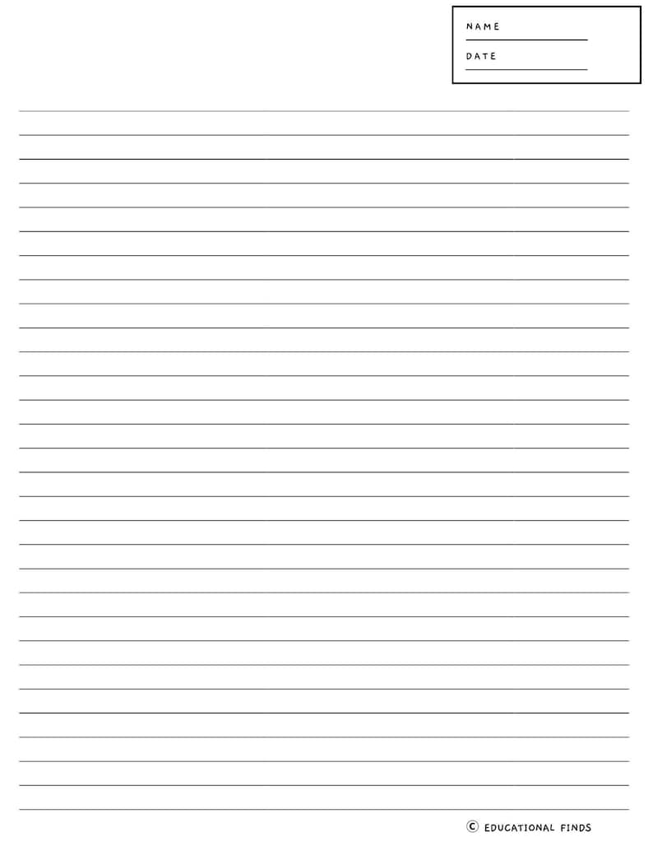Challenge: Write your own short Roald Dahl story. Can you invent some of your own words as well as using speech?