**Amber Class Homework autumn 2 week 3**

Homework due: Tuesday 26th November 2024

|  |
| --- |
| **Reading: Daily for 30 minutes, write up in your Reading Record with a comment about what was read/discussed.**  **Spelling: see below**  **Times tables: log on to PurpleMash and under games you will find monster multiplication. Have a go at this to help with your times tables!**    **Number bonds: log on to PurpleMash and under games you will find Bond Bubbles. Try this to help with your number bonds!** |

**Spellings:**

|  |  |  |
| --- | --- | --- |
| Group 1 | Group 2 | Group 3 |
| remember  question  disappear  enough  therefore  thought  through  weight | though  notice  library  answer  appear  decide  caught  difficult | said  clothes  again  every  after |

Use this space to practice your spellings!

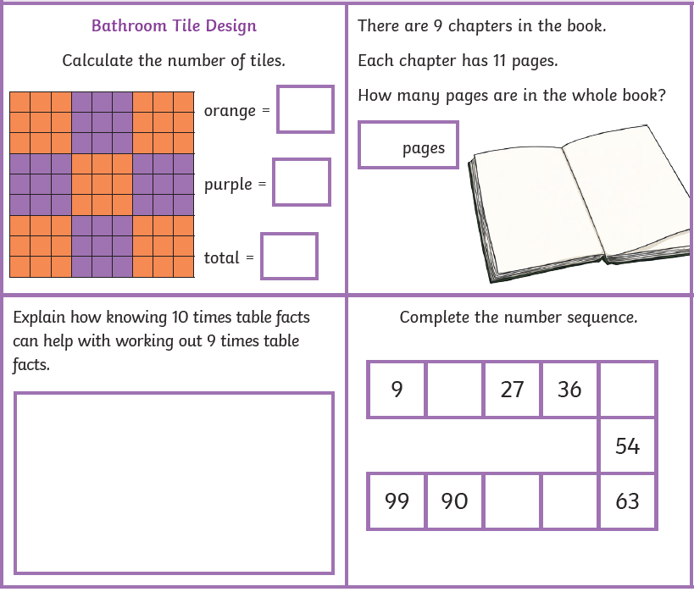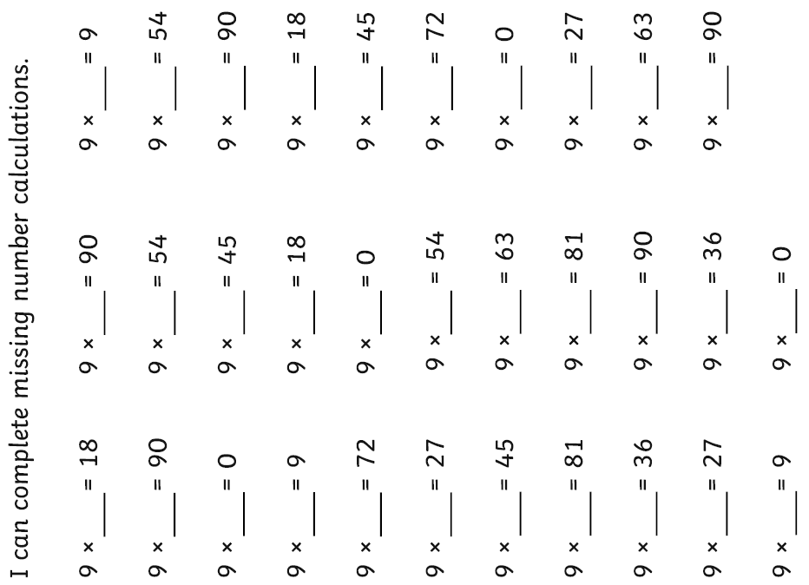

Maths challenge:

**English/science: Research the 3 different rock types. Can you then make a poster/factfile about the 3 different rock types (igneaous, sedimentary and metamorphic)? You must check your punctuation and try to rewrite the research into your own words.**