**Amber Class Homework autumn 2 week 2**

Homework due: Tuesday 19th November 2024

|  |
| --- |
| **Reading: Daily for 30 minutes, write up in your Reading Record with a comment about what was read/discussed.**  **Spelling: see below**  **Times tables: log on to PurpleMash and under games you will find monster multiplication. Have a go at this to help with your times tables!**    **Number bonds: log on to PurpleMash and under games you will find Bond Bubbles. Try this to help with your number bonds!** |

**Spellings: common misspelling of their, they’re and there for all this week.**

|  |  |  |
| --- | --- | --- |
| Group 1 | Group 2 | Group 3 |
| musician  electrician  magician  optician  politician  there  their  they’re | there  their  they’re  hear  here  quite  quiet | there  their  they’re  see  sea |

Use this space to practice your spellings!

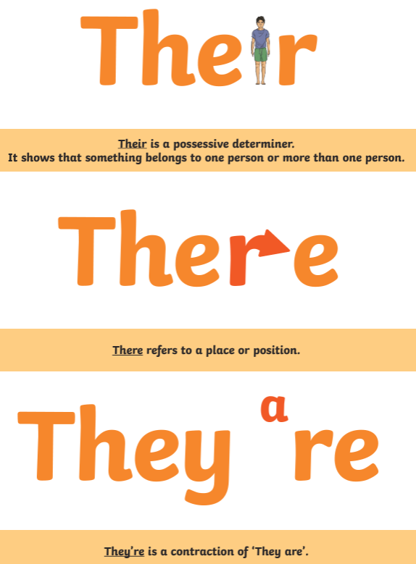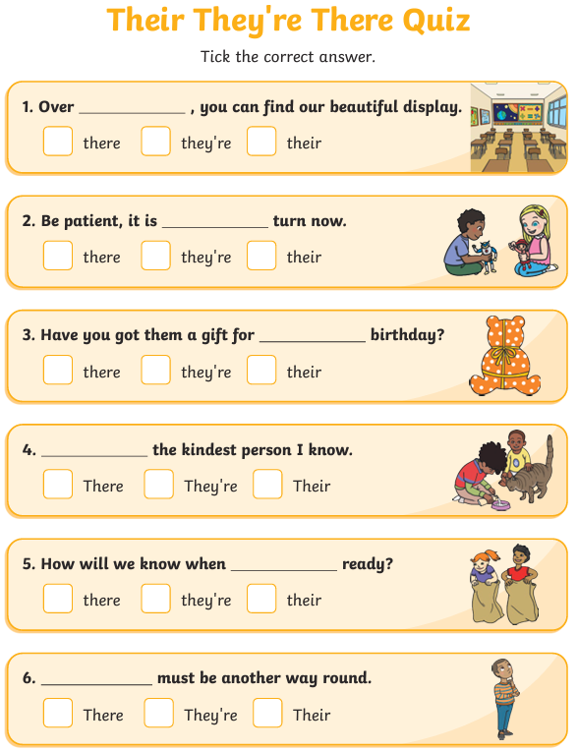

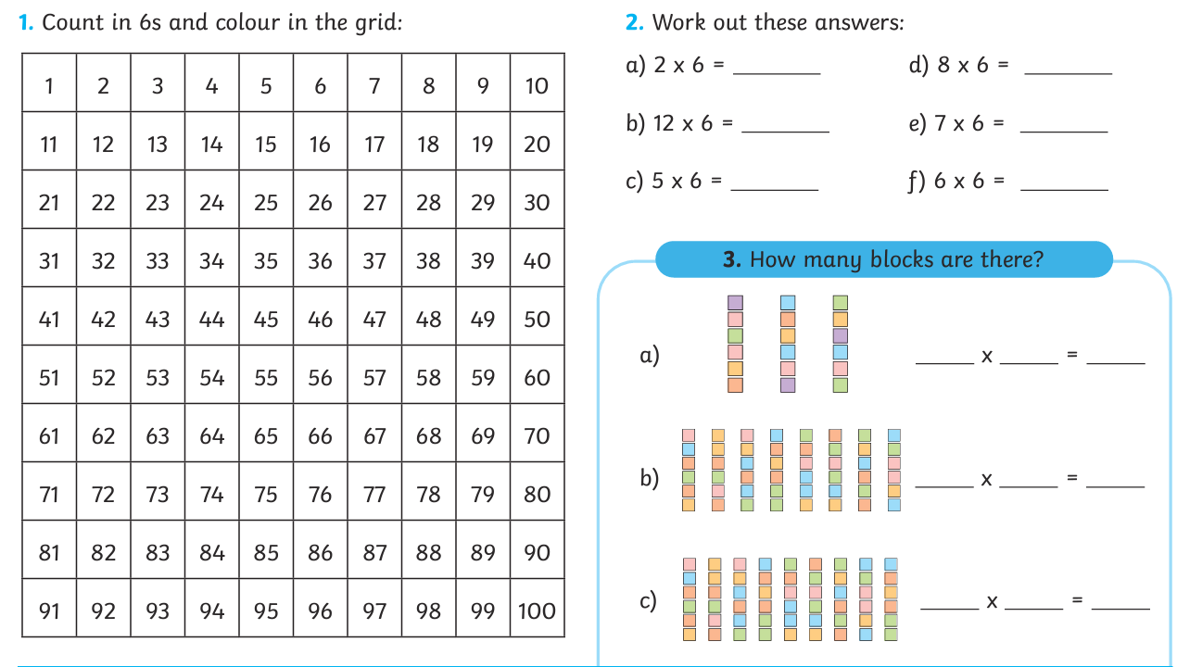

Maths challenge:

