**Amber Class Homework Autumn 1 week 2**

Homework due:

|  |  |  |  |
| --- | --- | --- | --- |
| **Next week we are learning:** | | | |
| Maths | Literacy | Science | RE |
| In maths next week we are continuing with place value numbers to 1000 and 10,000. | In literacy we are focusing on creating an opening setting from the characters we created this week. We will be focusing on paragraphs, new vocabulary and structuring sentences. | In science we will be looking at what animals have what skeletons and best diet for each animal. | In RE we will be continuing to look how different religions believe creation started and comparing similarities and differences. |

|  |
| --- |
| **Reading: Daily for 15 minutes.**  **Spelling:** See below (use the space on the back page to practise).  **Grammar:** Underline the verbs.  **Times tables:**  Log onto TTRockstars and play for 15 minutes (these log ins are in reading records)  See below  **Maths:** word problems. |

**Spellings:**

|  |  |  |
| --- | --- | --- |
| Group 1 | Group 2 | Group 3 |
| |  |  | | --- | --- | | fearless  sadness  playful  payment  happiness  loneliness  brightness  hopeless  movement  beautiful |  | | lyrics   |  | | --- | | symbol  hymns  crystal  typical  mystery  syrup  myth  lyrics  pyramid | | after  three  tree  floor  door  my |

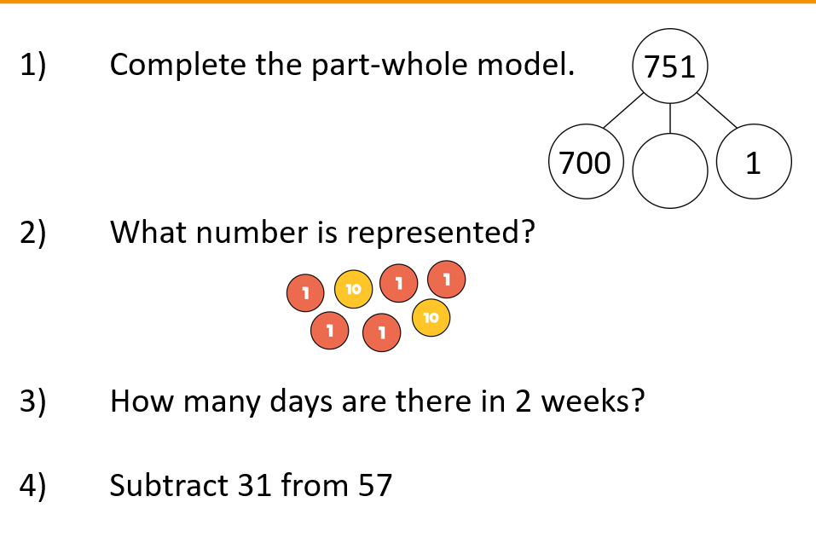**Maths**

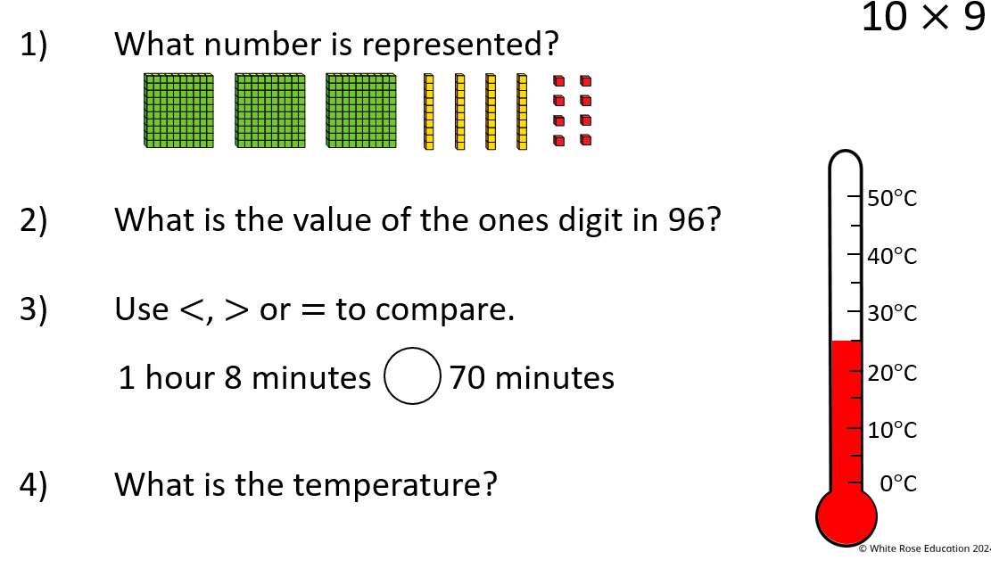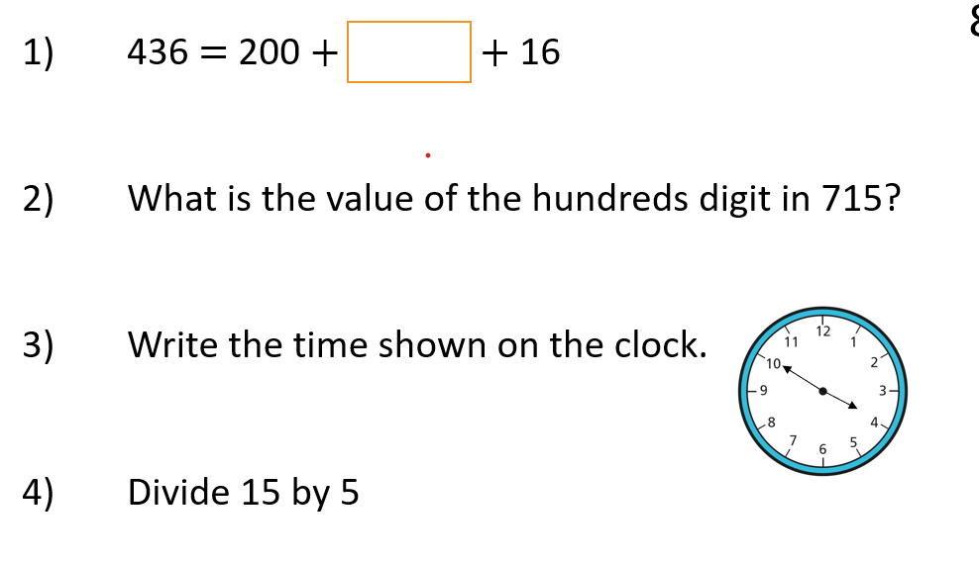

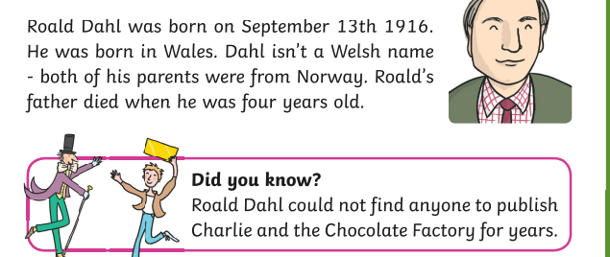**Times tables – Challenge**

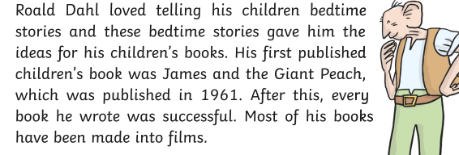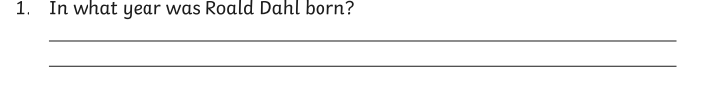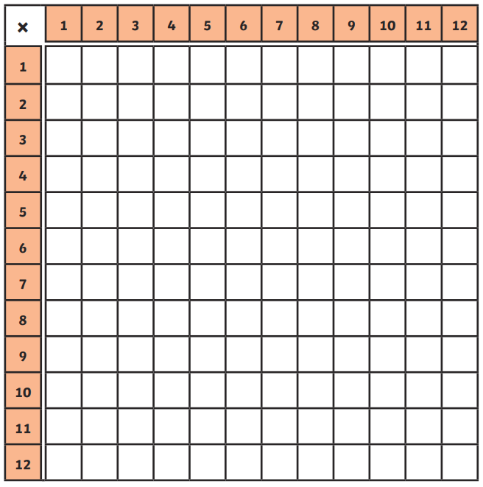

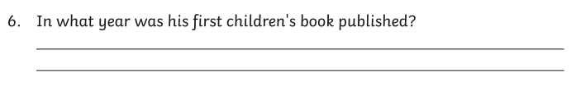Extra activity: Research about Quieten Blake the illustrator