**Amber class - Homework Autumn term 1– week 1**

**Homework due:** Tuesday

This half term our topic is “Roald Dahl”

|  |  |  |  |
| --- | --- | --- | --- |
| Next week we are learning about: | | | |
| **Maths** | **Literacy** | **Science** | **RE** |
| In maths next week we are continuing with place value looking at numbers to 100 and 10000. We will also be estimating on a number line to 1000 and ordering numbers. | In literacy we will be creating our own character description and opening of a story. We will be looking at the type of vocabulary Roald Dahl used and using this in our own writing. | In science we will be looking at what nutrient is important and human skeleton. This term we are looking at animal skeleton and human skeleton. | . In RE we will be continuing to look at the importance of creation from a theology point of view. This will lead onto what missions different Christians did to help with creation and keep the world safe. |

***Maths:***

Starter: Log onto TT Rock stars and complete challenges I have set for you.

|  |
| --- |
| **Challenge:**      ***Reading:***  Reading needs to happen 20 minutes per day, **please record what you do with your child in the reading record.** This is really important that they have this **practice at home**, so their reading can be challenged further. |

**Spellings:** This week in spelling I would like you to “Look, Cover, right, check” Be careful when spelling the split digraphs (e.g. a-e).

|  |
| --- |
| copied__________________________________  making  chiller  close_________________________________ |
| shiner  feared  because  their  know |

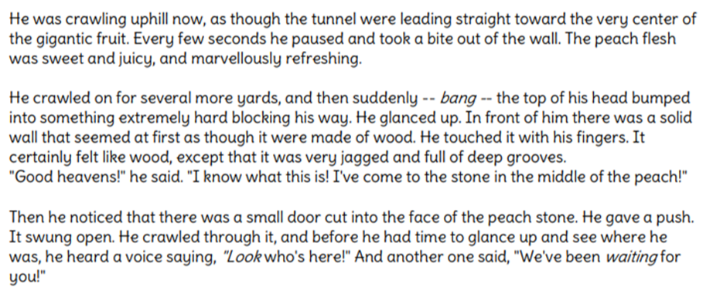

1. What is James doing?
2. What are speech marks?
3. Who do you think been waiting for James?

________________________________________________________________________________

________________________________________________________________________________

Underline the adjectives in this piece of text.

Additional tasks:

Investigate an animal of your choice. What do they eat? Where do they live? Etc.

__________________________________________________________________________________________________________________________________________________________________________________________________________________________________________________________________________________________________________________________________________________________________________________________________________________________________________________________________________________________