## Ruby Class Homework Autumn 1 week 7

B

Homework due: Tuesday 5th November 2024

|  |  |  |  |
| --- | --- | --- | --- |
| **Next week we are learning:** | | | |
| Maths | Literacy | Science | RE |
| We will be starting our new unit ‘addition and subtraction’.  We will be looking at related facts, focusing on number bonds to 10, 20 and 100. | We will be practicing our speaking skills through the Mighty Oak public speaking scheme. | We will be looking at how an aeroplane can fly. | We will be looking at the creation story in more depth and looking at what the story tells Christians about God. |

|  |
| --- |
| ***Spellings:***  Practise spellings ready for weekly spelling test- see below for your child’s spelling group – These groups are subject to change as they are based on their current spelling ages.  ***Reading:***  Read every day for 15 minutes.  Please log this in Reading Records.  Children must write a small comment in their journals everyday about their book.  ***Maths:*** counting in 2s and number bonds to 10  ***Challenges are optional –*** although please have a go if you can. |

**Spellings:**

|  |  |  |
| --- | --- | --- |
| **Group 1** | **Group 2** | **Group 3** |
| pen  dog  cat  bed  jam  tap  crab  frog  flag  my | hunting  hunted  hunter  buzzing  buzzed  buzzer  jumping  jumped  jumper  cracker | wrist  wreck  race  ice  cell  city  fancy  circle  friend  work |

**Maths:**

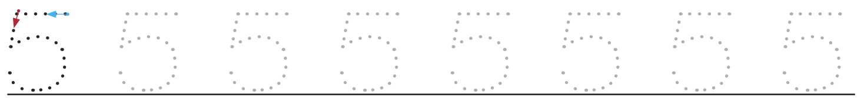



Write these numerals in words:

1 _____

2 _____

6 _____

5 _____

Colour the rekenrek to help you find the answer.



5 + ___ = 10



7 + ___ = 10



8 + ___ = 10



1 + ___ = 10



___ + 9 = 10



___ + 4 = 10



___ + 3 = 10

___ + 2 = 10

What do you notice about these number sentences?

Complete the number sentence.

**

Challenges:

**