## Ruby Class Homework Autumn 1 week 6

B

Homework due: Tuesday 22nd October 2024

|  |  |  |  |
| --- | --- | --- | --- |
| **Next week we are learning:** | | | |
| Maths | Literacy | Science | RE |
| We will be starting our new unit ‘addition and subtraction’.  We will be looking at related facts, focusing on number bonds to 10, 20 and 100. | We will be practicing our speaking skills through the Mighty Oak public speaking scheme. | We will be looking at how plants adapt to different habitats. | We will be looking at the creation story in more depth and looking at what the story tells Christians about God. |

|  |
| --- |
| ***Spellings:***  Practise spellings ready for weekly spelling test- see below for your child’s spelling group – These groups are subject to change as they are based on their current spelling ages.  ***Reading:***  Read every day for 15 minutes.  Please log this in Reading Records.  Children must write a small comment in their journals everyday about their book.  ***Maths:*** Place Value Consolidation  ***Challenges are optional –*** although please have a go if you can. |

**Spellings:**

|  |  |  |
| --- | --- | --- |
| **Group 1** | **Group 2** | **Group 3** |
| sit  sip  nip  pan  tip  dip  sad  man  map  pad | look  book  cook  for  sort  torch  you  they  my  by | knot  not  knew  new  write  written  wrote  wrong  wrap  water |

**Maths:**

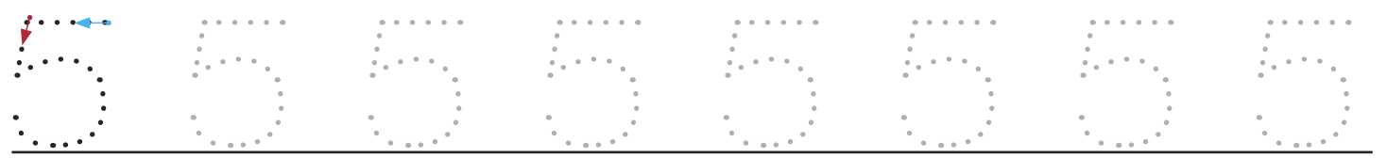

**

Challenge:

