Ruby Class Homework Autumn 1 week 6
A
Homework due: Tuesday 22nd October 2024
Next week we are learning:
Maths | Literacy | Science | RE
We will be starting our new unit ‘addition and subtraction’.  We will be looking at related facts, focusing on number bonds to 10, 20 and 100. | We will be practicing our speaking skills through the Mighty Oak public speaking scheme. | We will be looking at how plants adapt to different habitats. | We will be looking at the creation story in more depth and looking at what the story tells Christians about God.

Spellings:
Practise spellings ready for weekly spelling test- see below for your child’s spelling group – These groups are subject to change as they are based on their current spelling ages.

Reading:
Read every day for 15 minutes.
Please log this in Reading Records.
Children must write a small comment in their journals everyday about their book.

Maths: place value consolidation

Challenges are optional – although please have a go if you can.

Spellings:
Group 1 | Group 2 | Group 3
sit  sip  nip  pan  tip  dip  sad  man  map  pad | look  book  cook  for  sort  torch  you  they  my  by | knot  not  knew  new  write  written  wrote  wrong  wrap  water

Maths:
Can you write these numerals as words?

6 _____________ 16 _____________

66 _______________ 100 ________________

110 ________________ 115 _______________

120 ________________ 132 _______________

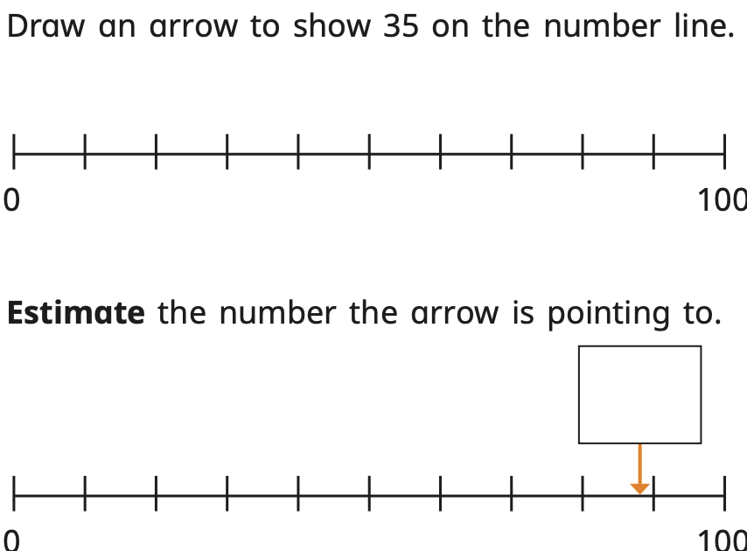

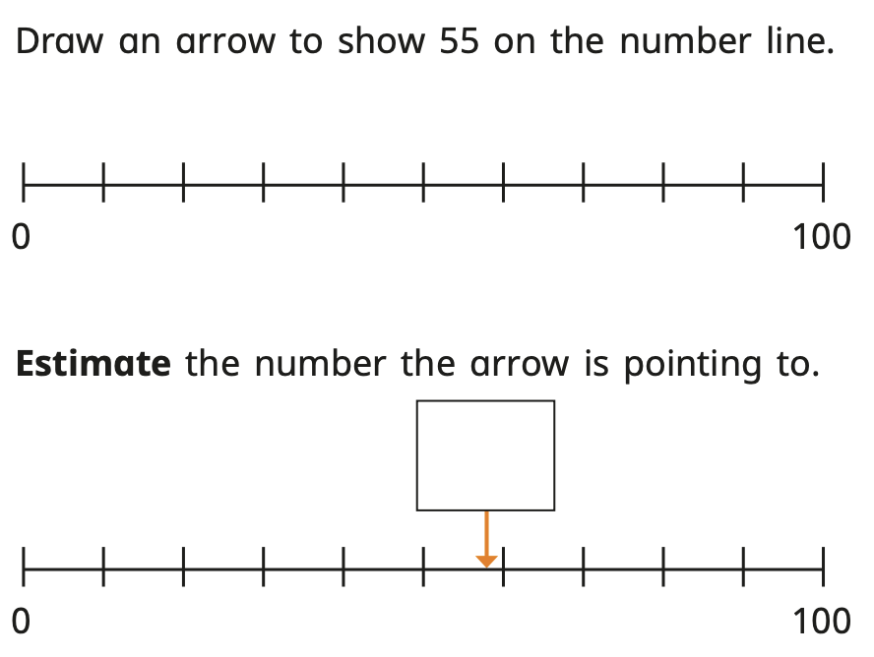

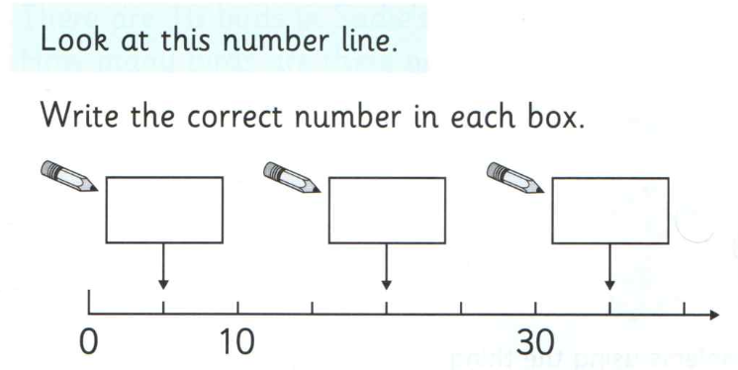

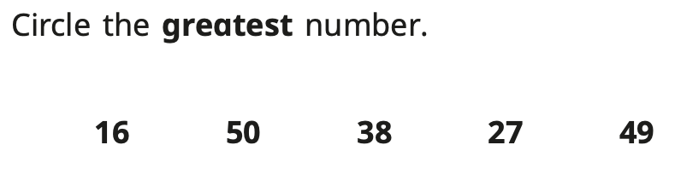
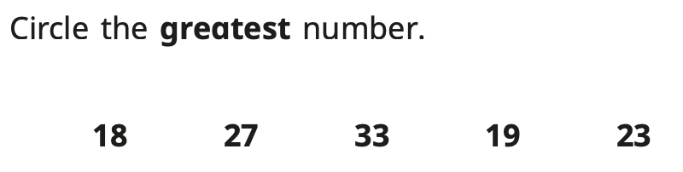

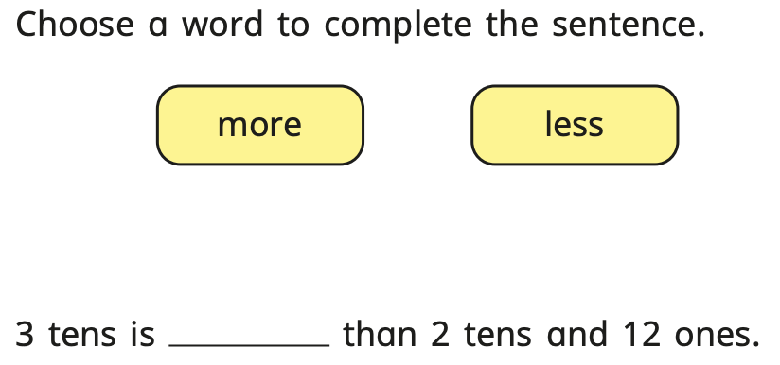

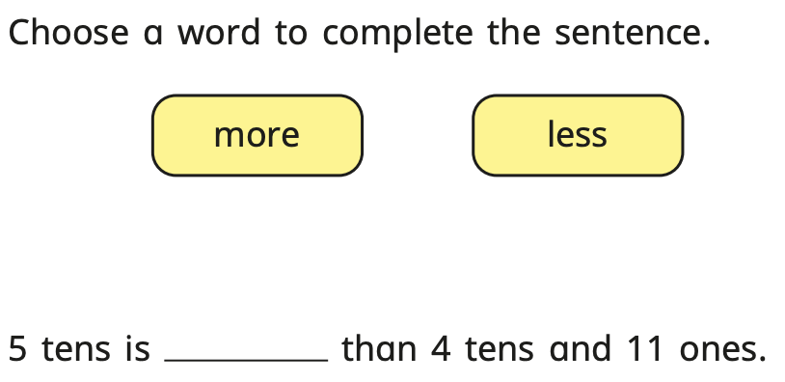
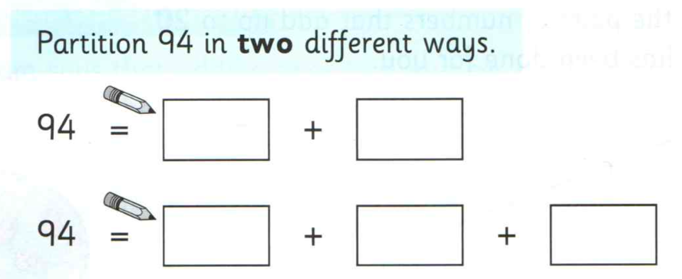

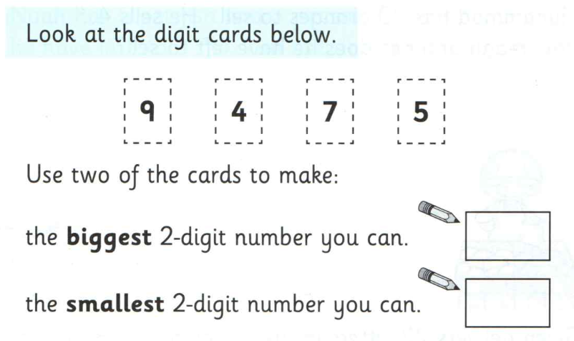

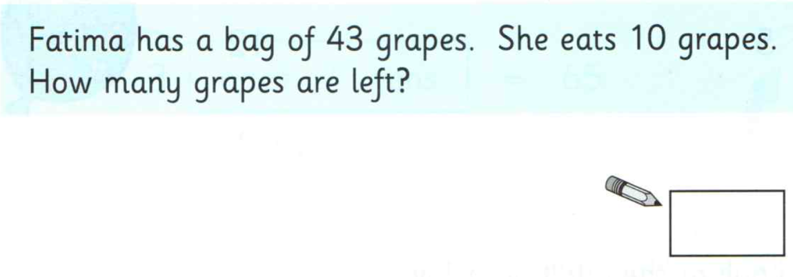

Challenges:
