Ruby Class Homework Autumn 1 week 5
B
Homework due: Tuesday 15th October 2024
Next week we are learning:
Maths | Literacy | Science | RE
We will be consolidating counting forwards and backwards in 2s, 5s and 10s. We will be looking at counting in 3s for the first time. | We will be practicing our speaking skills through the Mighty Oak public speaking scheme. | We will be looking at the results of our plant experiment and recording our findings. | We will be looking at the creation story in more depth and looking at what the story tells Christians about God.

Spellings:
Practise spellings ready for weekly spelling test- see below for your child’s spelling group – These groups are subject to change as they are based on their current spelling ages.

Reading:
Read every day for 15 minutes.
Please log this in Reading Records.
Children must write a small comment in their journals everyday about their book.

Maths: Counting in 2s, 5s and 10s.

Challenges are optional – although please have a go if you can.

Spellings:
Group 1 | Group 2 | Group 3
off  puff  sniff  miss  hiss  less  if  us  bus  yes | rain  wait  tail  mail  see  sheep  feel  high  light  might | knock  know  knee  knitting  knife  gnat  gnaw  gnash  gnome  gnarled

Maths:
Can you write these numerals as words?

2 _____________ 4 _____________

6 _______________ 8 ________________

10 ________________ 12 _______________

14 ________________ 16 _______________
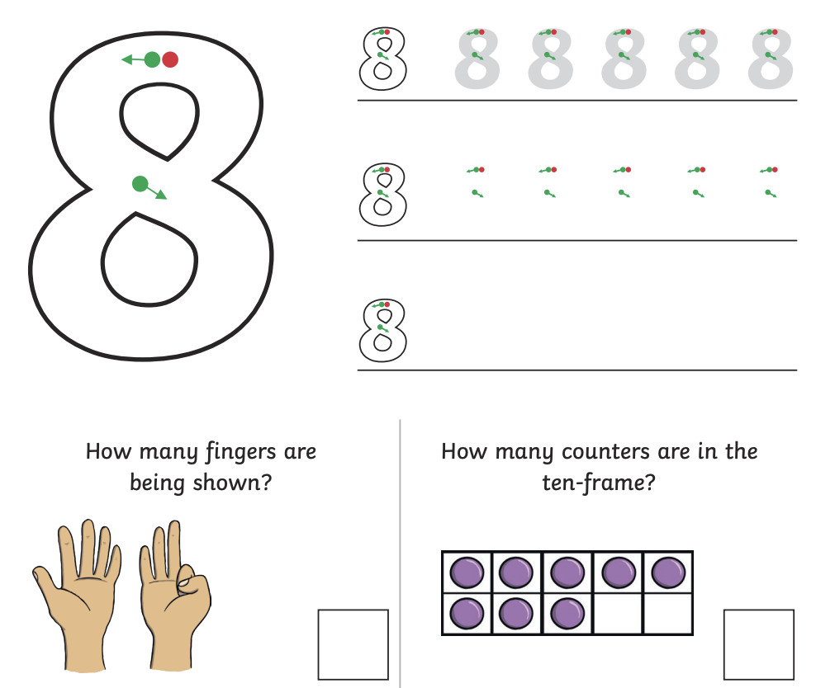
Count in 2s, 5s and 10s to find the missing numbers.
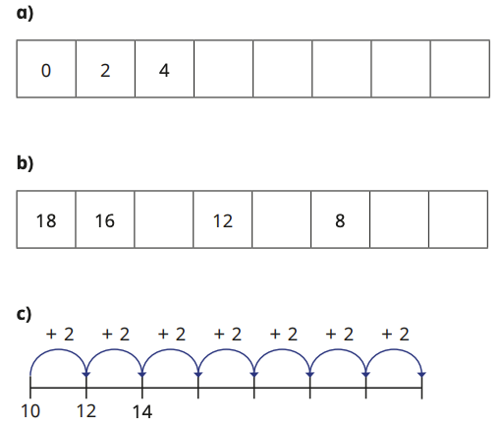

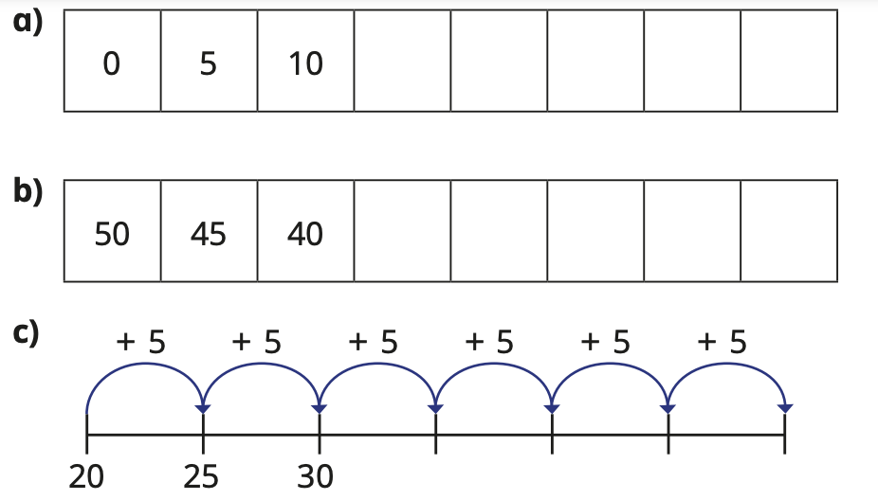

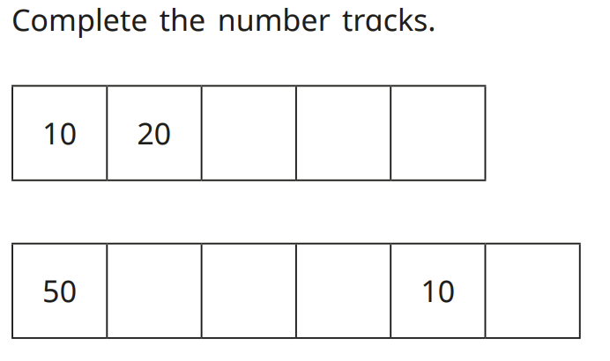

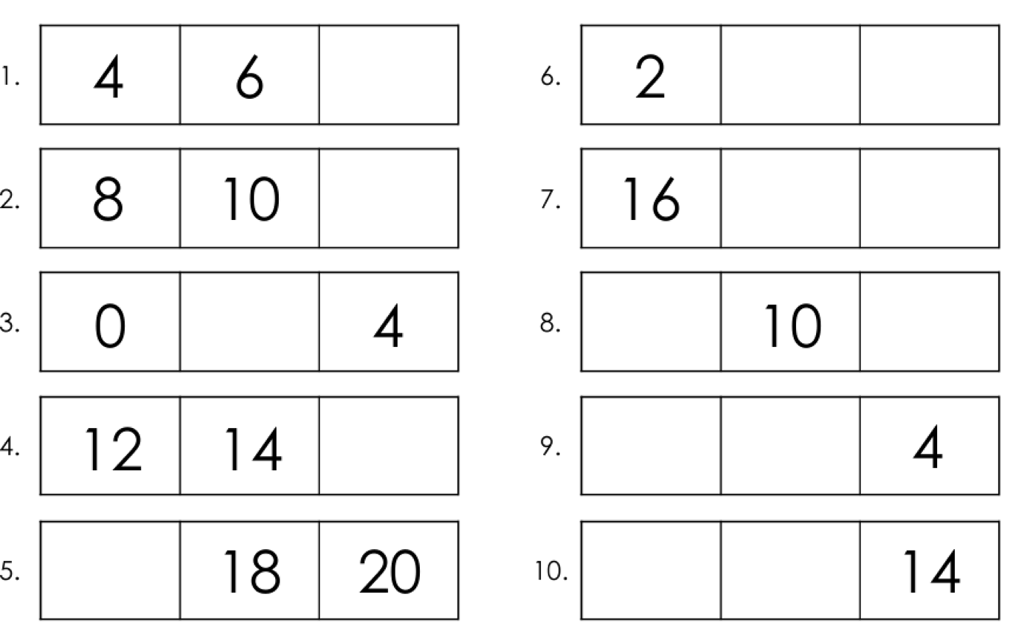

Challenge:
