Ruby Class Homework Autumn 1 week 5
A
Homework due: Tuesday 15th October 2024
Next week we are learning:
Maths | Literacy | Science | RE
We will be consolidating counting forwards and backwards in 2s, 5s and 10s. We will be looking at counting in 3s for the first time. | We will be practicing our speaking skills through the Mighty Oak public speaking scheme. | We will be looking at the results of our plant experiment and recording our findings. | We will be looking at the creation story in more depth and looking at what the story tells Christians about God.

Spellings:
Practise spellings ready for weekly spelling test- see below for your child’s spelling group – These groups are subject to change as they are based on their current spelling ages.

Reading:
Read every day for 15 minutes.
Please log this in Reading Records.
Children must write a small comment in their journals everyday about their book.

Maths: Counting in 2s, 3s, 5s and 10s.

Challenges are optional – although please have a go if you can.

Spellings:
Group 1 | Group 2 | Group 3
off  puff  sniff  miss  hiss  less  if  us  bus  yes | rain  wait  tail  mail  see  sheep  feel  high  light  might | knock  know  knee  knitting  knife  gnat  gnaw  gnash  gnome  gnarled

Maths:
Can you write these numerals as words?

3 _____________ 6 _____________

9 _______________ 12 ________________

15 ________________ 18 _______________

21 ________________ 24 _______________
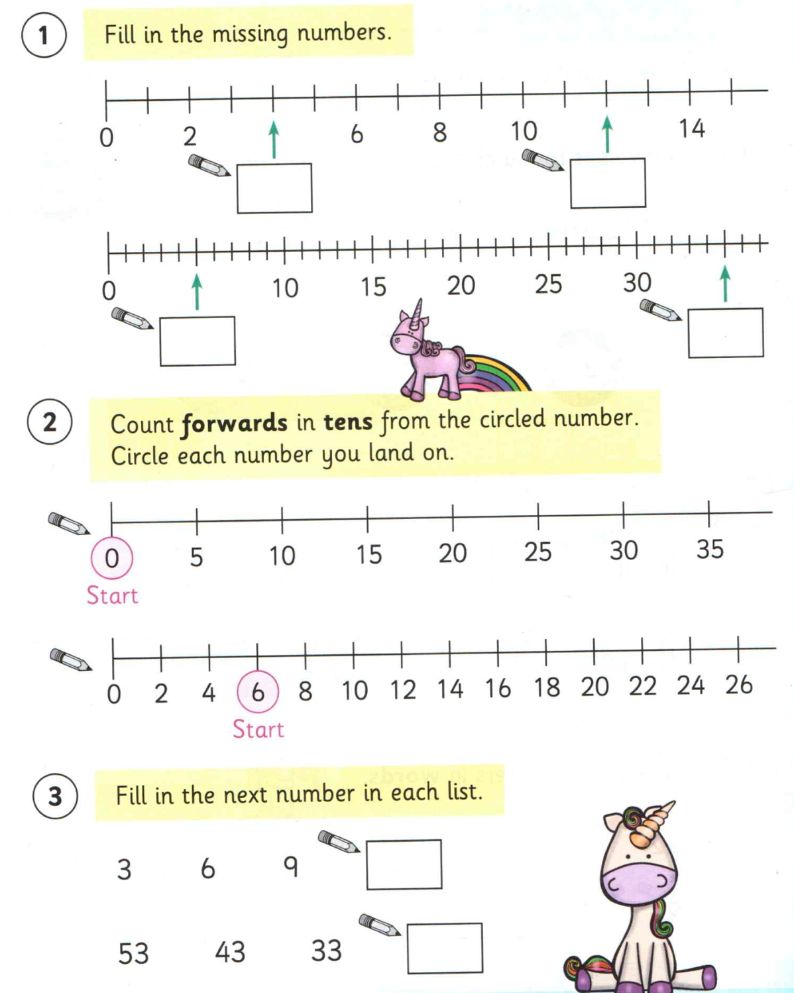

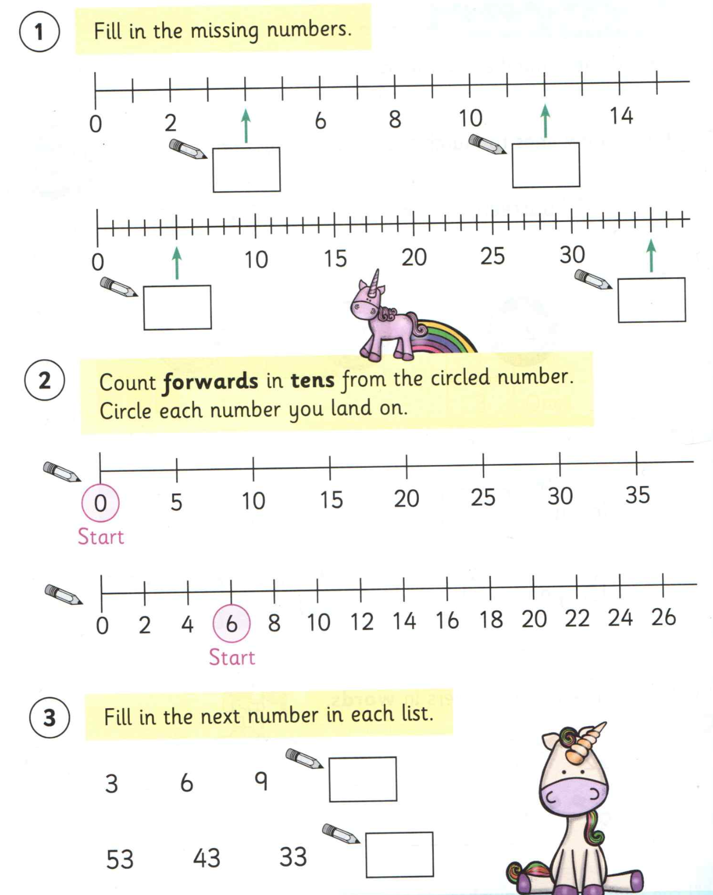
Fill in the missing gaps. (2s, 5s, 10s)
- 2, ___, 6, ___, 10, ___, 14, ___, ___
- 13, 15, ____, 19, ____, 23
- 20, ___, 16, ____, 12, 10
- ___, 40, 38, 36, ____, _____
- 50, ___, 40, 35, ____, ____, 20, ____
- 35, ____, 45, ____, 55, 60, _____
- ____, 80, 85, ____, 95, _____
- _____, 70, 80, 90, ____, _____
- 44, 55, ____, 77, ____, 99
- 79, 69, ____, 49, 39, ____, 19, ____

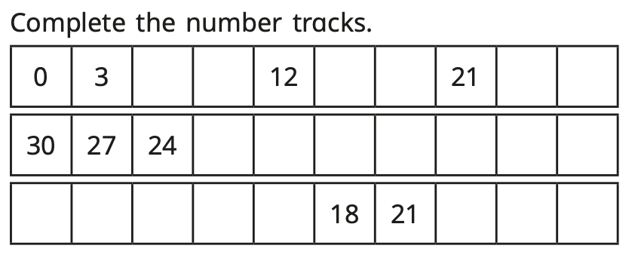
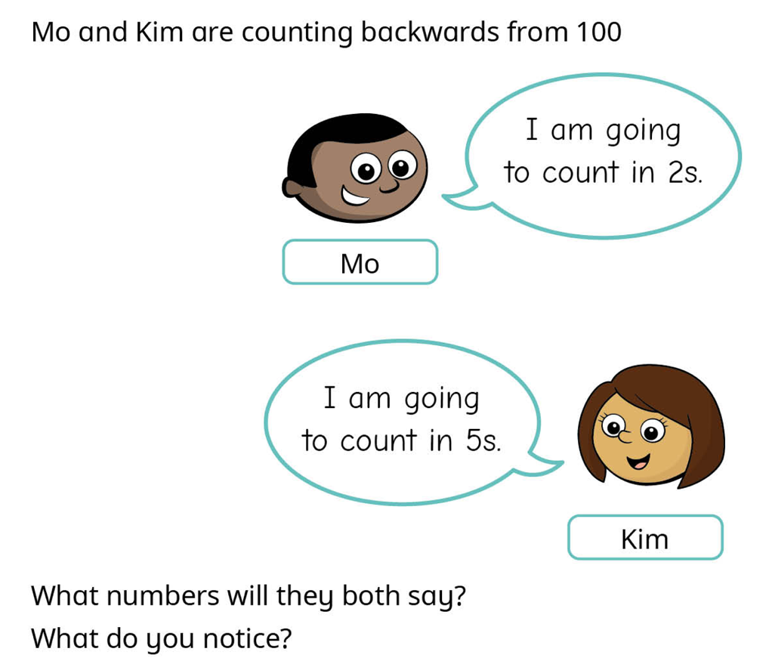
Challenges:

