**Emerald Class Homework Autumn 1 week 4 – Y4**

Homework due: Tuesday 8th October 2024

|  |  |  |  |
| --- | --- | --- | --- |
| **Next week we are learning:** | | | |
| Maths | Literacy | Science | RE |
| We will be starting our unit on Place Value recapping roman numerals and before numbers up to 1000 and then moving onto a 10,000 | We will be will be starting our explanation text on mummification | We will be continuing our topic on Properties and changes on materials | We will be continuing our unit of Creation focussing the conflicting and comparative views |

|  |
| --- |
| Log on to NumBots/ TTRS and practise your maths skills:  <https://play.numbots.com/#/account/school-login-type>  Purple Mash also have some lovely Maths and spellings activities  Or use other websites/ways that you enjoy 😊.  ***Spellings:***  Practise spellings ready for weekly spelling test- see below for your child’s spelling group – These groups are subject to change as they are based on their current spelling ages.  ***Reading:***  Read every day for 30 minutes. Please log this in Reading Records.    ***Maths: counting in 25, rounding to the nearest 10, 100 & 1000***  ***English – Reading comprehension*** |

Spellings:

|  |  |  |
| --- | --- | --- |
| **Group 1** | Group 2 | Group 3 |
| berry  bury  brake  break  meet  meat  ball  bawl  fair  fare | illegal  illegible  illogical  illiterate  illicit  irregular  irrelevant irresponsible irrational irresistible | apply  supply  identify  occupy multiply  rhyme  cycle  python hygiene hyphen |

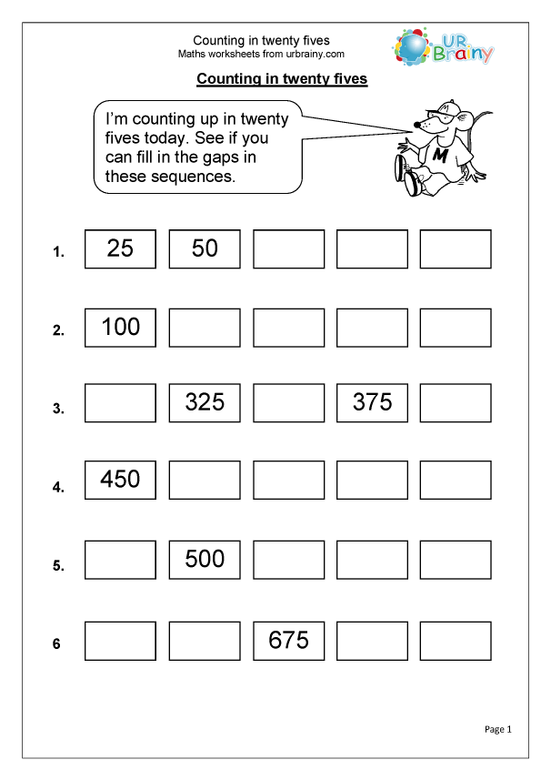

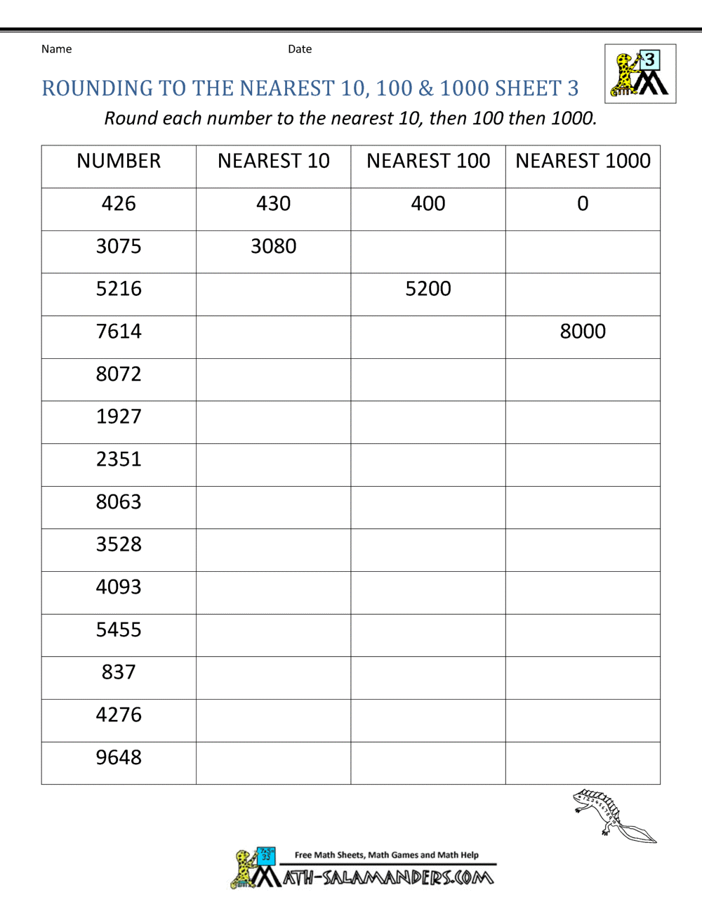

Challenge

