## Ruby Class Homework Autumn 1 week 4

B

Homework due: Tuesday 8th October 2024

|  |  |  |  |
| --- | --- | --- | --- |
| **Next week we are learning:** | | | |
| Maths | Literacy | Science | RE |
| We will be consolidating counting forwards and backwards in 2s, 5s and 10s. We will be looking at counting in 3s for the first time. | We will be applying our ideas to write our own innovative Jack and the Beanstalk story, | We will be exploring space!  We will be looking at the planets and learning about famous scientists. | We will be looking at the creation story in more depth and looking at what the story tells Christians about God. |

|  |
| --- |
| ***Spellings:***  Practise spellings ready for weekly spelling test- see below for your child’s spelling group – These groups are subject to change as they are based on their current spelling ages.  ***Reading:***  Read every day for 15 minutes.  Please log this in Reading Records.  Children must write a small comment in their journals everyday about their book.  ***Maths: Estimating numbers on number lines to 100.***  ***Challenges are optional –*** although please have a go if you can. |

**Spellings:**

|  |  |  |
| --- | --- | --- |
| **Group 1** | **Group 2** | **Group 3** |
| ant  tin  nap  hat  bag  the  chop  shop  wing  ring | with  come  some  they  when  what  one  today  flower  monster | wild  find  kind  child  children  guide  people  who  special  celebrate |

**Maths:**

Can you write these numerals as words?

Remember: Forty does not have a ‘u’ in its spelling.

**11 _____________ 12_____________**

**13_______________ 14________________**

**15________________ 16_______________**

Put the correct sign (<, > or =) between these numbers.

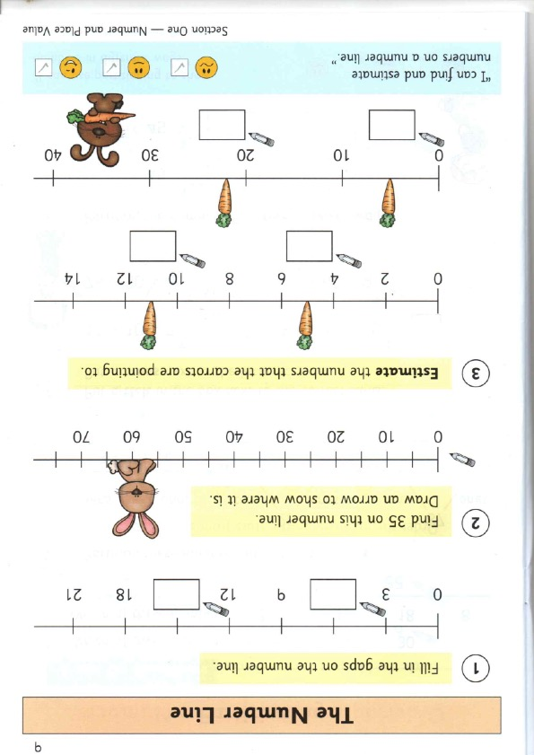

Challenges:

