Ruby Class Homework Autumn 1 week 4
A
Homework due: Tuesday 8th October 2024
Next week we are learning:
Maths | Literacy | Science | RE
We will be consolidating counting forwards and backwards in 2s, 5s and 10s. We will be looking at counting in 3s for the first time. | We will be applying our ideas to write our own innovative Jack and the Beanstalk story, | We will be exploring space!  We will be looking at the planets and learning about famous scientists. | We will be looking at the creation story in more depth and looking at what the story tells Christians about God.

Spellings:
Practise spellings ready for weekly spelling test- see below for your child’s spelling group – These groups are subject to change as they are based on their current spelling ages.

Reading:
Read every day for 15 minutes.
Please log this in Reading Records.
Children must write a small comment in their journals everyday about their book.

Maths: Estimating numbers on number lines to 100.

Challenges are optional – although please have a go if you can.

Spellings:
Group 1 | Group 2 | Group 3
ant  tin  nap  hat  bag  the  chop  shop  wing  ring | with  come  some  they  when  what  one  today  flower  monster | wild  find  kind  child  children  guide  people  who  special  celebrate

Maths:
Can you write these numerals as words?
Remember: Forty does not have a ‘u’ in its spelling.

41 _____________ 14_____________

46_______________ 64________________

48 ________________ 84_______________

34________________ 43_______________
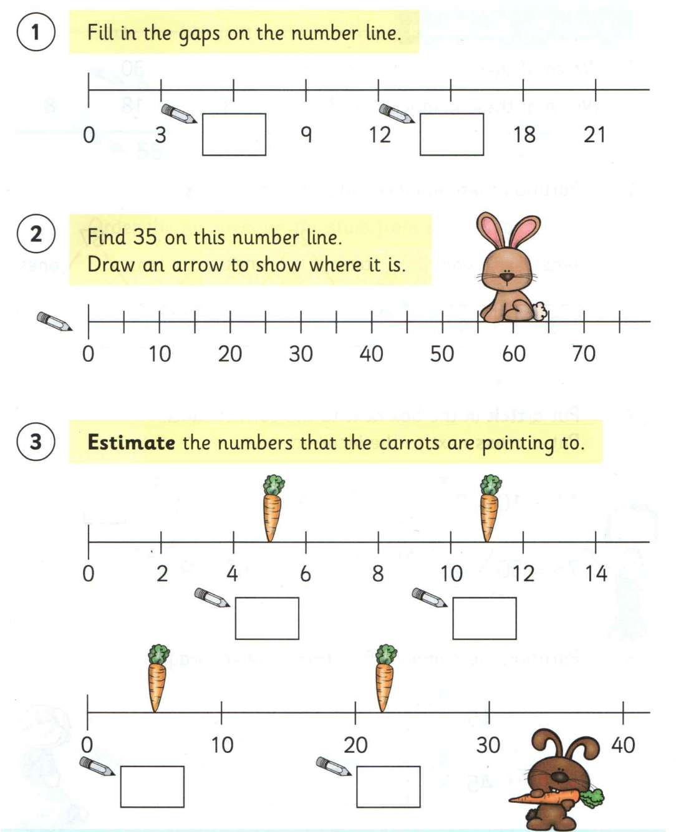

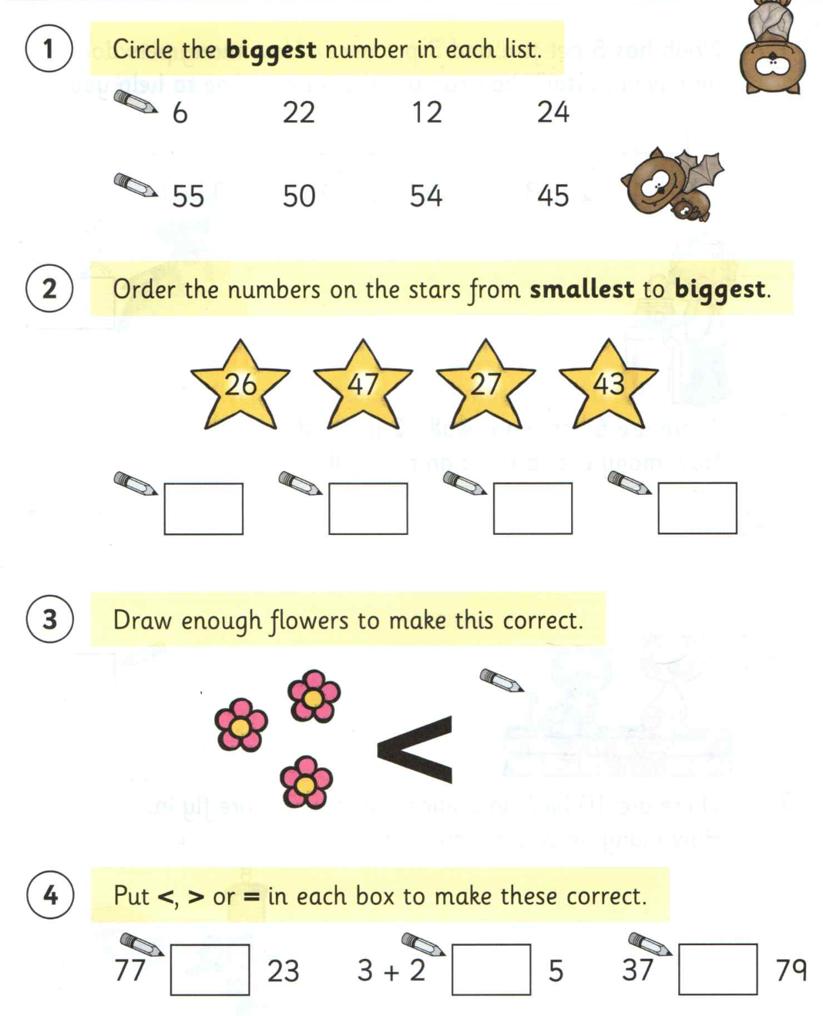

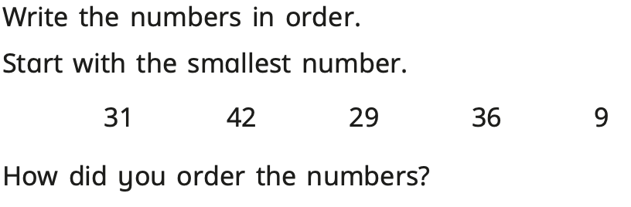

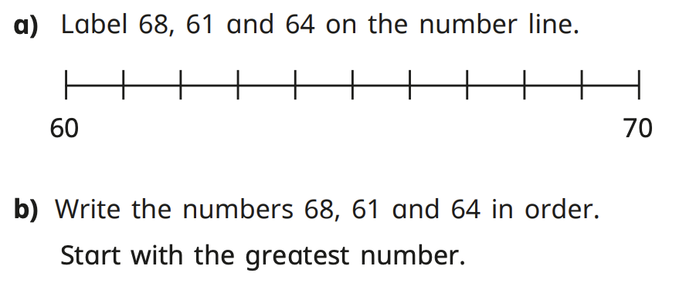

Challenges:
