**Ruby Class Homework Autumn 1 week 3**

B

Homework due: Tuesday 1st October 2024

|  |  |  |  |
| --- | --- | --- | --- |
| **Next week we are learning:** | | | |
| Maths | Literacy | Science | RE |
| We will be starting our unit on Place Value. We will be looking identifying and estimating numbers on a number line to 100. | We will be planning ideas for our innovative Jack and the Beanstalk story. | We will be exploring space!  We will be looking at the planets and learning about famous scientists. | We will be starting our unit on Creation. We will be looking at how different countries celebrate Harvest. |

|  |
| --- |
| ***Spellings:***  Practise spellings ready for weekly spelling test- see below for your child’s spelling group – These groups are subject to change as they are based on their current spelling ages.  ***Reading:***  Read every day for 15 minutes.  Please log this in Reading Records.  Children must write a small comment in their journals everyday about their book.  ***Maths:* Partitioning two-digit numbers using part-whole models.**  ***Challenges are optional –*** although please have a go if you can |

**Spellings:**

|  |  |  |
| --- | --- | --- |
| **Group 1** | **Group 2** | **Group 3** |
| big  back  off  mess  jug  van  wet  yes  put  pull | stole  sold  threw  barked  jogged  shouted  brighter  brightest  clearer  clearest | old  cold  gold  hold  told  when  what  why  donkey  honey |

**Maths:**

Can you write these numerals as words?

**10 _____________ 20_____________**

**30 ________________ 60 ________________**

**70 ________________ 80 _______________**

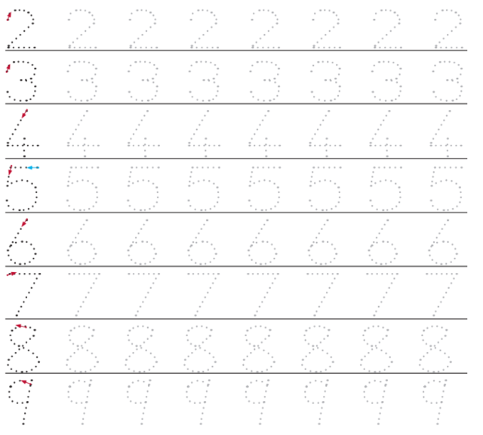

**Complete the sentences:**

**e.g. 3 tens are the same as thirty.**

1. 4 tens are the same as ___________.
2. 5 tens are the same as ___________.
3. 7 tens are the same as ____________.
4. 6 tens are the same as ____________.
5. 8 tens are the same as ____________.

**Write these numbers in numerals.**

1. **Sixty-two __________ 2) Thirty-one ___________**
2. **Fifty-four __________ 4) Seventy-six ___________**

**5) Forty-six __________ 6) Eighty-five ___________**

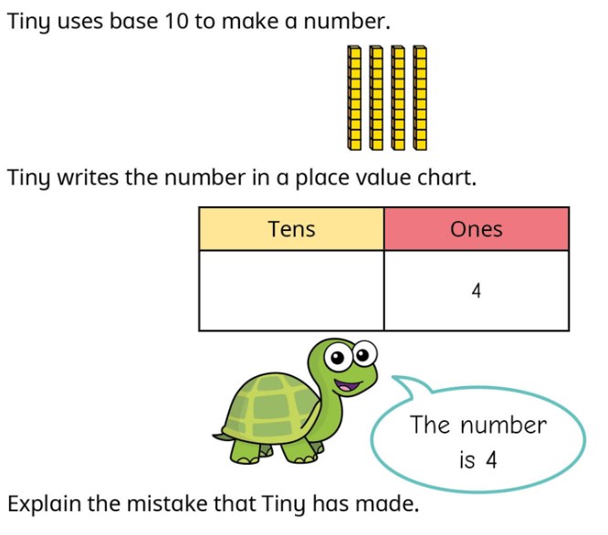

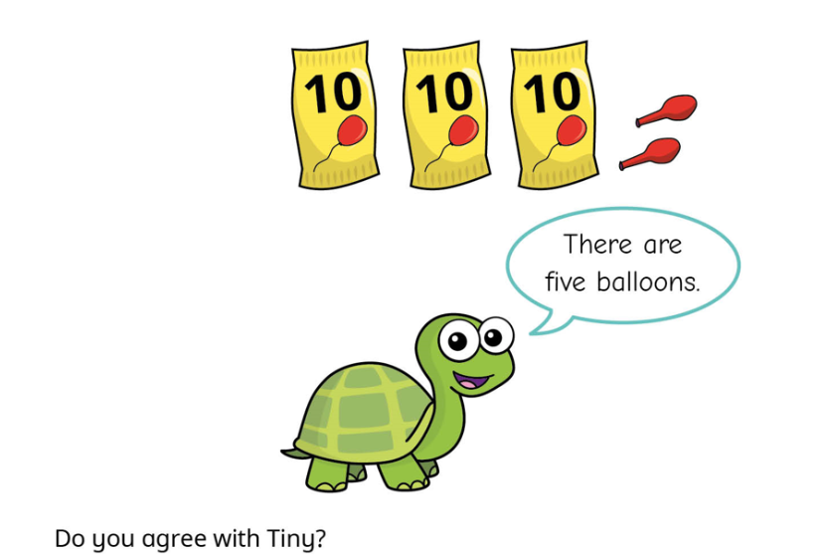

Why?

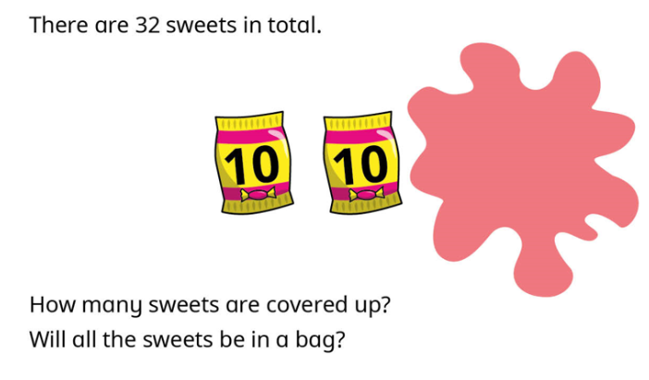Challenge:

