**Ruby Class Homework Autumn 1 week 2**

A

Homework due: Tuesday 1st October 2024

|  |  |  |  |
| --- | --- | --- | --- |
| **Next week we are learning:** | | | |
| Maths | Literacy | Science | RE |
| We will be starting our unit on Place Value. We will be looking identifying and estimating numbers on a number line to 100. | We will be planning ideas for our innovative Jack and the Beanstalk story. | We will be exploring space!  We will be looking at the planets and learning about famous scientists. | We will be starting our unit on Creation. We will be looking at how different countries celebrate Harvest. |

|  |
| --- |
| ***Spellings:***  Practise spellings ready for weekly spelling test- see below for your child’s spelling group – These groups are subject to change as they are based on their current spelling ages.  ***Reading:***  Read every day for 15 minutes.  Please log this in Reading Records.  Children must write a small comment in their journals everyday about their book.  ***Maths:* Partitioning two-digit numbers using part-whole models.**  ***Challenges are optional –*** although please have a go if you can |

**Spellings:**

|  |  |  |
| --- | --- | --- |
| **Group 1** | **Group 2** | **Group 3** |
| big  back  off  mess  jug  van  wet  yes  put  pull | stole  sold  threw  barked  jogged  shouted  brighter  brightest  clearer  clearest | old  cold  gold  hold  told  when  what  why  donkey  honey |

**Maths:**

Can you write these numerals as words?

**4 _____________ 14 _____________**

**44 ________________ 18 ________________**

**15 ________________ 27 _______________**

**64 ________________ 39 _______________**

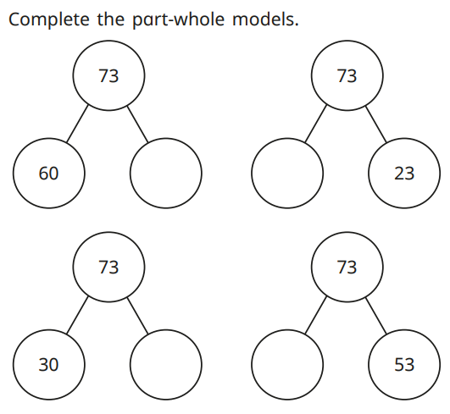

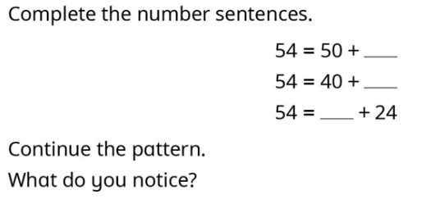

**Partition these numbers two different ways**.

e.g. 35 = 30 + 5 1) 45 = ____ + ____

35 = 20 + 15 45 = ____ + ____

2) 76= ___ + ____ 3) 38= ____ + ____

76= ____ + ____ 38= ____ + ____

 4) 67= ___ + ____ 5) 99= ____ + ____

67= _____ + _____ 99= ____ + ____

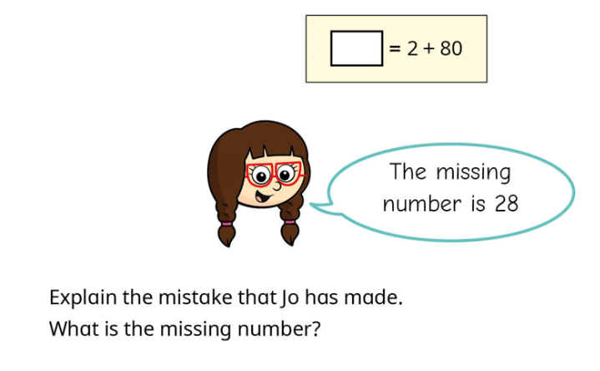

Challenge:

