**Ruby Class Homework Autumn 1 week 1**

Homework due: Tuesday17th September 2024

|  |  |  |  |
| --- | --- | --- | --- |
| **Next week we are learning:** | | | |
| Maths | Literacy | Science | RE |
| We will be starting our unit on Place Value. We will be looking at partitioning two-digit numbers into tens and ones and then using a place value chart. | We will be will be starting our unit on the story of Jack and the Beanstalk. | We will be starting our topic on plants. | We will be starting our unit on Creation. First, we will be looking at the symbolism of light in different religions. |

|  |
| --- |
| ***Spellings:***  Practise spellings ready for weekly spelling test- see below for your child’s spelling group – These groups are subject to change as they are based on their current spelling ages.  ***Reading:***  Read every day for 15 minutes. Please log this in Reading Records.    ***Maths:*** Recognise tens and ones  ***Challenges are optional –*** although please have a go if you can |

**Spellings:**

|  |  |
| --- | --- |
| **Group 1** | **Group 2** |
| pink  sink  rain  pain  need  seed  was  you  his  my | grew  bean  fast  past  last  some  come  should  could  would |

**Maths:**

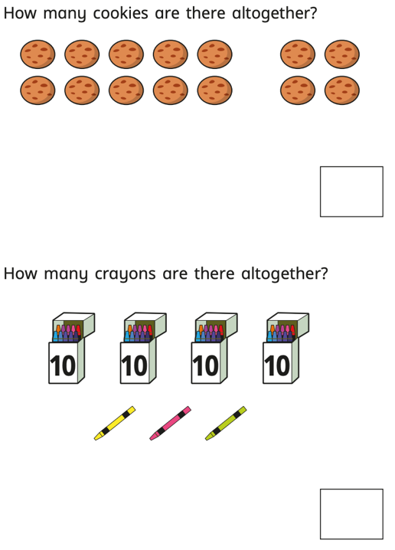

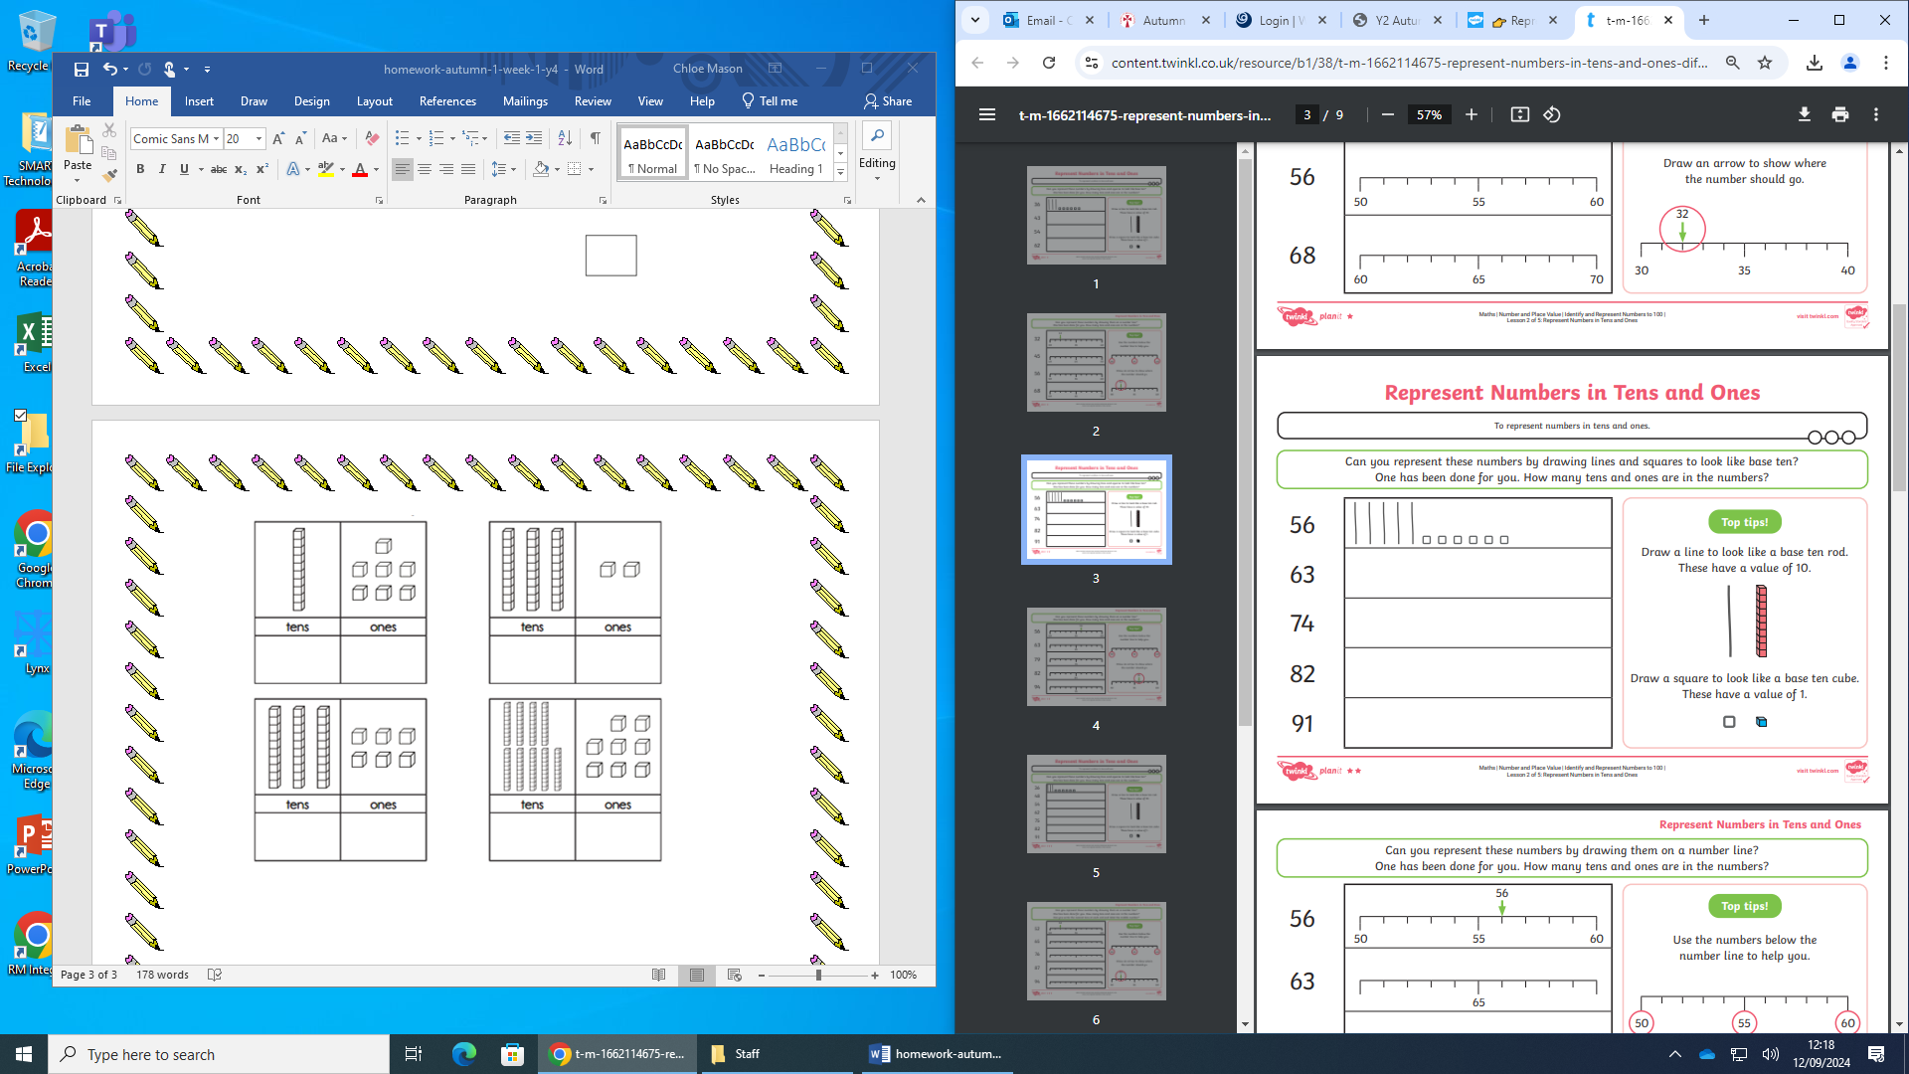

Draw these numbers on the place value charts.

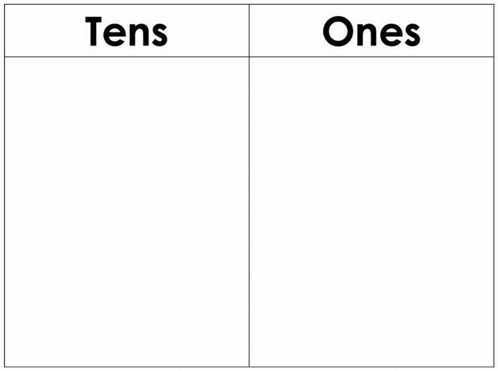

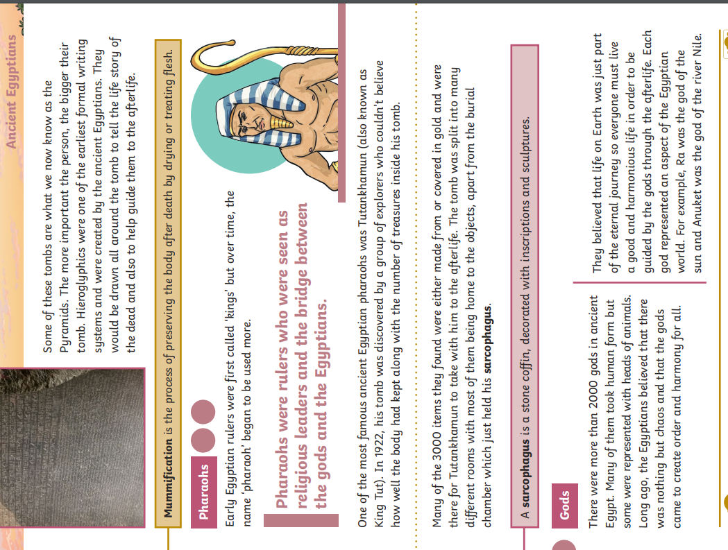 45

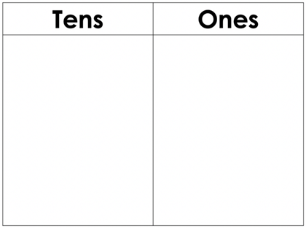

56



63



19

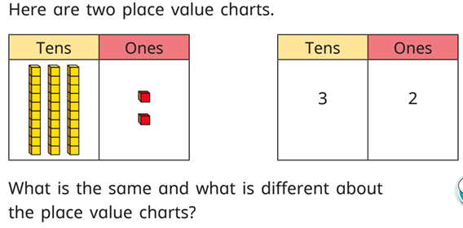Challenge:

