**Emerald Class Homework Autumn 1 week 1 – Y5**

Homework due: Tuesday17th September 2024

|  |  |  |  |
| --- | --- | --- | --- |
| **Next week we are learning:** | | | |
| Maths | Literacy | Science | RE |
| We will be starting our unit on Place Value recapping roman numerals and before numbers up to 1000 and then moving onto a 1, 000, 000 | We will be will starting our unit on the story The Egyptian Cinderella | We will be starting our topic on Properties and changes on materials | We will be starting our unit of Creation focussing the conflicting and comparative views |

|  |
| --- |
| Log on to NumBots/ TTRS and practise your maths skills:  <https://play.numbots.com/#/account/school-login-type>  Purple Mash also have some lovely Maths and spellings activities  Or use other websites/ways that you enjoy 😊.  ***Spellings:***  Practise spellings ready for weekly spelling test- see below for your child’s spelling group – These groups are subject to change as they are based on their current spelling ages.  ***Reading:***  Read every day for 30 minutes. Please log this in Reading Records.    ***Maths: Roman Numerals***  ***Challenges are optional –*** although please have a go if you can |

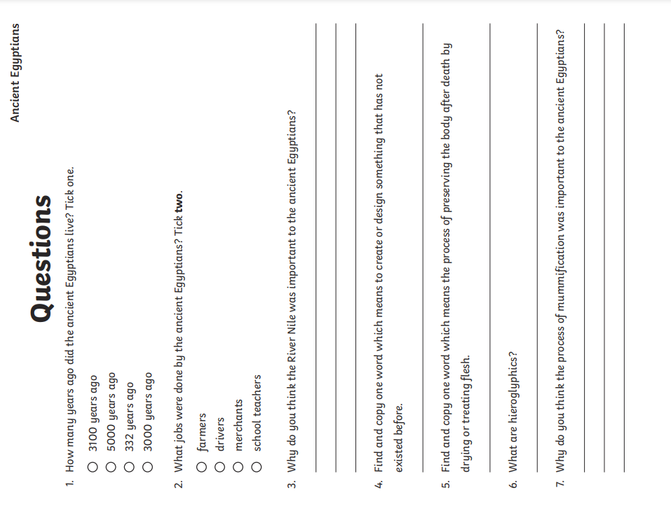

**Spellings:**

|  |  |  |
| --- | --- | --- |
| **Group 1** | Group 2 | Group 3 |
| eight  weigh  freight  they  disobey  prey  brain  complain  waist  straight | caught  naughty  taught  daughter  autumn  clause  cause  astronaut  applaud  author | vicious  gracious spacious malicious precious conscious delicious suspicious atrocious ferocious |

Challenge – Optional

