## Ruby Class Homework Autumn 1 week 7

A

Homework due: Tuesday 5th November 2024

|  |  |  |  |
| --- | --- | --- | --- |
| **Next week we are learning:** | | | |
| Maths | Literacy | Science | RE |
| We will be starting our new unit ‘addition and subtraction’.  We will be looking at related facts, focusing on number bonds to 10, 20 and 100. | We will be practicing our speaking skills through the Mighty Oak public speaking scheme. | We will be looking at how an aeroplane can fly. | We will be looking at the creation story in more depth and looking at what the story tells Christians about God. |

|  |
| --- |
| ***Spellings:***  Practise spellings ready for weekly spelling test- see below for your child’s spelling group – These groups are subject to change as they are based on their current spelling ages.  ***Reading:***  Read every day for 15 minutes.  Please log this in Reading Records.  Children must write a small comment in their journals everyday about their book.  ***Maths:*** number bonds and related facts  ***Challenges are optional –*** although please have a go if you can. |

**Spellings:**

|  |  |  |
| --- | --- | --- |
| **Group 1** | **Group 2** | **Group 3** |
| pen  dog  cat  bed  jam  tap  crab  frog  flag  my | hunting  hunted  hunter  buzzing  buzzed  buzzer  jumping  jumped  jumper  cracker | wrist  wreck  race  ice  cell  city  fancy  circle  friend  work |

**Maths:**

Can you write these numerals as words?

100 _____________ 150 _____________

122 _______________ 140 ________________

185 ________________ 117 _______________

145 ________________ 200 **_______________**

Complete the number tracks.

1. 2, 4, 6, 8, ___, 12, 14, ___, ___, 20

2.___, 4, 6, ___, ___, 12, 14, 16, 18, 20

3. 20, ___, 16, 14, ___, ___, 8, 6, 4, 2

4. ___, ___, 16, 14, 12, 10, 8, 6, ___, 2

5. 24, 22, 20, ___, 16, ___, 12, ___, ___

6. ___, 30, ___, 26, 24, 22, 20, 18, ___

Complete the number sentences.

**

Complete the number sentences:

3 + 7 = 10

____ + 7 = 20

5 + 5 = 10

5 + ____ = 20

What pattern do you notice?

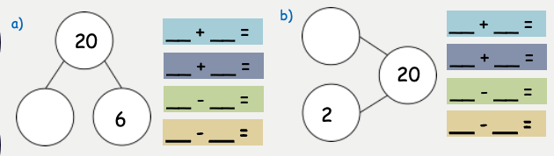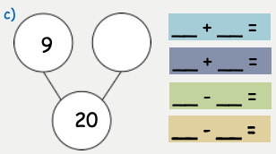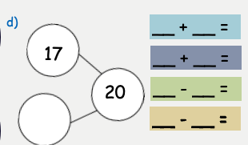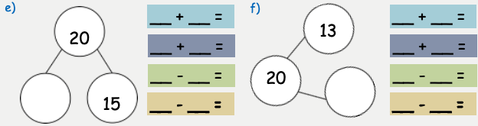

Challenges:

